B4x Booklets





B4x Getting started

Copyright: © 2018 Anywhere Software Edition 1.2

Last update : 2018.01.30

1 B4x 5

2 Getting started B4A 6

2.1 B4A Trial version 7

2.2 Installing B4A and Android SDK 8

2.2.1 Installing Java JDK 8

2.2.2 Installing Android SDK 9

2.2.3 Installing B4A 9

2.3 B4A Choice of the language 12

2.4 B4A Configure Paths in the IDE 11

2.5 B4A Connecting a real device 13

2.5.1 Connection via USB 13

2.5.2 Conneting via B4A-Bridge 14

2.5.2.1 Getting started with B4A-Bridge 14

2.5.2.2 Run B4A-Bridge on your device 15

2.5.2.3 Wireless connection 16

2.6 My first B4A program (MyFirstProgram.b4a) 18

2.7 Second B4A program (SecondProgram.b4a) 42

3 Getting started B4i 57

3.1 Installing B4i 58

3.1.1 Installing Java JDK 58

3.1.2 Installing B4i 59

3.1.3 Mac Builder installation 60

3.1.4 Hosted Mac builder service (optional) 61

3.2 Configure Paths in the IDE 62

3.3 Creating a certificate and provisioning profile 63

3.3.1 UDID 63

3.3.2 Certificate and Provisioning Profile 64

3.4 Installing B4i-Bridge and debugging first app 65

3.5 Install the B4I certificate 65

3.6 Set the package name based on the provision app id 65

3.6.1 Install Build B4i-Bridge 66

3.6.2 Load B4i-Bridge 66

3.6.3 Install B4i-Bridge and run it 67

3.7 My first B4i program (MyFirstProgram.b4i) 68

3.8 Second B4i program (SecondProgram.b4i) 91

4 Getting started B4J 106

4.1 Installing B4J 106

4.1.1 Installing Java JDK 106

4.1.2 Installing B4J 107

4.2 Configure Paths in the IDE 107

4.3 My first program (MyFirstProgram.b4j) 108

4.4 Second B4J program (SecondProgram.b4j) 129

5 Getting started B4R 145

5.1 Installing Arduino IDE 145

5.2 Install Microsoft .Net Framework 145

5.3 Install and configure B4R 146

5.4 Connecting a board 147

5.5 Select a Board 147

5.6 Arduino UNO board 149

5.6.1 Power supply 150

5.6.2 Pins 150

5.6.3 Power pins 150

5.6.3.1 Digital Input / Output pins 151

5.6.3.2 Analog input pins 151

5.6.4 Input modes INPUT / INPUT_PULLUP 151

5.6.5 Basic Pin functions 152

5.6.5.1 Initialize 152

5.6.5.2 DigitalRead 153

5.6.5.3 DigitalWrite 153

5.6.5.4 AnalogRead 153

5.6.5.5 AnalogWrite 154

5.7 First example programs 155

5.7.1 Button.b4r 156

5.7.1.1 Sketch 156

5.7.1.2 Code 157

5.7.2 LedGreen.b4r 158

5.7.2.1 Sketch 158

5.7.2.2 Code 159

5.7.3 LedGreenNoSwitchBounce.b4r 160

5.7.3.1 Sketch 161

5.7.3.2 Code 162

5.7.4 TraficLight.b4r 163

5.7.4.1 Sketch 163

5.7.4.2 Code 164

6 Help tools 166

6.1 Search function in the forum 166

6.2 B4x Help Viewer 168

6.3 Help documentation - B4A Object Browser 173

6.4 Useful links 174

6.4.1 B4A 174

6.4.2 B4i 175

6.4.3 B4J 176

6.4.4 B4R 177

6.5 Books 178

Main contributors: Klaus Christl (klaus), Erel Uziel (Erel)

**To search for a given word or sentence use the Search function in the Edit menu.**

All the source code and files needed (layouts, images etc.) of the example projects in this booklet are included in the SourceCode folder.

For each program there are three folders.

SourceCode

MyFirstProgram

B4A

MyFirstProgram.b4a

B4i

MyFirstProgram.b4i

B4J

MyFirstProgram.b4j

Both programs MyFirstProgram and SecondProgram are almost the same for B4A, B4i and B4J.

Updated for following versions:

B4A version 7.80

B4i version 4.81

B4J version 6.01

B4R version 2.20

B4X Booklets:

[B4x Getting Started](https://www.b4x.com/android/forum/threads/b4x-booklets-basic-language-and-ide.79951/#content)

[B4x Baisc Language](https://www.b4x.com/android/forum/threads/b4x-booklets-basic-language-and-ide.79951/#content)

[B4x IDE Integrated Development Environment](https://www.b4x.com/android/forum/threads/b4x-booklets-basic-language-and-ide.79951/#content)

[B4x Visual Designer](https://www.b4x.com/android/forum/threads/b4x-booklets-basic-language-and-ide.79951/#content)

[B4x CustomViews](https://www.b4x.com/android/forum/threads/b4x-b4x-booklet-customviews.76229/#content)

# B4x

B4x is a suite of BASIC programming languages for different platforms.

B4X suite supports more platforms than any other tool

ANDROID | IOS | WINDOWS | MAC | LINUX | ARDUINO | RASPBERRY PI | ESP8266 | AND MORE...

* **B4A**  **Android**  
  B4A includes all the features needed to quickly develop any type of Android app.
* **B4i**  **iOS**  
  B4i is a development tool for native iOS applications.  
  B4i follows the same concepts as B4A, allowing you to reuse most of the code and build apps for both Android and iOS.
* **B4J**  **Java / Windows / Mac / Linux / Raspberry PI**  
  B4J is a **100% free** development tool for desktop, server and IoT solutions.  
  With B4J you can easily create desktop applications (UI), console programs (non-UI) and server solutions.  
  The compiled apps can run on Windows, Mac, Linux and ARM boards (such as Raspberry Pi).
* **B4R**  **Arduino / ESP8266**B4R is a **100% free** development tool for native Arduino and ESP8266 programs.  
  B4R follows the same concepts of the other B4X tools, providing a simple and powerful development tool.  
  B4R, B4A, B4J and B4i together make the best development solution for the Internet of Things (IoT).

# Getting started B4A

**B4A (Basic for Android) is a simple yet powerful development environment that targets Android devices.**  
B4A language is similar to Visual Basic language with additional support for objects.  
B4A compiled applications are native Android applications; there are no extra runtimes or dependencies.  
Unlike other IDE’s, B4A is 100% focused on Android development.  
B4A includes a powerful GUI designer with built-in support for multiple screens and orientations.

**No XML writing is required.**

You can develop and debug with:

- a real device connected via B4A Bridge

- a real device connected via USB cable

- or an Android emulator.

B4A has a rich set of libraries that make it easy to develop advanced applications.   
This includes: [SQL databases](http://www.basic4ppc.com/android/help/sql.html), [GPS](http://www.basic4ppc.com/android/help/gps.html), [Serial ports (Bluetooth)](http://www.basic4ppc.com/android/help/serial.html), [Camera](http://www.basic4ppc.com/android/help/camera.html), [XML parsing](http://www.basic4ppc.com/android/help/xmlsax.html), [Web services (HTTP)](http://www.basic4ppc.com/android/help/http.html), [Services (background tasks)](http://www.basic4ppc.com/forum/basic4android-getting-started-tutorials/7542-service-modules.html), [JSON](http://www.basic4ppc.com/android/help/json.html), [Animations](http://www.basic4ppc.com/forum/basic4android-getting-started-tutorials/6967-android-views-animation-tutorial.html), [Network (TCP and UDP)](http://www.basic4ppc.com/android/help/network.html), [Text To Speech (TTS)](http://www.basic4ppc.com/forum/basic4android-getting-started-tutorials/7043-android-text-speech-example.html), [Voice Recognition](http://www.basic4ppc.com/android/help/phone.html#voicerecognition), [WebView](http://www.basic4ppc.com/android/help/views.html#webview), [AdMob (ads)](http://www.basic4ppc.com/forum/basic4android-getting-started-tutorials/7300-admob-tutorial-add-ads-your-application.html), [Charts](http://www.basic4ppc.com/forum/basic4android-getting-started-tutorials/8260-android-charts-framework.html), [OpenGL](http://www.basic4ppc.com/android/help/opengl.html), [Graphics](http://www.basic4ppc.com/android/help/drawing.html) and [more](http://www.basic4ppc.com/android/documentation.html).

Android 1.6 and above are supported (including tablets).

## B4A Trial version

Look at this page for instructions how to use the trial version: <https://www.b4x.com/b4a.html>

## Installing B4A and Android SDK

B4A depends on two additional (free) components:

- Java JDK  
- Android SDK

### Installing Java JDK

Installation instructions:  
The first step should be to install the **Java JDK**, as Android SDK requires it as well.  
Note that there is no problem with having several versions of Java installed on the same computer.  
  
- Open the [Java 8 JDK download link](http://www.oracle.com/technetwork/java/javase/downloads/jdk8-downloads-2133151.html).

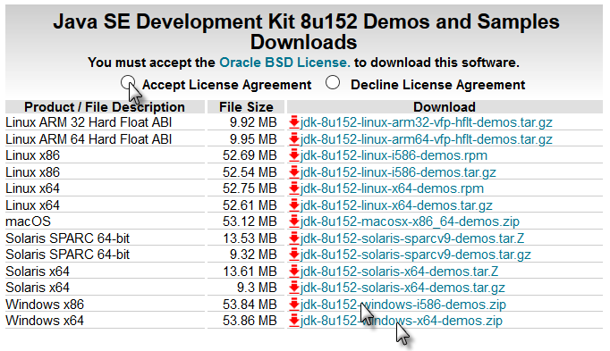

- Check the Accept License Agreement radio button.  
- Select **"Windows x86"** or **"Windows x64"** (for 64 bit machines) in the platforms list.

- Download the file and install it.

### Installing Android SDK

**The next step is to install the Android SDK and a platform:**

[Download the Android SDK command line tools](https://dl.google.com/android/repository/sdk-tools-windows-3859397.zip).

**Unzip it in a folder such as C:\Android.**

### Installing B4A

Download and install B4A.

Open B4A.

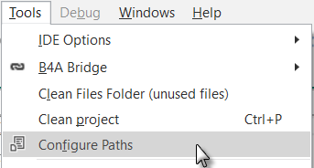  
In the menu  click on .

Set the path to "javac.exe" if it is empty (C:\Program Files\Java\jdk1.8.0_xxx\bin\javac.exe).

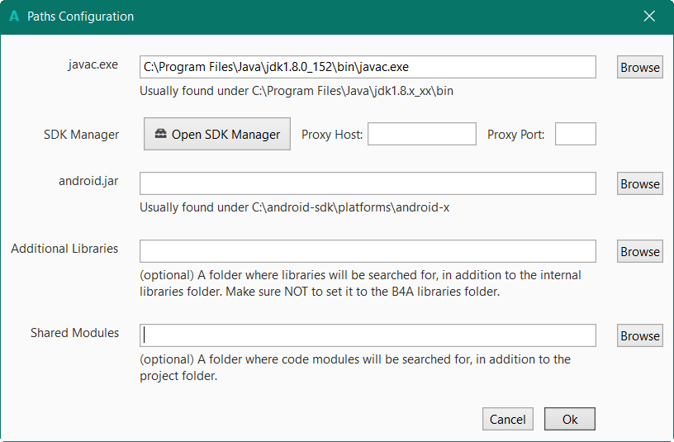

Click on 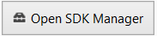.

On top, enter the path for sdkmanager.bat.

“C:\Android\tools\bin\ sdkmanager.bat”



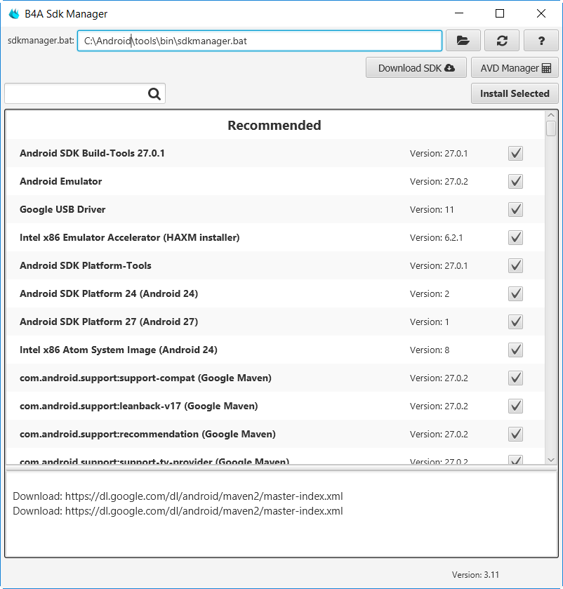

Install all recommended items.

Read and accept the licenses when you are asked for.

Return to B4A and set the path for “android.jar”.

## B4A Configure Paths in the IDE

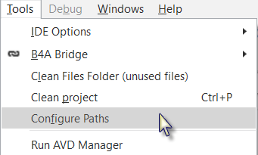

- Open B4A.

- Click on  in the  menu.

The window below will be displayed.

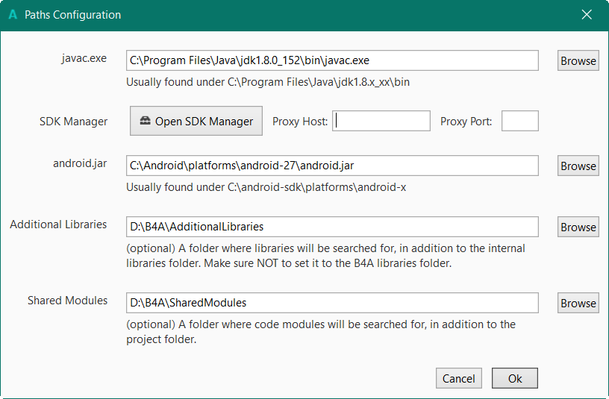

The path for “java.exe” and are already set.

Set the path for “android.jar”: C:\Android\platforms\android-27\android.jar.

It is recommended to create a specific folder for Additional libraries.

B4A utilizes two types of libraries:

* Standard libraries, which come with B4A and are located in the  
  Libraries folder of B4A.   
  These libraries are automatically updated when you install a new version of B4A.
* Additional libraries, which are not part of B4A, and are mostly written by members. These libraries should be saved in a specific folder different from the standard libraries folder.

Shared modules: Module files can be shared between different projects and must therefore be saved in a specific folder.

Libraries and modules are explained in the B4x Basic Language booklet.

## B4A Choice of the language

You can select a language of your choice, if it is available.

In the IDE menu Tools / IDE Options / Language select the language of your choice.

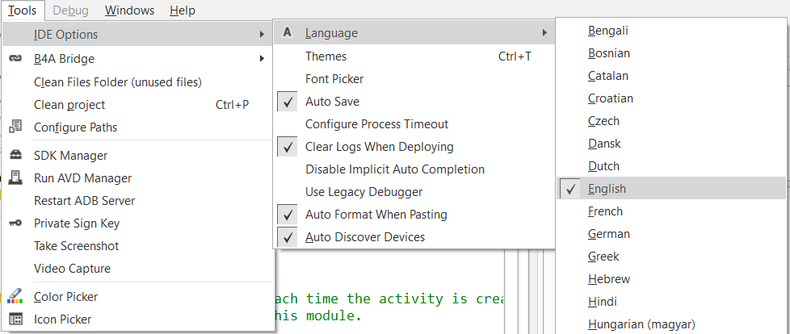

## B4A Connecting a real device

There are different means to connect a real device:

* USB  
  Needs that the device supports ADB debugging.  
  Need to activate USB Debugging on the device.
* B4A Bridge, via WiFi.

### Connection via USB

If you followed the previous steps, the Google USB driver is already download by default.

If this driver doesn’t work you must look for a specific one for your device.

To be able to connect a device via USB you must activate USB debugging on the device.  
This is also needed if you use an Emulator.

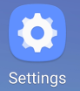

On the device, execute Settings

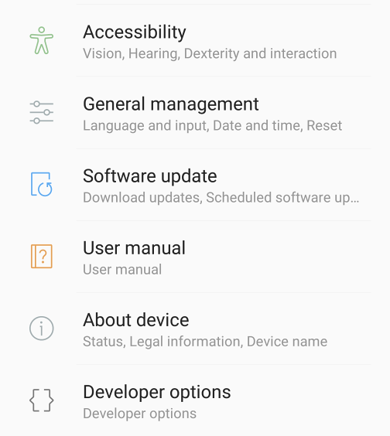

Scroll the screen until you see *Developper options*.

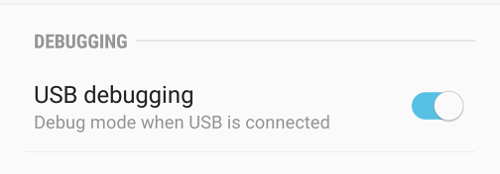

Scroll the screen until you see *USB debugging*.

Activate it.

The device will automatically be recognized by the IDE.

In this case, on some older devices, it was no more possible to access the SD card from the PC.

If you want to access the SD card you must deactivate USB debugging.

### Conneting via B4A-Bridge

It is always recommended to use a real device instead of an Android emulator which is very slow compared to a real device (especially with applications installation).

However not all devices support ADB debugging. This is the reason for the B4A-Bridge tool.

B4A-Bridge is made of two components. One component runs on the device and allows the second component which is part of the IDE to connect and communicate with the device.

The connection is done over a network (B4A-Bridge cannot work if there is no network available).

Once connected, B4A-Bridge supports all of the IDE features which include: installing applications, viewing LogCat and the visual designer.

Android doesn't allow applications to quietly install other applications, therefore when you run your application using B4A-Bridge you will see a dialog asking for your approval.

#### Getting started with B4A-Bridge

First you need to install B4A-Bridge on your device.

B4A-Bridge can be downloaded here: <http://www.basic4ppc.com/android/files/b4a_bridge.apk>.

B4A-Bridge is also available on Play Store. Search for: B4A Bridge.

Note that you need to allow install of applications from "Unknown sources".



On the device, execute Settings

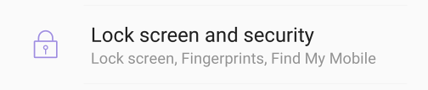Scroll the screen until you see

*Lock screen and security*.

Select it.

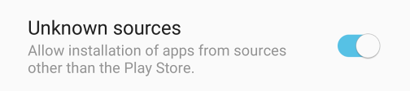

Scroll the screen until you see

*Unknown sources*.

Activate it.

B4A-Bridge requires writable storage card. It is not possible to install applications without it.

#### Run B4A-Bridge on your device

Run B4A-Bridge on your device, it will display a screen similar to the picture below.

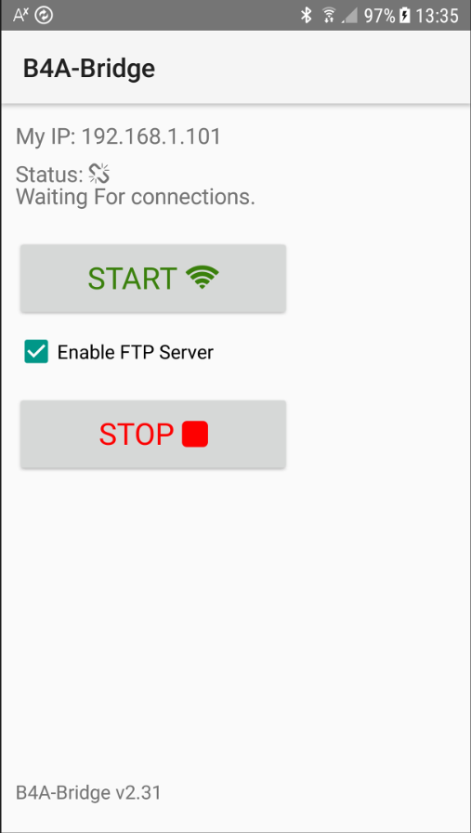

Status will be:

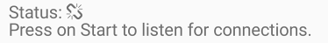

Press 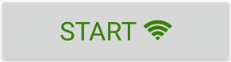 for connection.

Status will change to:

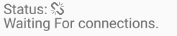

Note that B4A-Bridge was written with B4A.

#### Wireless connection

In the IDE menu Tools select .

If the address already exists click directly on this address.

If this device was already connected before you can simply press F2 to connect it.

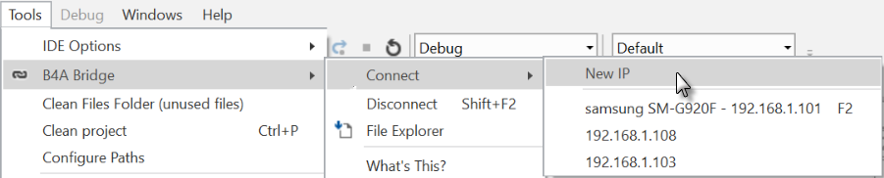

Enter the IP of the device, you find it on top of the B4A-Bridge screen on the device.

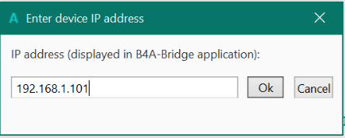 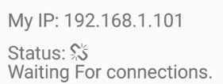

Click on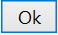, the device is connected to the IDE.

You see that the status changed on both,   
the device and the IDE in the lower left corner.

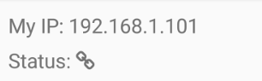 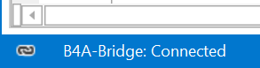.

B4A-Bridge keeps running as a service until you press on the Stop button.

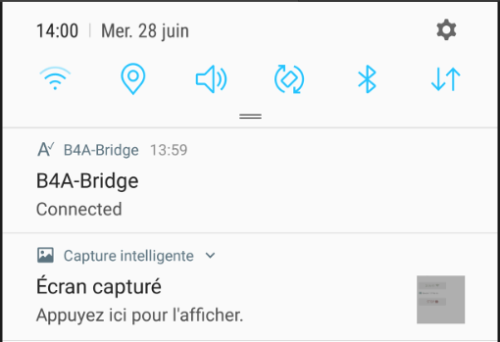You can always reach it by opening the notifications screen.



You see B4A-Bridge with the current status.

Note that the Internet permission are automatically added in debug mode.

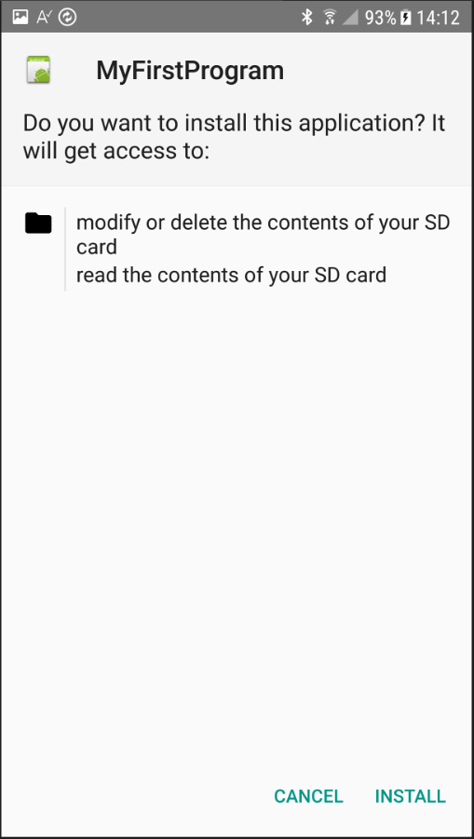

When you run an application you are required to approve the installation. You will usually see a screens like the picture.

Press on  to install the program.

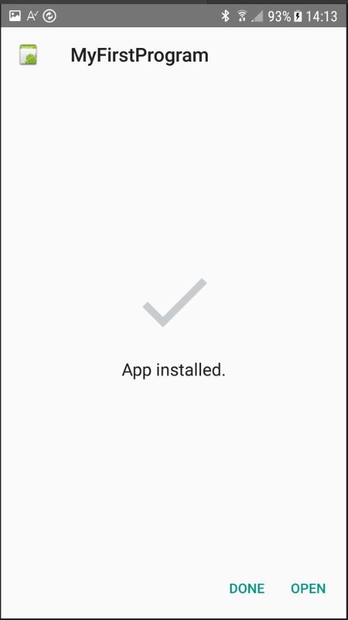

If you pressed on  you will see a screen like in picture.

On this screen you should choose 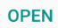to start the application.  
**If you try to install an existing application signed with a different key, the install will fail (without any meaningful message). You should first uninstall the existing application. Go to the home screen - Settings - Applications - Manage applications - choose the application - Uninstall.**  
  
Once you finished developing you should press on the Stop button in B4A-Bridge in order to save battery.

## My first B4A program (MyFirstProgram.b4a)

Let us write our first program. The suggested program is a math trainer for kids.

The project is available in the SourceCode folder shipped with this booklet:

SourceCode\MyFirstProgram\ B4A\MyFirstProgram.b4a

The look of the screen is different depending on the Android version of the devices, also with Emulators.

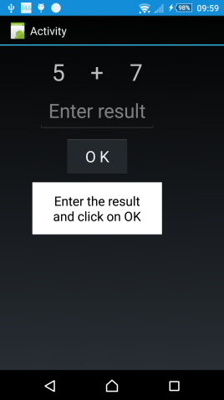 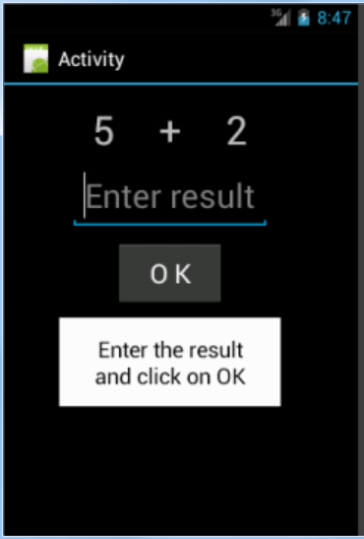 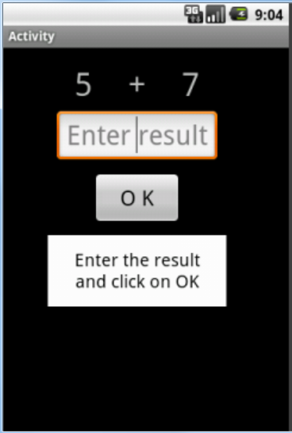

Sony xperia z1 Emulator Android version 4.2 Emulator Android version 2.2

On the screen, we will have:

- 2 Labels displaying randomly generated numbers (between 1 and 9).

- 1 Label with the math sign (+).

- 1 EditText view where the user must enter the result.

- 1 Button, used to either confirm when the user has finished entering the result or generate a new calculation.

- 1 Label with a comment about the result.

In Android:

- Label is an object to show text.

- EditText is an object allowing the user to enter text.

- Button is an object allowing user actions.

We will design the layout of the user interface with the VisualDesigner and go step by step through the whole process.

**Run the IDE** 

When you open the IDE you will see on the top left two Tabs Main and Starter.

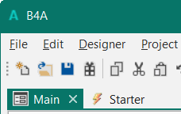

*   
  Is the Main module for B4A which is the normal starting module. Its name cannot be changed.
*   
  Is a Service, which is startet when the program is lauched.

For our first program we don’t need this Starter service, so we delete it.

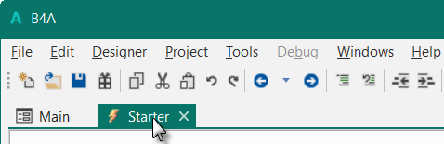

Click on  tab to select the service.

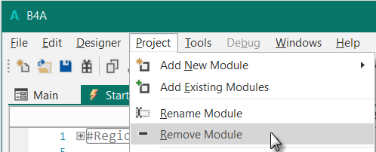

In the menu    
click on .

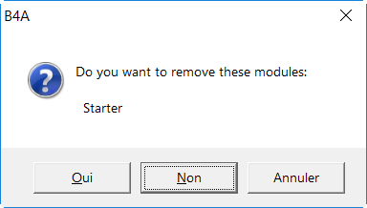

You are asked if you really want to remove it.

Click on OUI (YES)

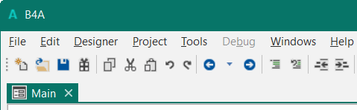

The Starter service module is removed.

You could also leave the Starter service, the removal is not mandatory.

**Save the project.**

You must save the project before you can run the Designer.

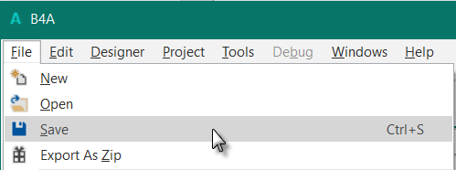

Create a new folder MyFirstProgram and save the project with the name MyFirstProgram.

**Set the Package Name.**

Each program needs a package name.

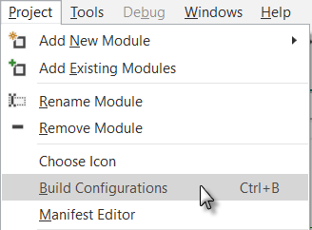

In the menu  click on .

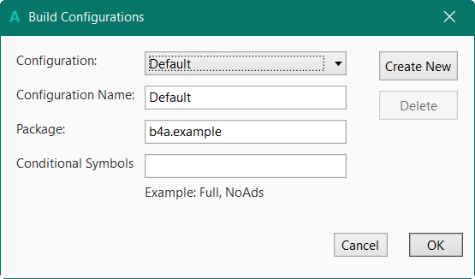

This window appears:

The default name is b4a.example.

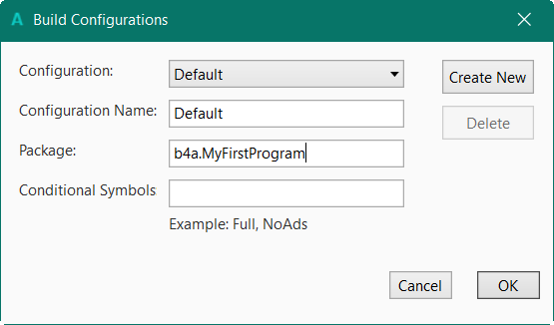

We will change it to b4a.MyFirstProgram.

And click on 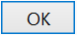.

**Set the Application Label.**

The Application label is the name of the program that will be shown on the device.

On top of the code screen you see these two lines showing two 'regions'.

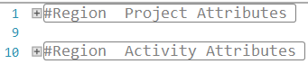

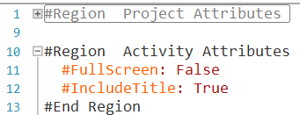Regions are code parts which can be collapsed or extended.

Clicking on  will expand the Region.

Clicking on  will collapse the Region.

Regions are explained in chapter Collapse a Region in the B4x IDE booklet.

#Region Project Attributes

#ApplicationLabel: B4A Example

#VersionCode: 1

#VersionName:

'SupportedOrientations possible values: unspecified, landscape or portrait.

#SupportedOrientations: unspecified

#CanInstallToExternalStorage: False

#End Region

#Region Activity Attributes

#FullScreen: False

#IncludeTitle: True

#End Region

The default name is B4A Example, but we will change it to MyFirstProgram for naming consistency.

Change this line:

#ApplicationLabel: B4A Example

to

#ApplicationLabel: MyFirstProgram

The other lines are explained in Chapter Code header Project Attributes / Activity Attributes.

**Connect a device**

To test the program you should connect a device to the IDE.

The best connection is via B4A-Bridge.

You can connect the IDE to a device via (see previous chapter):

* B4A-Bridge
* USB cable

It is also possible to connect an Emulator, not advised, too slow.

**In the IDE run the Designer**.

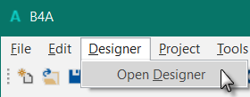

Click on .

The Visual Designer looks like this.

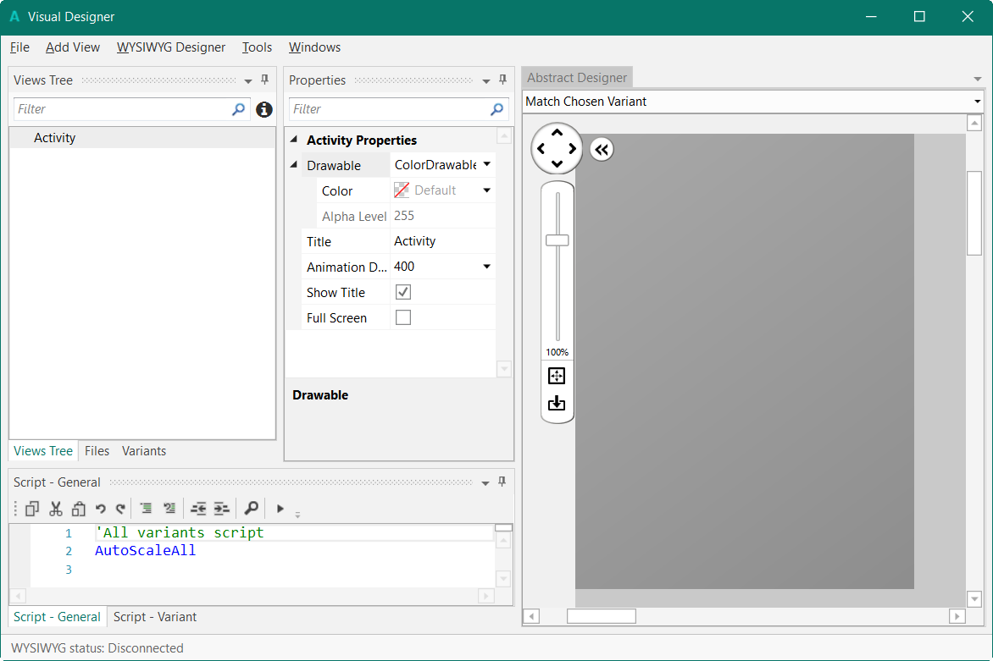

There are different windows:

* Views Tree shows all views as a tree.
* Properties shows all properties of the selected view.
* Abstract Designer shows the views on a screen
* Script - General allows to ‘fine tune’ the layouts.

The Designer is explained in detail in the B4x Visual Designer booklet.

In this first project we will only look at the three first windows.

* Liste of views
* Properties
* Abstract Designer

So we hide the Script- General window to increase the size of the two other windows on top.

Click on .

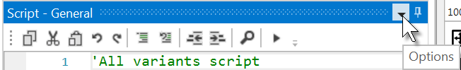

And on  .

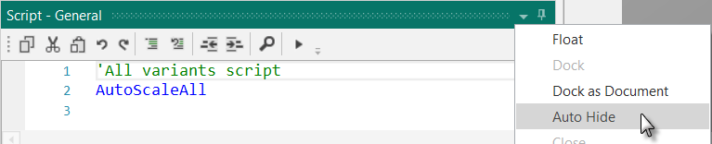

The Designer will look like this.

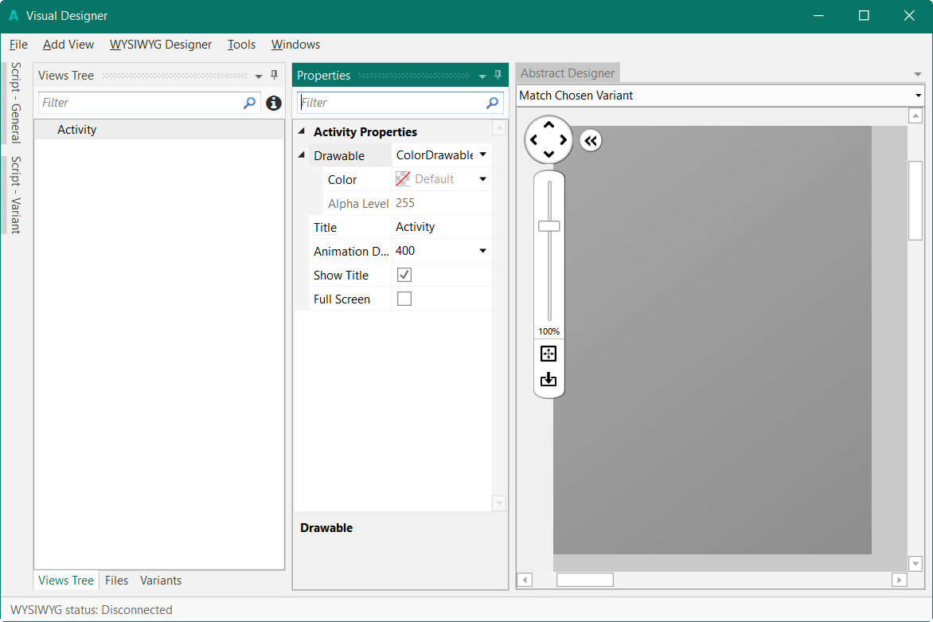

To shows the views on the device you must connect the device to the Designer.

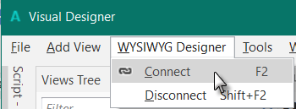

Wait until the Designer and the device are connected. This can take some time, so be patient.

You will see the state of the Designer in the bottom left corner of the Designer:

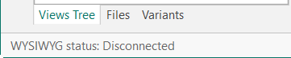

Now we will add the 2 Labels for the numbers.

In the Designer, add a Label.

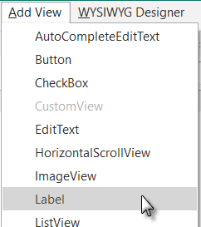

We see the Label with the default name Label1 in following windows:

**Properties** **Abstract Designer**

with its default at its default position and

**Views Tree** properties. default dimensions.

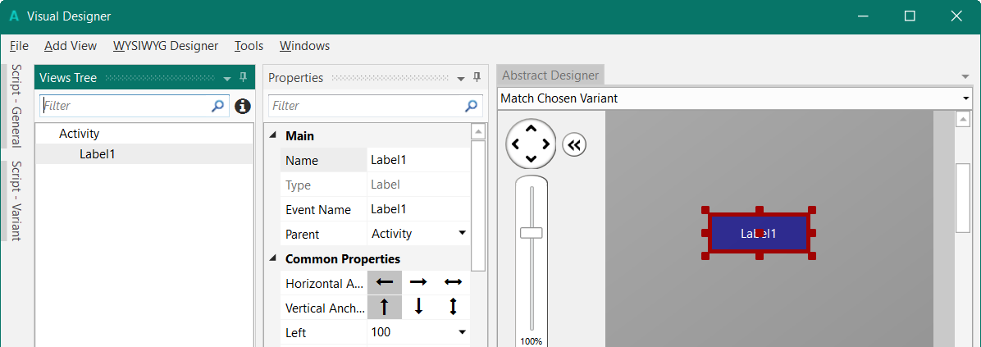

Resize and move the Label with the red squares like this.

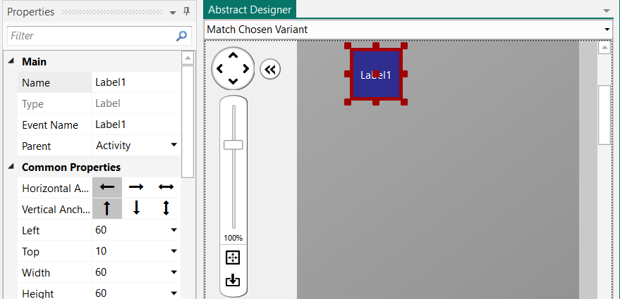

The new properties Left, Top, Width and Height are directly updated in the Properties window.

You can also modify the Left, Top, Width and Height properties directly in the Properties window.

Let us change the properties of this first Label according to our requirements.

By default, the name is Label with a number, here Label1, let us change its name to lblNumber1.

The three letters 'lbl' at the beginning mean 'Label', and 'Number1' means the first number.

It is recommended to use meaningful names for views so we know directly what kind of view it is and its purpose.

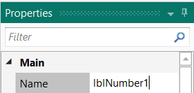

Pressing the 'Return' key or clicking elsewhere will update the name in the other windows and change the Event Name property.

Main: Main module.

Name: Name of the view.

Type: Type of the view. In this case, Label, which is not editable.

Event Name: Generic name of the routines that handle the events of the Label.

Parent: Parent view the Label belongs to.

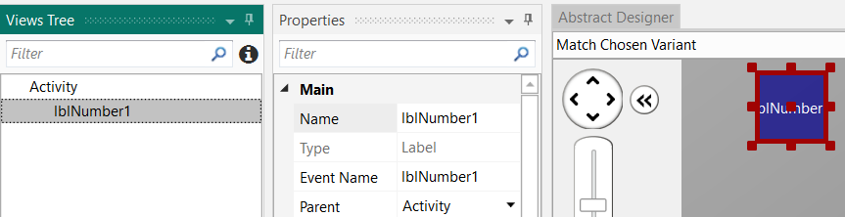

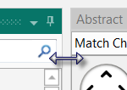

To better see the other properties we enlarge the Properties window.

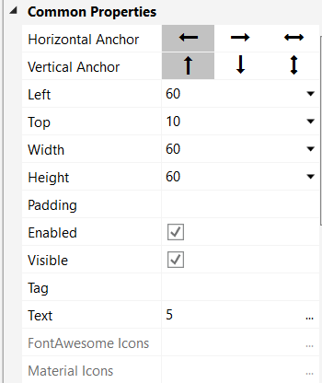Let us check and change the other properties:

Left, Top, Width and Height are OK.

Or if the values are not the same you should change them.

Enabled, Visible are OK

Tag, we leave empty.

Text, we set a default number, say 5

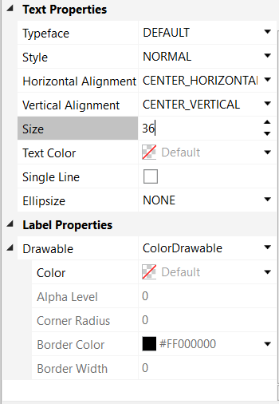

Typeface, Style are OK

Horizontal Alignment, we set to CENTER_HORIZONTAL

Vertical Alignment, we leave CENTER_VERTICAL.

Size, we set to 36

We leave all the other properties as they are.

We need a second Label similar to the first one. Instead of adding a new one, we duplicate the first one with the same properties. Only the Name and Left properties will change.

Right click in the Abstract Designer on lblNumber1 and click on .

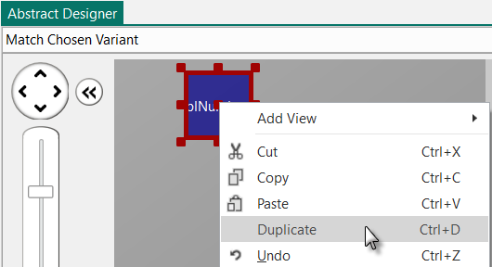

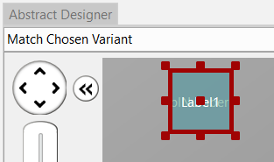

The new label covers the previous one.

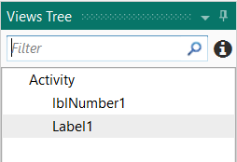

We see the new label added in the Views Tree.

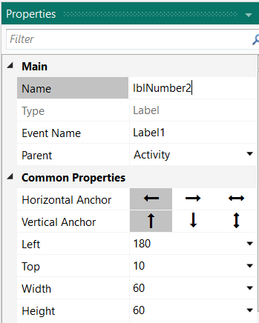

Change its name to lblNumber2.

Change the Left property to 180.

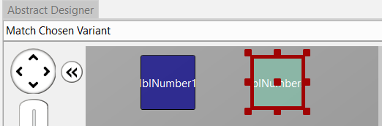

The new label with its new name and at its new position

Now we add a 3rd Label for the math sign. We copy once again lblNumber1.

In the Abstract Designer right click on lblNumber1, click on .

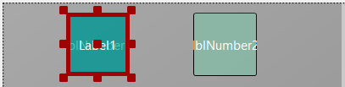

The new label covers lblNumber1.

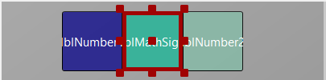

Position it between the first two Labels and change its name to lblMathSign and its

Text property to '+'.

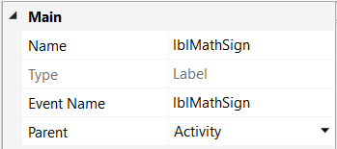

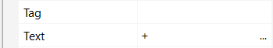

Now let us add an EditText view.

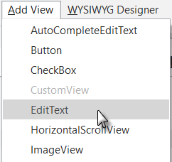In the Designer menu

click on .

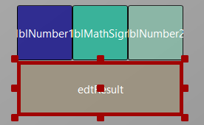

Position it below the three Labels and change its name to edtResult. 'edt' means EditText and 'Result' for its purpose.

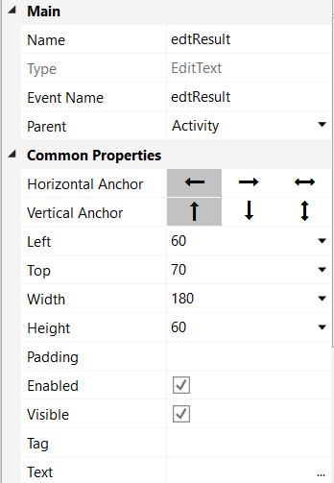

Let us change these properties.

Name to edtResult

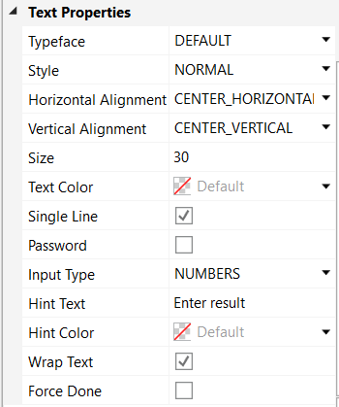

Horizontal Alignment to CENTER_HORIZONTAL

Size to 30

Input Type to NUMBERS

Hint Text to Enter result

Setting Input Type to NUMBERS lets the user enter only numbers.

Hint Text represents the text shown in the EditText view if no text is entered.

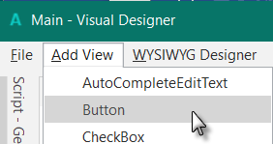Now, let's add the Button which, when pressed, will either check the result the user supplied as an answer, or will generate a new math problem, depending on the user's input.

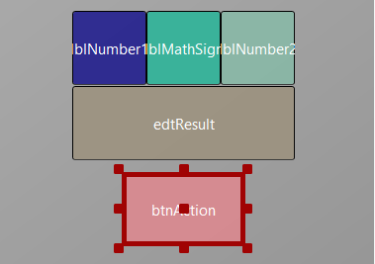

Position it below the EditText view. Resize it and change following properties:

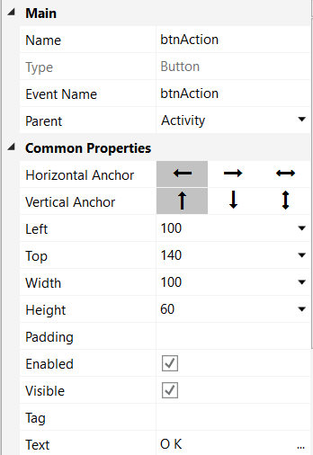

Set the properties like below.

Name to btnAction

Text to O K (with a space between O and K)

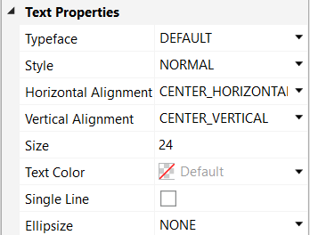

Size to 24

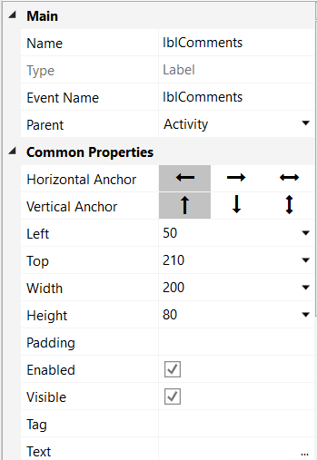Let us add the last Label for the comments. Position it below the Button and resize it.

Change the following properties:

Name to lblComments

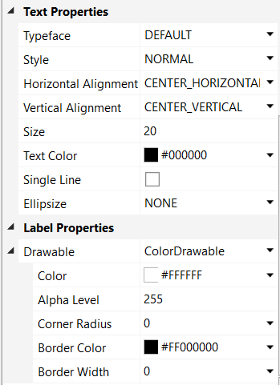

Horizontal Alignment CENTER_HORIZONTAL

Size to 20

Text Color to #000000

We set the Text Color property to Black (#000000).

Color to #FFFFFF

Alpha to 255

By default, the Label background color is black and transparent.

We set it to white and opaque Alpha = 255.

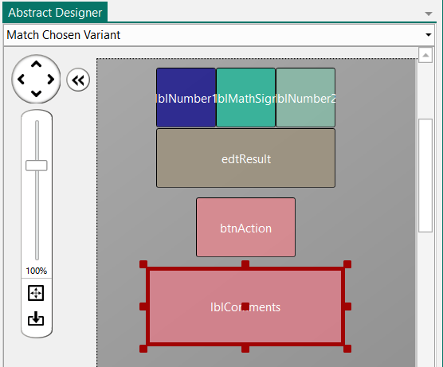

The result will look like this in the Designer.

And on a device or Emulator.

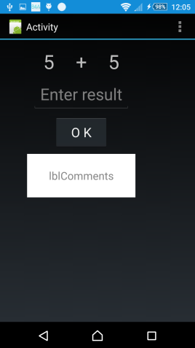 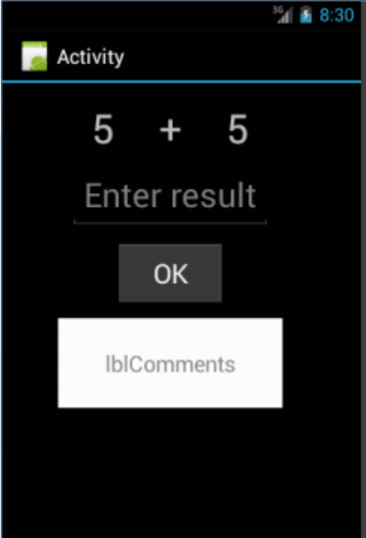 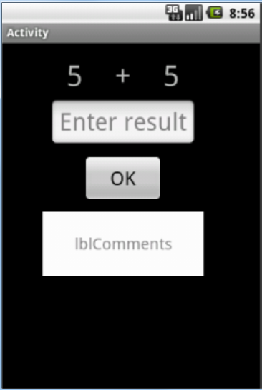

Sony xperia z1 Android 4.2 Emulator Android 2.2 Emulator

Let us save the layout in a file.

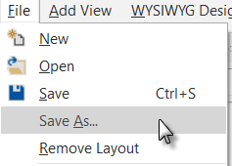

In the  menu click on  and save it with the name 'Main'.

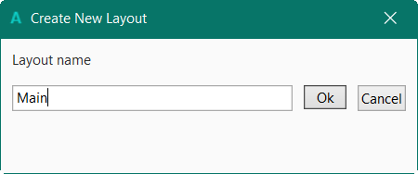

Click on 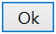 .

To write the routines for the project, we need to reference the Views in the code.

This can be done with the *Generate Members* tool in the Designer.

The *Generate Members* tool automatically generates references and subroutine frames.

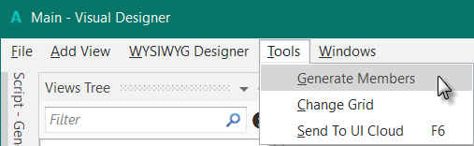In the  menu click on  to open the generator.

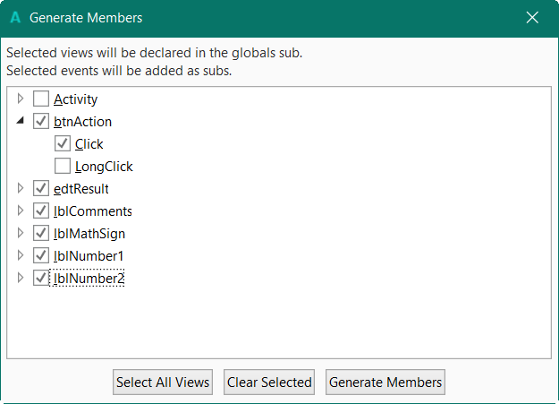

Here we find all the views added to the current layout.

We check all views and check the Click event for the btnAction Button.

Checking a view  generates its reference in the Globals Sub routine in the code.

This is needed to make the view recognized by the system and allow the autocomplete function.

Private btnAction As Button

Private edtResult As EditText

Private lblComments As Label

Private lblMathSign As Label

Private lblNumber1 As Label

Private lblNumber2 As Label

Clicking on an event of a view generates the Sub frame for this event.

Sub **btnAction_Click**

End Sub

Click on 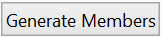 to generate the references and Sub frames.

Now we go back to the IDE to enter the code.

First, we need our Activity to load our layout file. Within the “Activity_Create” sub, do the following. You can remove the lines in green.

We will enter this line of code Activity.LoadLayout(“Main”).

- Enter 'A’, as soon as you begin typing the autocomplete function shows you all keywords beginning with ‘a’.

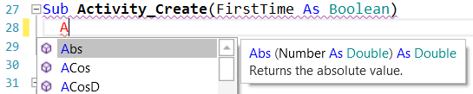

- Continue typing ‘Act’.

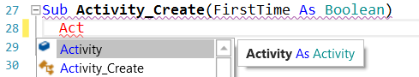

- Press ‘Return’ or click on .

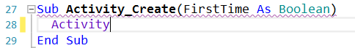

- We have the word Activity, now enter a dot.

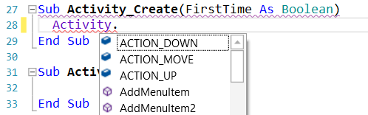

- The autocomplete function shows all the possible properties of the view.

- Enter 'L' , and the autocomplete function shows the properties beginning with 'L'

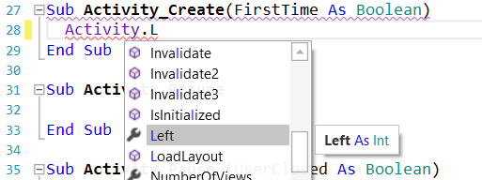

- Press the down arrow key, and LoadLayout will be highlighted with the online help for the given property or method.

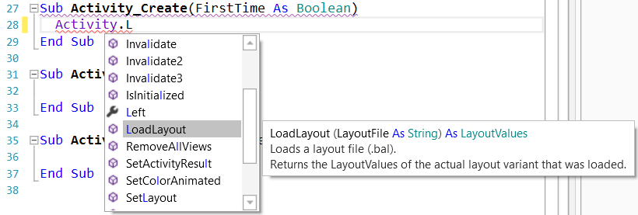

- Press 'Return' to add LoadLayout.

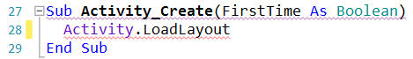

Note that the line is underlined in red meaning an error, the line is incomplete, missing parameters.

- Press '(' to display the online help showing the needed parameters for the method.

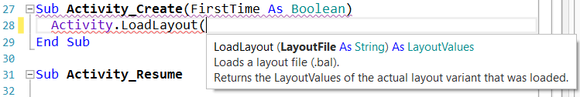

- Enter "Main")

Sub **Activity_Create**(FirstTime As Boolean)

Activity.LoadLayout("Main")

End Sub

We want to generate a new problem as soon as the program starts. Therefore, we add a call to the New subroutine.

Sub **Activity_Create**(FirstTime As Boolean)

Activity.LoadLayout("Main")

New

End Sub

Note the New is in red meaning an error, ‘Undeclared variable …’ in this case, meaning that the system doesn’t recognize this name.

Generating a new problem means generating two new random values between 1 and 9 (inclusive) for Number1 and Number2, then showing the values using the lblNumber1 and lblNumber2 ‘Text’ properties.

To do this we enter following code:

In Sub Globals we add two variables for the two numbers.

Public Number1, Number2 As Int

End Sub

And the 'New' Subroutine:

Sub **New**

Number1 = Rnd(1, 10) ' Generates a random number between 1 and 9

Number2 = Rnd(1, 10) ' Generates a random number between 1 and 9

lblNumber1.Text = Number1 ' Displays Number1 in label lblNumber1

lblNumber2.Text = Number2 ' Displays Number2 in label lblNumber2

lblComments.Text = "Enter the result" & CRLF & "and click on OK"

edtResult.Text = "" ' Sets edtResult.Text to empty

End Sub

This function Rnd(1, 10) generates a random number from '1' (inclusive) to '10' (exclusive), therefore beween ‘1’ and ‘9’.

The following line displays the comment in the lblComments view:

lblComments.Text = "Enter the result" & CRLF & "and click on OK"

CRLF is the LineFeed character.

Now we add the code for the Button click event.

We have two cases:

- When the Button text is equal to "O K" (with a space between O and K), it means that a new problem is displayed, and the program is waiting for the user to enter a result and press the Button.

- When the Button text is equal to "NEW", it means that the user has entered a correct answer and when the user clicks on the Button a new problem will be generated.

Sub **btnAction_Click**

If btnAction.Text = "O K" Then

If edtResult.Text = "" Then

Msgbox("No result entered","E R R O R")

Else

CheckResult

End If

Else

New

btnAction.Text = "O K"

End If

End Sub

If btnAction.Text = "O K" Then checks if the Button text equals "O K".

If yes then we check if the EditText is empty.

If yes, we display a MessageBox telling the user that there is no result in the EditText view.

If no, we check if the result is correct or if it is false.

If no then we generate a new problem, set the Button text to "O K" and clear the EditText view.

The last routine checks the result.

Sub **CheckResult**

If edtResult.Text = Number1 + Number2 Then

lblComments.Text = "G O O D result" & CRLF & "Click on NEW"

btnAction.Text = "N E W"

Else

lblComments.Text = "W R O N G result" & CRLF & "Enter a new result" & CRLF & "and click OK"

End If

End Sub

With If edtResult.Text = Number1 + Number2 Then we check if the entered result is correct.

If yes, we display in the lblComments label the text below:

'G O O D result'

'Click on NEW'

and we change the Button text to "N E W ".

If no, we display in the lblComments label the text below:

'W R O N G result'

'Enter a new result'

and click OK.

On the left side of the editor you see a yellow line.

This means that the code was modified.

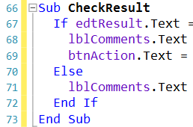

If we click on  to save the project the yellow line becomes green showing a modified code but already saved. You can also press Ctrl + S to save the project.

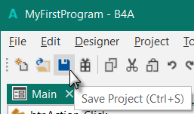 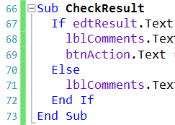

If we leave the IDE and load it again the green line disappears.

Let us now compile the program and transfer it to the Device.

In the IDE on top click on  :

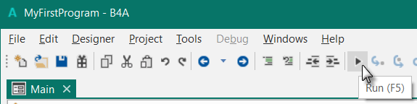

The program is going to be compiled.

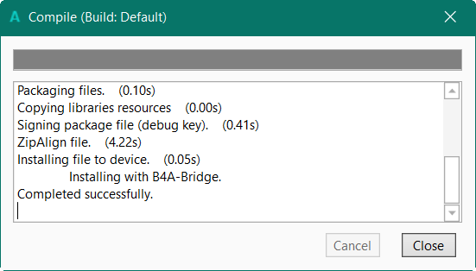

When the Close button becomes enabled as in message box, above, the compiling and transfer is finished.

Looking at the device, you should see something similar to the image below, with different numbers.

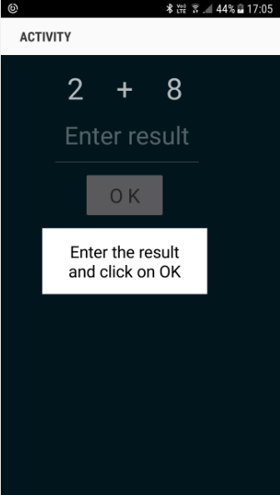

The screenshot may look different depending on the device and the Android version.

Of course, we could make aesthetic improvements in the layout, but this was not the main issue for the first program.

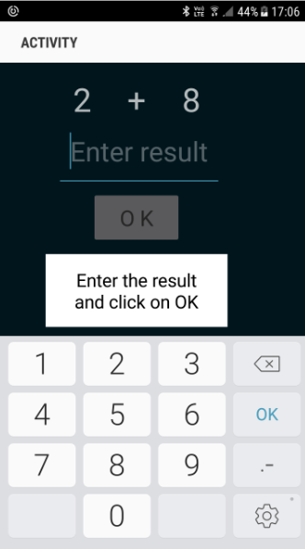

On a real device, you need to use the virtual keyboard.

Click on the EditText view to show the keyboard.

On some devices the current layout has the disadvantage that the comment label is covered by the virtual keyboard.

This will be improved in the next chapter,

'Second program', where we create our own keyboard.

## Second B4A program (SecondProgram.b4a)

The project is available in the SourceCode folder:

SourceCode\SecondProgram\B4A\SecondProgram.b4a

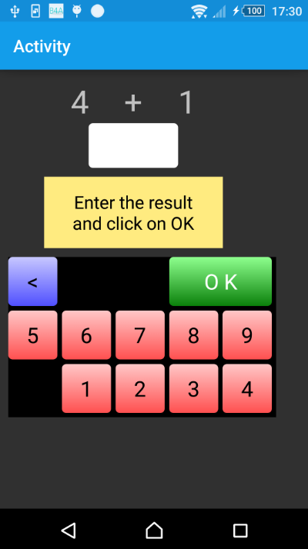

Improvements to “ My first program”.

We will add a numeric keyboard to the layout to avoid the use of the virtual keyboard.

Create a new folder called “SecondProgram”. Copy all the files and folders from MyFirstProgram to the new SecondProgram folder and rename the program files MyFirstProgram.b4a to SecondProgram.b4a and MyFirstProgram.b4a.meta to SecondProgram.b4a.meta.

Load this new program in the IDE.

We need to change the Package Name.

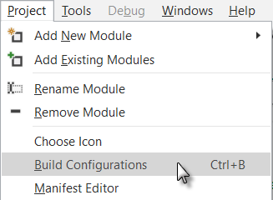

In the IDE  menu.

Click on 

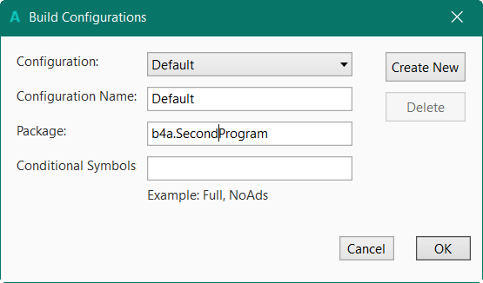

Change the Package name to

b4a.SecondProgram.

Click on 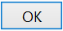.

Then we must change the ApplicationLabel on the very top of the code.

#Region Project Attributes

#ApplicationLabel: SecondProgram

We want to replace the edtResult EditText view by a new Label.

Run the Visual Designer. If you want you can already connect the device or an Emulator.

In the Abstract Designer, click on the edtResult view.

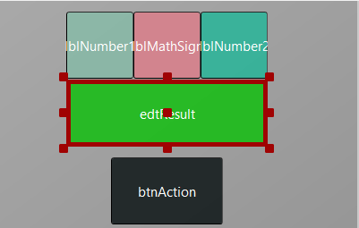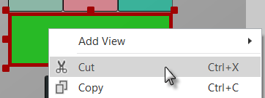

Right click on edtResult and click on .

Right click on lblNumber1 to select it.

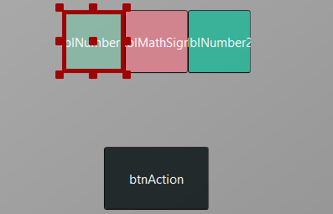Click on .

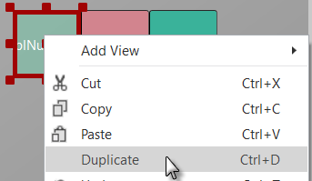

The new label covers lblNumber1.

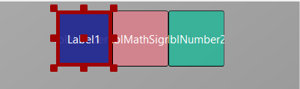

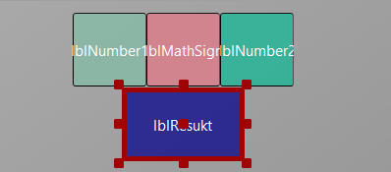

Move it between the upper labels and the button

and resize it.

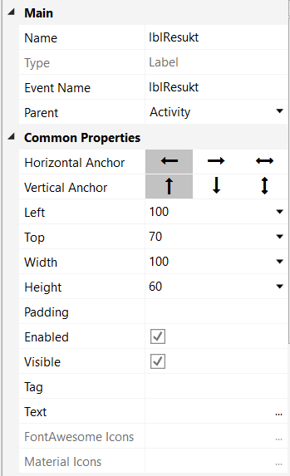

Modify the following properties:

Name to lblResult

Change the Left, Top, Width and Height properties if they are not the same as in the image.

Text to " " blank character

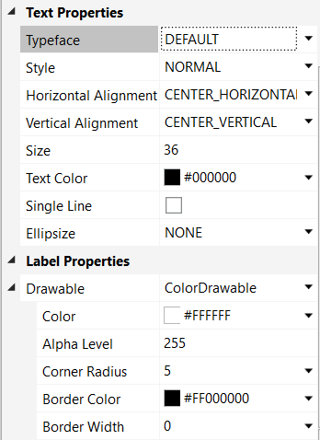

Text Color to Black #000000

Color to White #FFFFFF

Alpha to 255

Corner Radius to 5

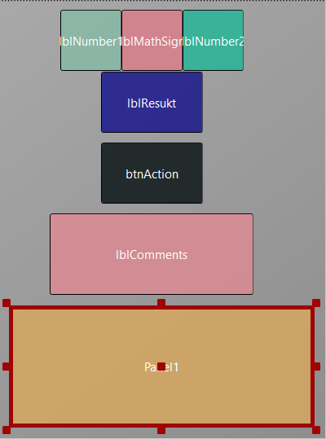

Now we add a Panel for the keyboard buttons.

Position and resize it as in the image.

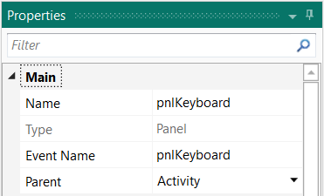

Change its Name to pnlKeyboard

"pnl" for Panel, the view type.

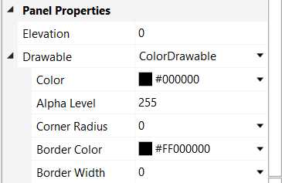

Change

Color to #000000

Alpha Level to 255

Corner radius to 0

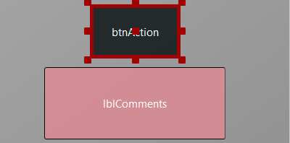

We will move the btnAction button from the Activity to the pnlKeyboard Panel.

Click on btnAction.

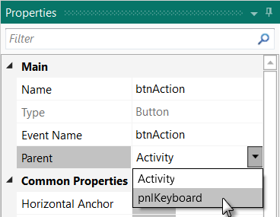

and in the Parent list click on .

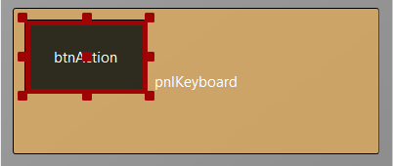

The button now belongs to the Panel.

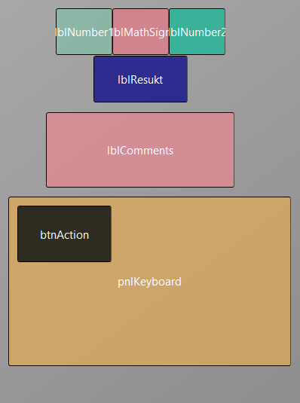

Now we rearrange the views to get some more space for the keyboard.

Set the Height property of the 4 Labels to 50 instead of 60.

Set the Top property of label lblResult to 60.

Set the Top property of label lblComments to 120.

Set the Top property of panel pnlKeyboard to 210.

Set the Height property of panel pnlKeyboard to 180.

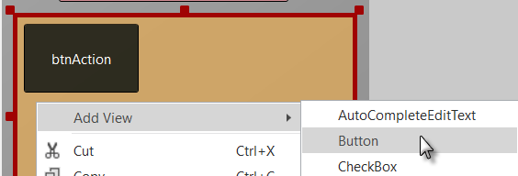

Right click on the pnlKeyboard and click on 

And click on .

to add a new button.

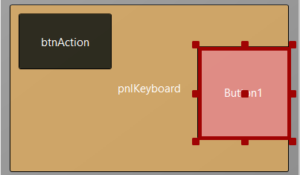

The new button is added.

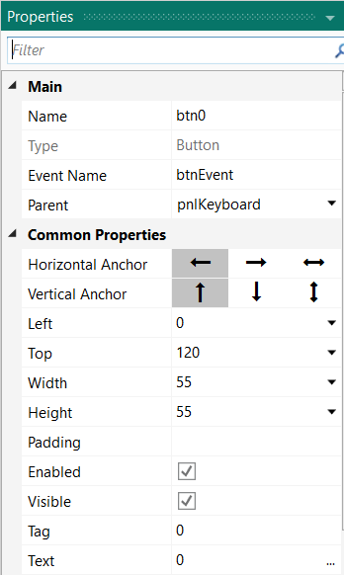

Change the following properties:

Name to btn0

Event name to btnEvent

Left to 0

Top to 120

Width to 55

Height to 55

Tag to 0

Text to 0

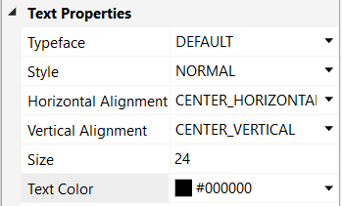

Size to 24

TextColor to Black #000000

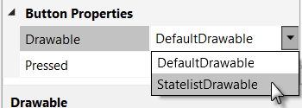

Now we want to change the button colors.

Click on .

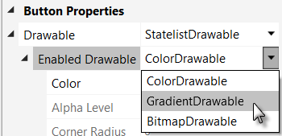

In Enabled Drawable

click on .

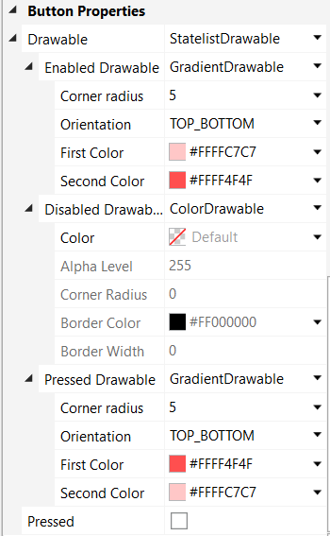

Change the following properties:

Orientation to TOP_BOTTOM

First Color

Second Color

Pressed Drawable to GradientDrawable

Orientation to TOP_BOTTOM

First Color

Second Color

If you have connected a device the button looks now like this.

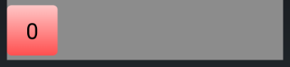

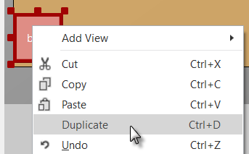Now we duplicate btn0 and position the new one beside button btn0 with a small space.

Right click on btn0 and click on .

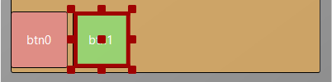

Move the new Button next to the previous one.

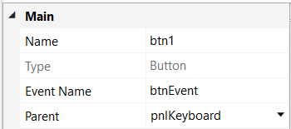

Change the following properties:

Name to btn1

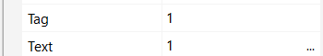Tag to 1

Text to 1

And the result.

In the Abstract Designer and on the device.

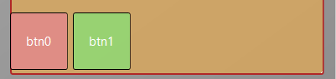 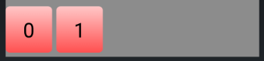

Let us add 8 more Buttons and position them like in the image.

Change following properties:

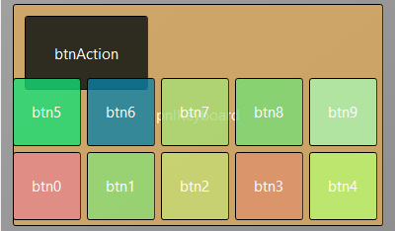

Name btn2 , btn3 , btn4 etc.

Tag 2 , 3 , 4 etc.

Text 2 , 3 , 4 etc.

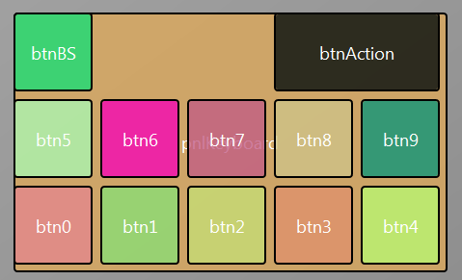To create the BackSpace button, duplicate one of the number buttons, and position it like in the image.

Resize and position btnAction.

Change the pnlKeyboard Color to Black #000000.

Change their Name, Tag, Text and Color properties as below.

btnAction O K btnBS **<**

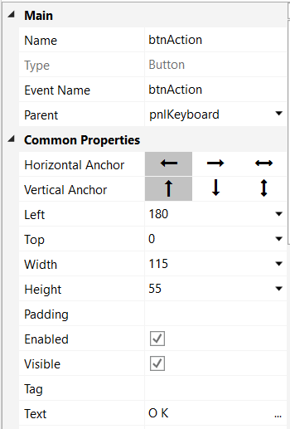 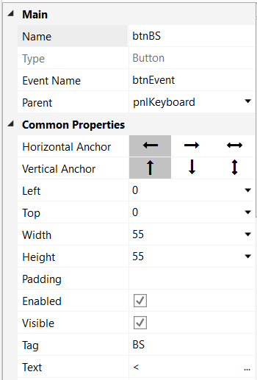

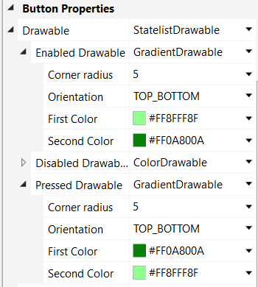 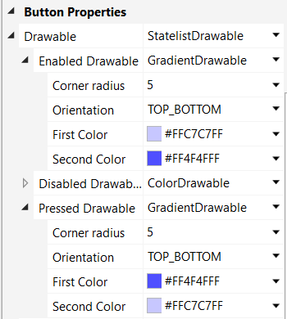

Another improvement is to center the objects on the screen.

For this, we add some code in the Designer Scripts in the Script-General window.

First, we ‘dock’ the Script – General window.

Click on Script – General. And click on .

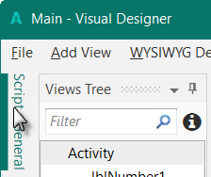 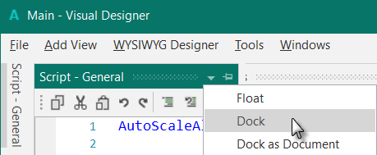

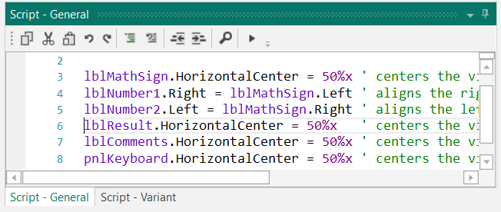

'All variants script

AutoScaleAll

lblMathSign.HorizontalCenter = 50%x ' centers the view on the middle of the screen

lblNumber1.Right = lblMathSign.Left ' aligns the right edge ont the left edge

lblNumber2.Left = lblMathSign.Right ' aligns the left edge ont the right edge

lblResult.HorizontalCenter = 50%x ' centers the view on the middle of the screen

lblComments.HorizontalCenter = 50%x ' centers the view on the middle of the screen

pnlKeyboard.HorizontalCenter = 50%x ' centers the view on the middle of the screen

The first two lines are added by default, we leave them.

'All variants script

AutoScaleAll

lblSigneMath.HorizontalCenter = 50%x

HorizontalCenter centers a view horizontally on the screen at the given value, 50%x in our case, which means in the middle of the screen.

lblNombre1.Right = lblSigneMath.Left

Aligns the right edge of lblNombre1 on the left edge of lblSigneMath, positons lblNombre1 just besides lblSigneMath on the left.

lblNombre2.Left = lblSigneMath.Right

Aligns the left edge of lblNombre2 on the right edge of lblSigneMath, positons lblNombre2 just besides lblSigneMath on the right.

The finished new layout.

In the Abstract Designer and on the device.

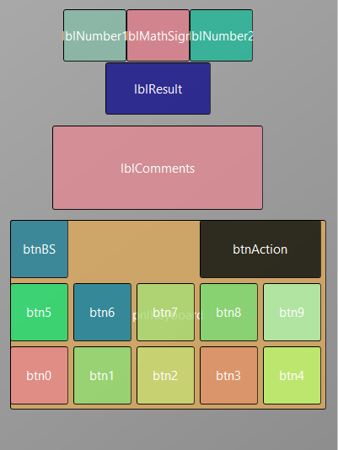 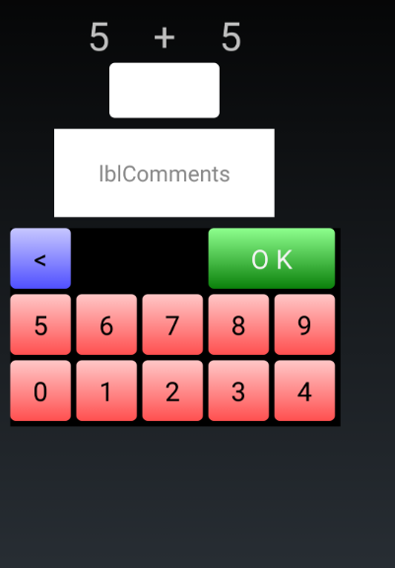

Now we will update the code.

First, we must replace the edtResult by lblResult because we replaced the EditText view by a Label.

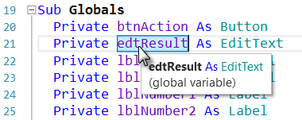

Double click on edtResult to select it.

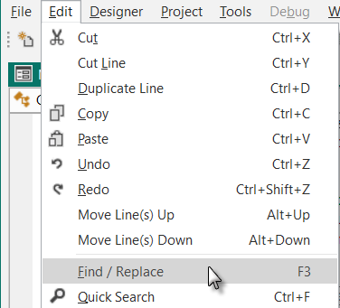

In the menu  click on  or press F3.

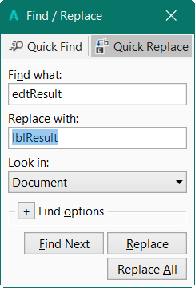

Enter ‘lblResult’ in the Replace with field.

Click on 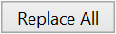

We also need to change its view type form EditText to Label.

Private lblResult As Label

Now we write the routine that handles the Click events of the Buttons.

The Event Name for all buttons, except btnAction, is "btnEvent".

The routine name for the associated click event will be btnEvent_Click.

Enter the following code:

Sub **btnEvent_Click**

End Sub

We need to know what button raised the event. For this, we use the Sender object which is a special object that holds the object reference of the view that generated the event in the event routine.

Sub **btnEvent_Click** To have access to the properties of the view that raised the

Private btnSender As Button event we declare a local variable

Private btnSender As Button.

btnSender = Sender And set btnSender = Sender.

Select btnSender.Tag Then, to differentiate between the backspace button and

Case "BS" the numeric buttons we use a Select / Case / End Select

Case Else structure and use the Tag property of the buttons.

End Select Remember, when we added the different buttons we

End Sub set their Tag property to BS, 0, 1, 2 etc.

Select btnSender.Tag sets the variable to test.

Case "BS" checks if it is the button with the "BS" tag value.

Case Else handles all the other buttons.

Now we add the code for the numeric buttons.

We want to add the value of the button to the text in the lblResult Label.

Select btnSender.Tag

Case "BS"

Case Else

lblResult.Text = lblResult.Text & btnSender.Text

End Select

End Sub

This is done in this line

lblResult.Text = lblResult.Text & btnSender.Text

The "&" character means concatenation, so we just append to the already existing text the value of the Text property of the button that raised the event.

Now we add the code for the BackSpace button.

Select btnSender.Tag

Case "BS"

If lblResult.Text.Length >0 Then

lblResult.Text = lblResult.Text.SubString2(0, lblResult.Text.Length - 1)

End If

Case Else

lblResult.Text = lblResult.Text & btnSender.Text

End Select

End Sub

When clicking on the BS button we must remove the last character from the existing text in lblResult.

However, this is only valid if the length of the text is bigger than 0. This is checked with:

If lblResult.Text.Length >0 Then

To remove the last character we use the SubString2 function.

lblResult.Text = lblResult.Text.SubString2(0,lblResult.Text.Length - 1)

SubString2(BeginIndex, EndIndex) extracts a new string beginning at BeginIndex (inclusive) until EndIndex (exclusive).

Now the whole routine is finished.

Sub **btnEvent_Click**

Private btnSender As Button

btnSender = Sender

Select btnSender.Tag

Case "BS"

If lblResult.Text.Length >0 Then

lblResult.Text = lblResult.Text.SubString2(0,lblResult.Text.Length - 1)

End If

Case Else

lblResult.Text = lblResult.Text & btnSender.Text

End Select

End Sub

We can try to improve the user interface of the program by adding some colors to the lblComments Label.

Let us set:

- Yellow for a new problem

- Light Green for a GOOD answer

- Light Red for a WRONG answer.

Let us first modify the New routine, where we add the line

lblComments.Color = Colors.RGB(255,235,128).

Sub **New**

Number1 = Rnd(1, 10) ' Generates a random number between 1 and 9

Number2 = Rnd(1, 10) ' Generates a random number between 1 and 9

lblNumber1.Text = Number1 ' Displays Number1 in label lblNumber1

lblNumber2.Text = Number2 ' Displays Number2 in label lblNumber2

lblComments.Text = "Enter the result" & CRLF & "and click on OK"

lblComments.Color = Colors.RGB(255,235,128) ' yellow color

lblResult.Text = "" ' Sets lblResult.Text to empty

End Sub

And in the CheckResult routine we add lines 76 and 80.

Sub **CheckResult**

If lblResult.Text = Number1 + Number2 Then

lblComments.Text = "G O O D result" & CRLF & "Click on NEW"

lblComments.Color = Colors.RGB(128,255,128) ' light green color

btnAction.Text = "N E W"

Else

lblComments.Text = "W R O N G result" & CRLF & "Enter a new result" & CRLF & "and click OK"

lblComments.Color = Colors.RGB(255,128,128) ' light red color

End If

End Sub

Another improvement would be to hide the '0' button to avoid entering a leading '0'.

For this, we hide the button in the New subroutine in line btn0.Visible = False.

Sub **New**

Number1 = Rnd(1, 10) ' Generates a random number between 1 and 9

Number2 = Rnd(1, 10) ' Generates a random number between 1 and 9

lblNumber1.Text = Number1 ' Displays Number1 in label lblNumber1

lblNumber2.Text = Number2 ' Displays Number2 in label lblNumber2

lblComments.Text = "Enter the result" & CRLF & "and click on OK"

lblComments.Color = Colors.RGB(255,235,128) ' yellow color

lblResult.Text = "" ' Sets lblResult.Text to empty

btn0.Visible = False

End Sub

In addition, in the btnEvent_Click subroutine, we hide the button if the length of the text in lblResult is equal to zero and show it if the length is greater than zero, lines 98 to 102.

Sub **btnEvent_Click**

Private btnSender As Button

btnSender = Sender

Select btnSender.Tag

Case "BS"

If lblResult.Text.Length >0 Then

lblResult.Text = lblResult.Text.SubString2(0,lblResult.Text.Length - 1)

End If

Case Else

lblResult.Text = lblResult.Text & btnSender.Tag

End Select

If lblResult.Text.Length = 0 Then

btn0.Visible = False

Else

btn0.Visible = True

End If

End Sub

As we are accessing btn0 in the code we need to declare it in the Globals routine.

Modify line 25 like below:

Private btnAction, btn0 As Button

Run the program to check the result.

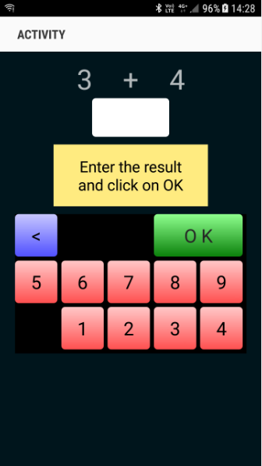 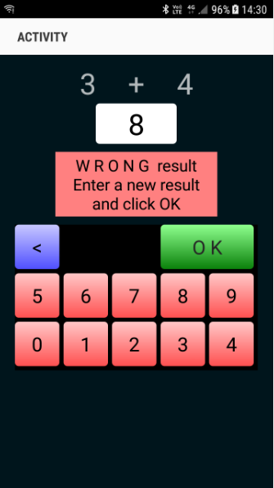 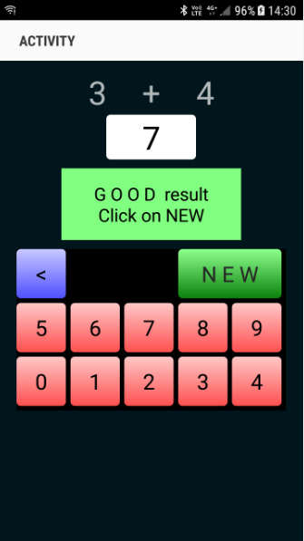

# Getting started B4i

**B4i is a simple yet powerful development environment that targets Apple devices (iPhone, iPad etc.).**  
The B4i language is similar to Visual Basic and B4A language.  
B4i compiled applications are native iOS applications; there are no extra runtimes or dependencies.  
Unlike other IDE’s, B4i is 100% focused on iOS.  
B4i includes a powerful GUI designer, built-in support for multiple screens and orientations.   
You can develop and debug with a real device.

iOS 7 and above are supported.

What you need:

* The B4i program, this is a Windows program running on a PC.
* The Java SDK on the PC, free.
* An Apple developer license, cost 99$ per year.
* A device for testing.
* The Basi4i-Bridge program on the device, free.
* A Mac builder to compile the program, this be either.
  + A Mac computer with the Mac Builder program, on local wifi.
  + The hosted Mac Builder service over Internet, cost 26$ per year.
* A Mac computer or a MacInCloud service to distribute the program.

Links to tutorials in the forum:

[Local Mac Builder Installation](http://www.b4x.com/android/forum/threads/local-mac-builder-installation.46402/)

[Creating a certificate and provisioning profile](http://www.b4x.com/android/forum/threads/creating-a-certificate-and-provisioning-profile.45880/)

[Installing B4i-Bridge and debugging first app](http://www.b4x.com/android/forum/threads/installing-b4i-bridge-and-debugging-first-app.45871/)

## 

## Installing B4i

### Installing Java JDK

B4i depends on the free Java JDK component

**If you are already using B4A you can skip this chapter.**

Installation instructions:

The first step should be to install the **Java JDK**, as B4i requires it.  
Note that there is no problem with having several versions of Java installed on the same computer.  
  
- Open the [Java 8 JDK download link](http://www.oracle.com/technetwork/java/javase/downloads/jdk8-downloads-2133151.html).

- Check the Accept License Agreement radio button.



- Select **"Windows x86"** or **"Windows x64"** (for 64 bit machines) in the platforms list.

- Download the file and install it.

### Installing B4i

Download and install the B4i file on your computer.

Copy the license file *b4i-license.txt* to the B4i folder and to a safe place on the computer for backup. Note that this is not a text file, do not open it with a text editor.

When you first run B4i you will be asked to enter your e-mail address, the one you used when you purchased it B4i.

You find it also in the mail you received with the B4i file.

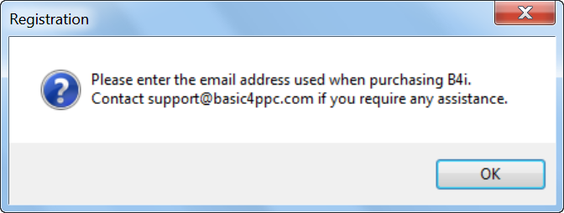

Enter the e-mail address.

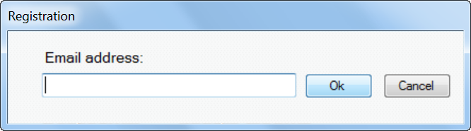

You get a confirmation window that B4i is registered.

Contact [support@basic4ppc.com](mailto:support@basic4ppc.com) if you require any assistance.

### Mac Builder installation

iOS compilation requires an Apple Mac computer. Developers have two options with B4i:

* Use a local Mac machine connected over the local network.   
  For this you should also download the Mac builder and install it.
* Use our hosted builder rental service. Hosted Mac Builder installation.  
  The builder service allows you to develop iOS applications without a Mac computer.  
  All of the development steps can be done with the builder service except of the final step which is uploading the application to Apple App Store. This step requires a Mac or a service such as MacInCloud.  
  Note that the builder is currently limited to projects of up to 15mb.

Link to the tutorial in the forum: [Local Mac Builder Installation](http://www.b4x.com/android/forum/threads/local-mac-builder-installation.46402/).

These instructions explain how to install the builder on a local Mac machine.  
  
1. Install Java JDK 8: <http://www.oracle.com/technetwork/java/javase/downloads/jdk8-downloads-2133151.html>  
2. Install Xcode 6.  
3. Download and unzip the B4i-Builder.  
4. Open a terminal and navigate to B4i-Builder folder.  
5. Run it with: java -jar B4iBuildServer.jar  
6. Set the builder IP address in the IDE under Tools - Build Server - Server Settings  
  
**Notes & Tips**  
  
**-** By default ports numbers 51041 (http) and 51042 (https) are used.  
- The firewall should be either disabled or allow incoming connections on these two ports.  
- You can test that the server is running by going to the following link: http://<server ip>:51041/test  
- You can kill the server with: http://<server ip>:51041/kill  
- It is recommended to set your Mac server ip address to a static address. This can be done in your router settings or in the Mac under Network settings.  
- A single Mac builder can serve multiple developers as long as they are all connected to the same local network. Note that you are not allowed to host builders for developers outside of your organization.  
  
**Multiple IPs.**  
  
When the server is started it takes the first IP address reported by the OS and uses it as its own IP address. You can see this address in the server messages.  
In most cases this is the correct address. However if it is not the correct IP address then the server will not be usable.  
In that case you need to explicitly set the correct address:   
- Open the key folder and delete all files.  
- Edit key.txt and change it to: manuel:<correct ip address>

For example:  
manual:192.168.0.199

### Hosted Mac builder service (optional)

If you have bought the *hosted Mac builder service* you got a mail with your user ID.

You must enter it in the IDE.

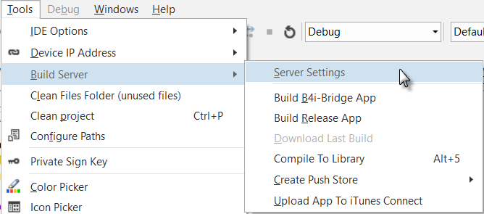

Enter the ID.

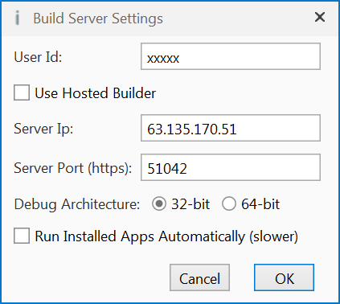 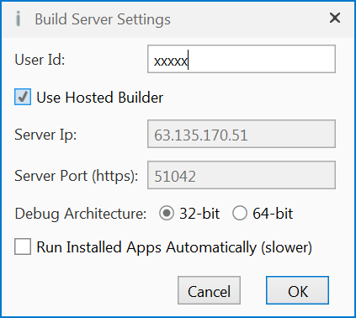

Don’t forget to check 

if you use the Hosted Builder Service!

## Configure Paths in the IDE

Then you need to configure the different paths in the IDE.

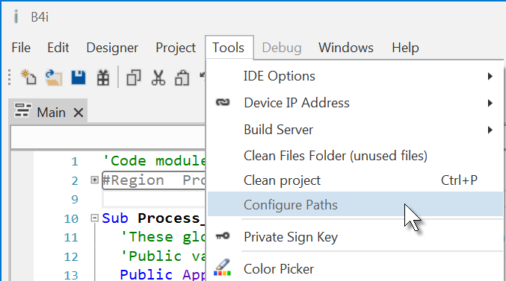

Run the IDE.

In the Tools menu click on Configure Paths.

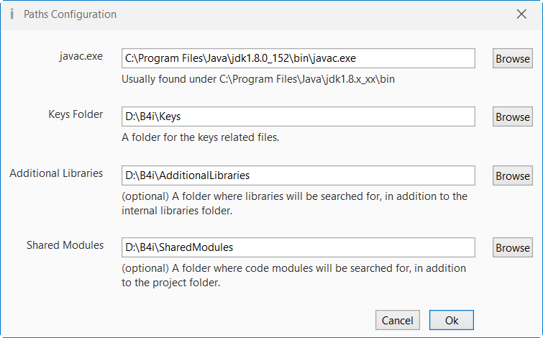

**javac.exe**:

Enter the folder of the javac.exe file.

**Keys folder**:

Create a special folder for the Keys, for example C:\B4i\Keys.

**Additional libraries**:

Create a specific folder for additional libraries, for example C:\B4i\AdditionalLibraries.

**Shared Modules**:

Create a specific folder for shared modules, for example C:\B4i\SharedModules.

## Creating a certificate and provisioning profile

Don't panic!  
While this process can be a bit annoying it is not too complicated and you can always delete the keys and start from scratch (which is not always the case in Android).  
  
Note that you must first register with Apple as an iOS developer (costs $99 per year).  
The whole process is done on a Windows computer.  
  
In order to install an app on an iOS device you need to create a certificate and a provisioning profile.  
  
The certificate is used to sign the application. The provisioning profile, which is tied to a specific certificate, includes a list of devices that this app can be installed on.  
  
The video shows the steps required for creating and downloading a certificate and provisioning profile.  
There are two steps which are not shown in the video and are also required before you can create a provisioning profile:   
  
- Create an App ID. This step is quite simple. Just make sure that you create a wildcard id.  
- Add one or more devices. You will need to find the devices UDID for that.

Link to the tutorial in the forum: [Creating a certificate and provisioning profile](http://www.b4x.com/android/forum/threads/creating-a-certificate-and-provisioning-profile.45880/).

### UDID

Devices are recognized by their UDIDs. There are two ways to get the device UDID:

1. If iTunes is installed then you can find it in iTunes.  
   The first time, connect your device with the USB cable to the computer.  
   Run iTunes, you should see on top this icon . It can take a while before you see it.  
     
   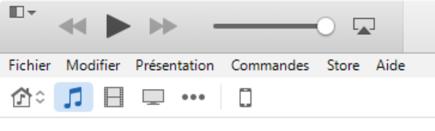

Click on and you get this screen:

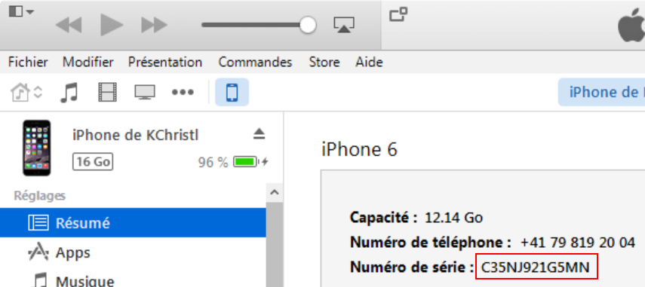

Now click on 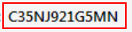 to get the UDID.

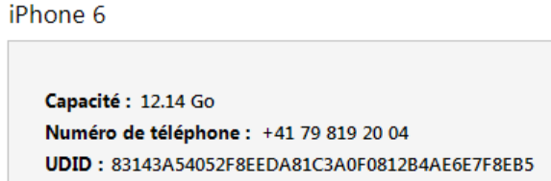

Right click on  to copy the UDID.

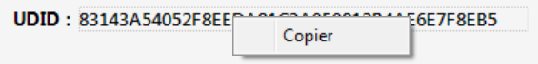

1. Use an online service such as this one: <http://get.udid.io/>

### Certificate and Provisioning Profile

Main steps:

1. Set a new keys folder in the IDE.   
2. Create a key by choosing Tools - Private Sign Key  
3. Create and download the certificate as demonstrated in the video. You will need to upload

the CSR file that was created in step 2.  
  
Note that you can choose either **iOS App Development** or **App Store and Ad Hoc** in the certificate page.

4. Create and download a provisioning profile.

## Installing B4i-Bridge and debugging first app

B4i-Bridge is an application that you install on the device.

It has three purposes:

1. Launch the installation process when needed.

2. Run the installed app (when installation is not needed).

3. The bridge is also the WYSIWYG visual designer.   
  
You need to install B4i-Bridge once. It is done from the device browser.

Link to the tutorial in the forum: [Installing B4i-Bridge and debugging first app](http://www.b4x.com/android/forum/threads/installing-b4i-bridge-and-debugging-first-app.45871/).

## Install the B4I certificate

Open Safari (device browser) and navigate to: [www.b4x.com/ca.pem](http://www.b4x.com/ca.pem)

Follow the instructions.

You can see at any time the profile in Settings / General / Profile.

## Set the package name based on the provision app id

Run B4i, load a project or use the default project and set the package name based on the provision app ID.

In the 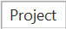 menu click on .

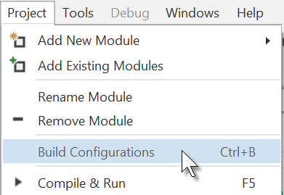

The window below is shown:

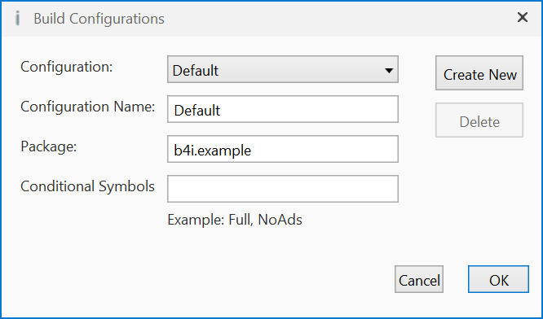

Change the Package name according to the provision app ID.



Example in my case:

### Install Build B4i-Bridge

In the 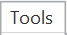 menu click on  and click on :

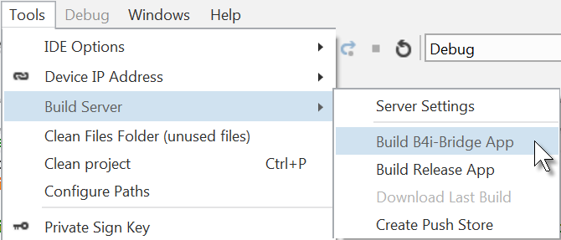

You get the compilation window with a code for Safari (see next chapter).

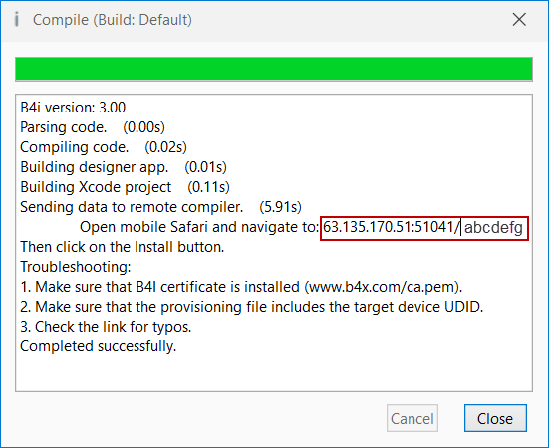

**The code you see in the red rectangle will be different!**

### Load B4i-Bridge

Open Safari on the device 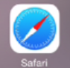.

Enter the code in the search box on top.

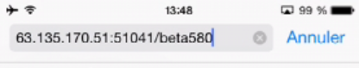

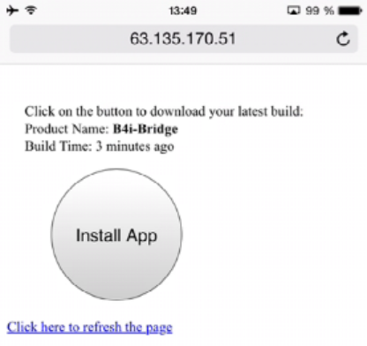

This screen will appear.

Click on

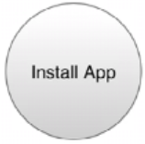

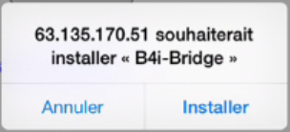

Click on  to install it.

Close Safari.

### Install B4i-Bridge and run it

Click on this B4i-Bridge icon 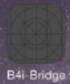 on the device, you will see the installing animation and finally the B4i-Bridge icon 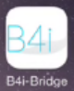 .

Tips:   
- You don't need to wait for the installation animation to complete. Once the animation starts you can click on the app icon.  
- If the installation is stuck in the "waiting" step for more than 10 or 15 seconds then uninstall it and install it again.  
- B4i-Bridge must be in the foreground for it to be able to start an installation or to run the application. In most cases it will be in the foreground automatically. If it is not in the foreground then you need to click on it to bring it to the foreground.

## My first B4i program (MyFirstProgram.b4i)

Let us write our first B4i program. The suggested program is a math trainer for kids.

The project is available in the SourceCode folder shipped with this booklet:

SourceCode\MyFirstProgram\B4i\MyFirstProgram.b4i

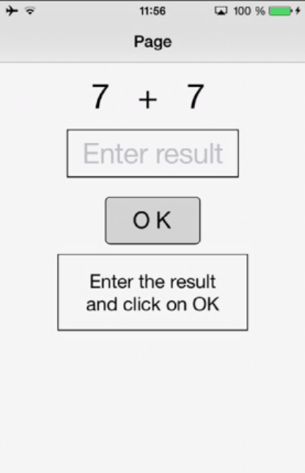

On the screen, we will have:

- 2 Labels displaying randomly generated numbers (between 1 and 9)

- 1 Label with the math sign (+)

- 1 TextField where the user must enter the result

- 1 Button, used to either confirm when the user has finished entering the result or generate a new calculation.

- 1 Label with a comment about the result.

In iOS:

- Label is an object to show text.

- TextField is an object allowing the user to enter text.

- Button is an object allowing user actions.

We will design the layout of the user interface with the Designer, the Abstract Designer and on a Device and go step by step through the whole process.

The Designer manages the different objects of the interface.

The AbstractDesigner shows the positions and sizes of the objects and allows moving or resizing them on the screen.

On the Device we see the real result.

**Run the IDE** 

**Save the project.**

You must save the project before you can run the Designer.

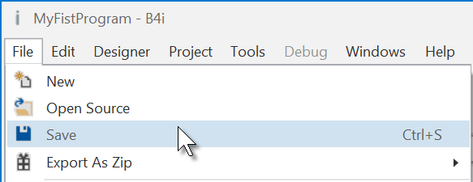

Create a new folder MyFirstProgram and save the project with the name MyFirstProgram.

**Set the Package Name.**

Each program needs a package name.

In the menu 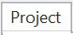 click on .

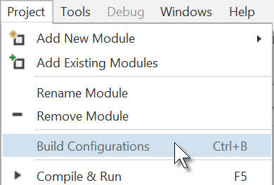

This window appears:

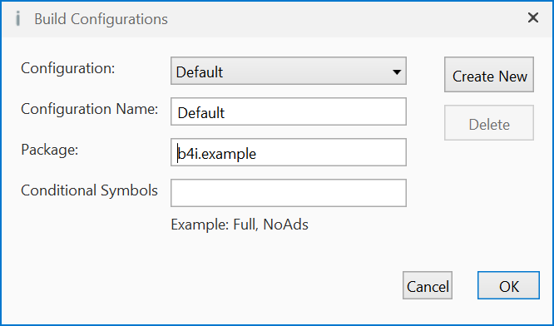

The default name is b4i.example. We will change it to anywheresoftware.b4i.MyFirstProgram.

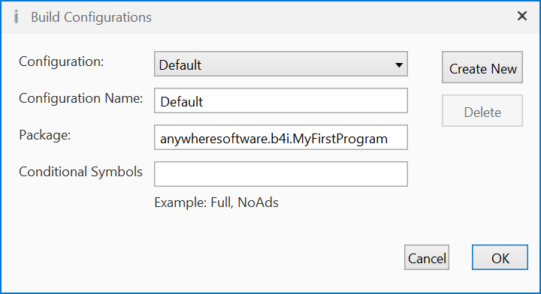

**Set the Application Label.**

The Application label is the name of the program that will be shown on the device blow the icon.

On top of the code screen you see the ‘region’ Project Attributes.

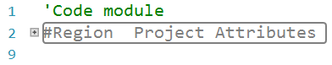

Regions are code parts which can be collapsed

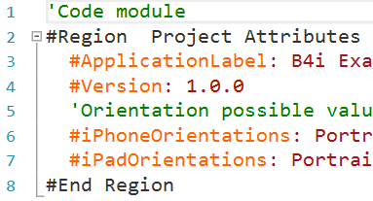

or extended at the right.

Clicking on  will expand the Region.

Clicking on  will collapse the Region.

Regions are explained in the chapter *Collapse a Region* in the *B4x IDE* booklet.

#Region Project Attributes

#ApplicationLabel: B4i Example

#Version: 1.0.0

'Orientation possible values: Portrait, LandscapeLeft, LandscapeRight and PortraitUpsideDown

#iPhoneOrientations: Portrait, LandscapeLeft, LandscapeRight

#iPadOrientations: Portrait, LandscapeLeft, LandscapeRight, PortraitUpsideDown

#Target: iPhone, iPad

#ATSEnabled: True

#MinVersion: 7

#End Region

The default name is B4i Example, but we will change it to MyFirstProgramfor naming consistency.

Change this line: #ApplicationLabel: B4i Example to #ApplicationLabel: MyFirstProgram

The other attributes are explained in chapter *Code header Project Attributes / Activity Attributes* in the *B4x IDE* booklet.

**In the IDE run Build B4i-Bridge App.**

IDE menu 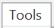 / 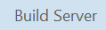 / 

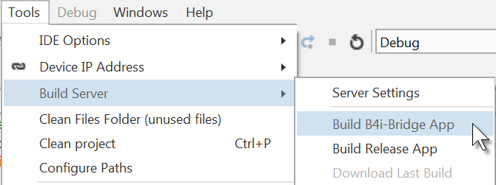

You get this screen.

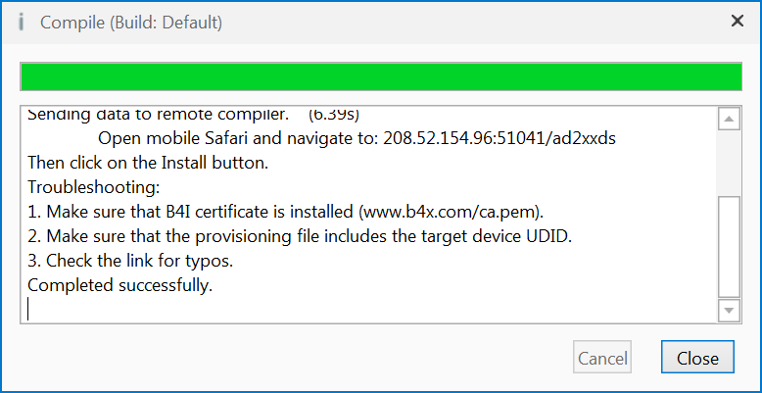

On the device run B4i-Bridge .

On the screen you see the IP address of the device.

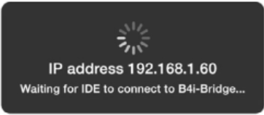

In the IDE click on 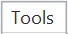 /  / 

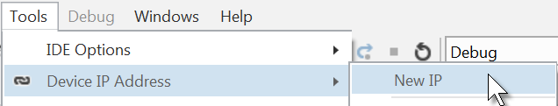

Enter the IP address:

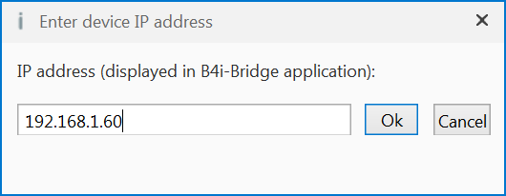

Click on 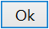.

You will see this screen on the device (only the upper part is shown).

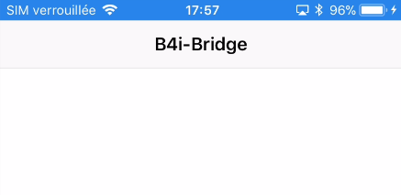

**In the IDE open the Designer**.

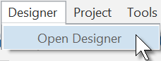

Wait until the Designer is ready.

The Designer looks like this.

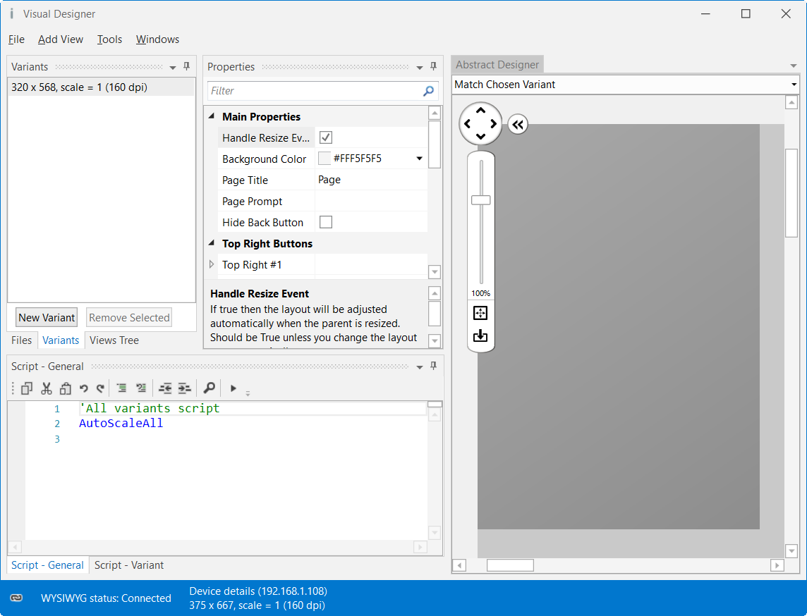

Note that in the bottom left of the Designer window you see the connection status: 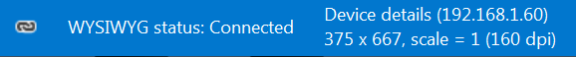

You may see



if the device is not connected.

With the Designer we have also the Abstract Designer which shows the layout not exactly WYSIWYG but the positions and size of the different objects.

Only the top of the image is shown.

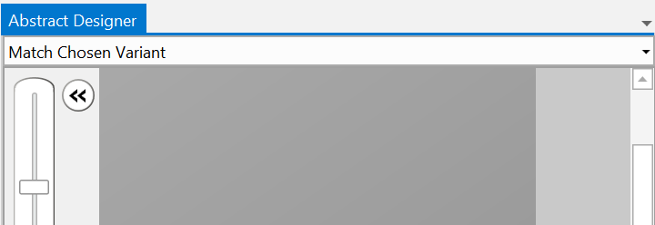

The dark gray area represents the screen area of the connected device.

Now we will add the 2 Labels for the numbers.

In the Designer, add a Label.

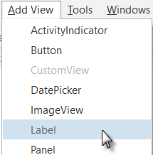 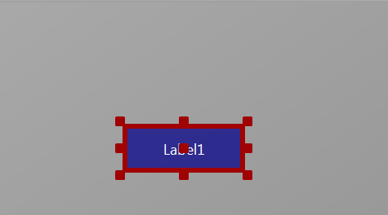

The label appears in the Abstract Designer, in the Views Tree window and its default properties are listed in the Properties window.

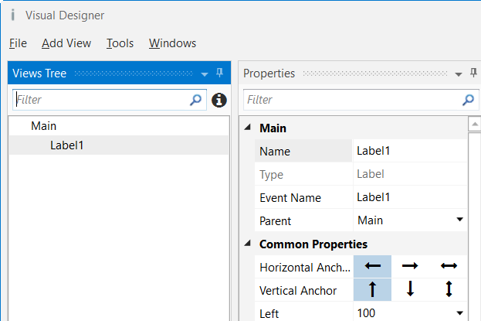

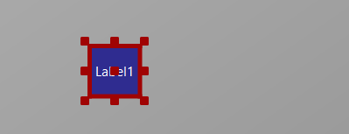

Resize and move the Label with the red squares like this.

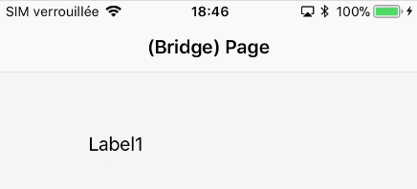

You can follow the layout on the device.

At the moment we see Label1.

The background color is by default transparent.

Label1 is the default name of the Label.

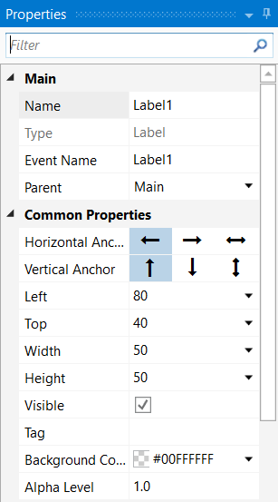The new properties Left, Top, Width and Height are directly updated in the Properties window.

You can also modify the Left, Top, Width and Height properties directly in the Properties window.

Let us change the properties of this first Label according to our requirements.

By default, the name is Label with a number, here Label1, let us change its name to lblNumber1.

The three letters 'lbl' at the beginning mean 'Label', and 'Number1' means the first number.

It is recommended to use significant names for views so we know directly what kind of view it is and its purpose.

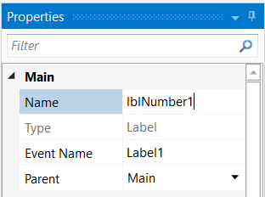

Pressing the 'Return' key or clicking elsewhere will also change the Event Name property.

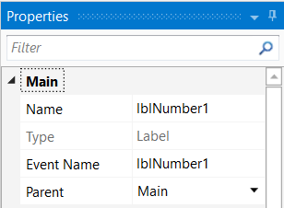

We have now:

Main : Main module.

Name : Name of the view.

Type : Type of the view. In this case, Label,

which is not editable.

Event Name : Generic name of the routines that handle

the events of the Label.

Parent : Parent view the Label belongs to.

Main in this case

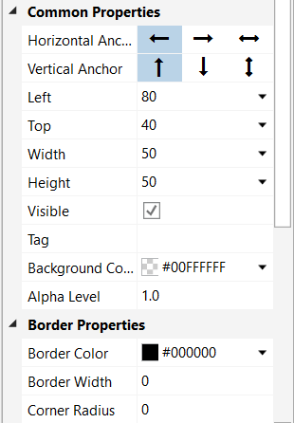Let us check and change the other properties:

Set Left, Top, Width and Height to the values in the picture.

Visible is checked.

We leave the default colors.

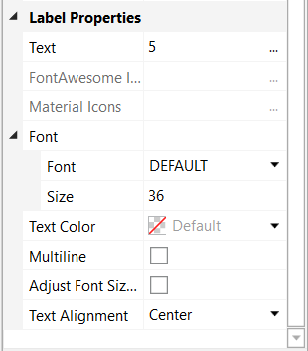

Text set to 5

We leave the default Font.

Text Size, we set it to 36.

Set Text Alignment to Center.

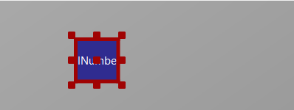 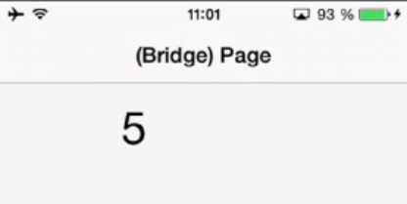

And the result in the Abstract Designer and on the device.

We need a second Label similar to the first one. Instead of adding a new one, we copy the first one with the same properties. Only the Name and Left properties will change.

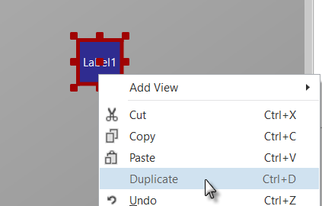

Right click on lblNumber1 and click on  in the popup menu.

The new label covers the duplicated one.

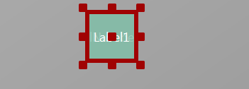

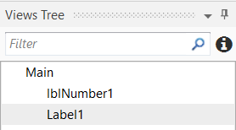

In the left part, in the Views Tree, you see the different views.

The new label Label1 is added.

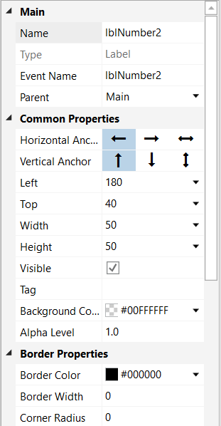Let us position the new Label and change its name to lblNumber2.

Change the name to lblNumber2.

The Left property to 180.

And the result in the Abstract Designer

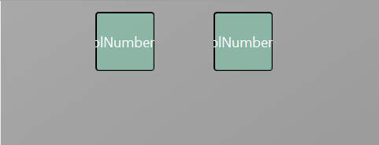

and on the device.

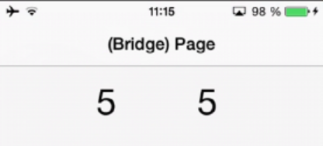

Let us now add a 3rd Label for the math sign. We copy once again lblNumber1.

Right click on lblNumber1 in the Abstract Designer and click  on in the popup menu.

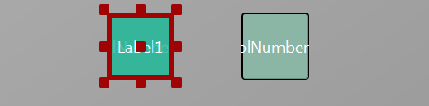

The new label covers lblNumber1.

Position it between the first two Labels and change its name to lblMathSign, its

Text property to '+'.

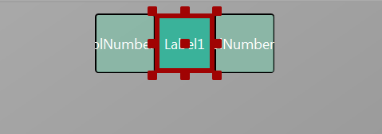 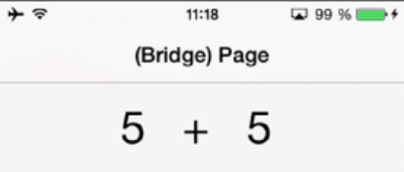

And the result in the Abstract Designer and on the device.

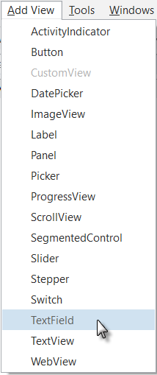

Now let us add a TextField view.

In the Designer 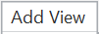 menu

click on .

Position it below the three Labels and change its name to txfResult.

'txf' means TextField and 'Result' for its purpose.

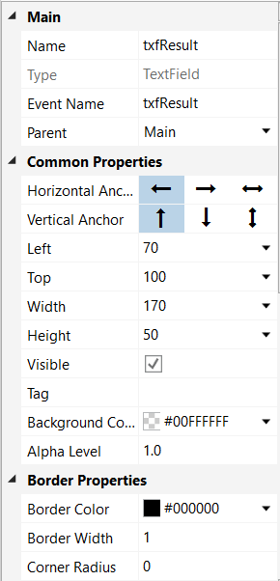Change these properties.

Name to txfResult

Left, Top, Width and Height.

Border Width to 1

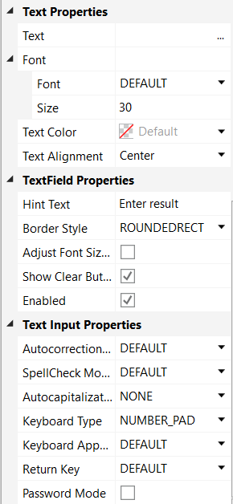

Text Size to 30

Text Alignment to Center

Hint Text to Enter result

Hint Text represents the text shown in the TextField view if no text is entered.

Keyboard Type to NUMBER_PAD

Setting Input Type to NUMBER_PAD lets the user enter only numbers.

After making these changes, you should see something like this.

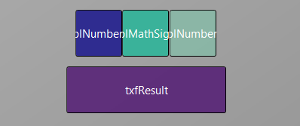 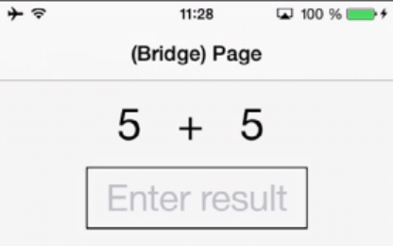

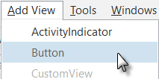Now, let's add the Button which, when pressed, will either check the result the user supplied as an answer, or will generate a new math problem, depending on the user's input.

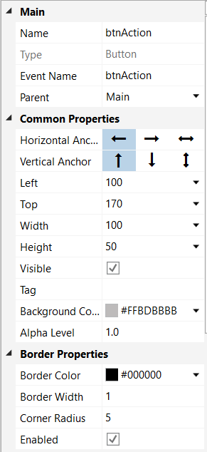

Position it below the TextField view. Resize it and change following properties:

Name to btnAction

Left, Top, Width and Height.

Background Color to #FFBDBBBB

Border Width to 1

Corner Radius to 5

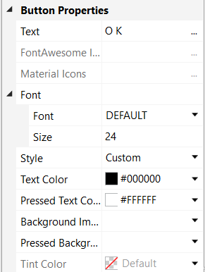

Text to O K (with a space between O and K)

Text Size to 24

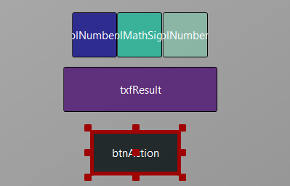 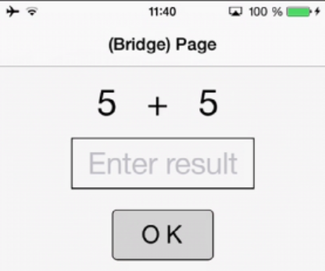

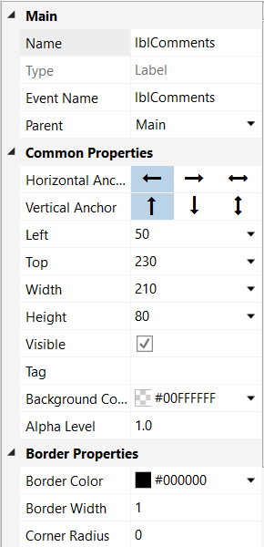 Let us add the last Label for the comments. Position it below the Button and resize it.

Change the following properties:

Name to lblComments

Left, Top, Width and Height.

Border Width to 1

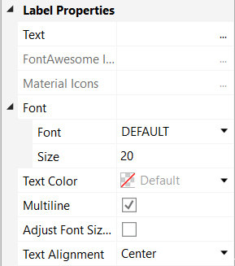

Text Size to 20

Multiline to True (checked)

Text Alignment to Center

And the result.

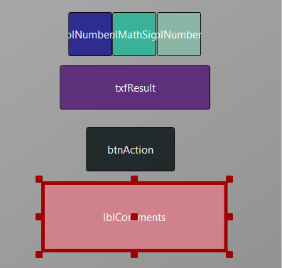 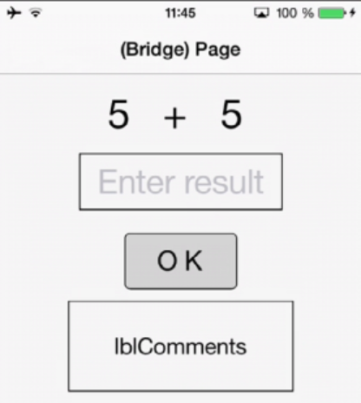

Now we save the layout in a file.

Click on 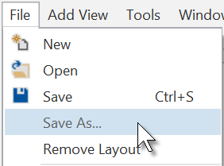 and save it with the name 'Main'.

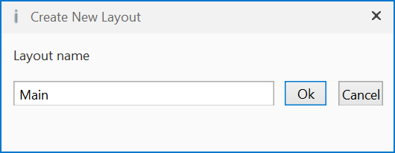

Click on 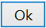.

To write the routines for the project, we need to reference the Views in the code.

This can be done with the *Generate Members* tool in the Designer.

The *Generate Members* tool automatically generates references and subroutine frames.

Click on 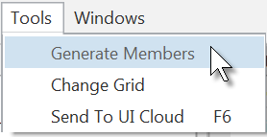 to open the generator.

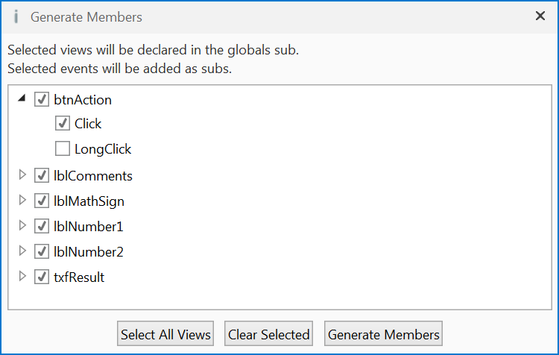

Here we find all the views added to the current layout.

We check all views and check the Click event for the btnAction Button.

Checking a view  generates its reference in the Process_Globals Sub routine in the code.

This is needed to make the view recognized by the system and allow the autocomplete function.

Private btnAction As Button

Private lblComments As Label

Private lblMathSign As Label

Private lblNumber1 As Label

Private lblNumber2 As Label

Private txfResult As TextField

Clicking on 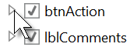shows all events for the selected view 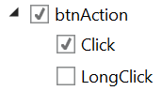.

Clicking on an event of a view generates the Sub frame for this event.

Sub **btnAction_Click**

End Sub

Click on 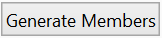 to generate the references and Sub frames, then close the window.

Now we go back to the IDE to enter the code.

On the top of the program code we have:

Sub **Process_Globals**

'These global variables will be declared once when the application starts.

'Public variables can be accessed from all modules.

Public App As Application

Public NavControl As NavigationController

Private Page1 As Page

Private btnAction As Button

Private lblComments As Label

Private lblMathSign As Label

Private lblNumber1 As Label

Private lblNumber2 As Label

Private txfResult As TextField

End Sub

These lines are automatically in the project code.

Public App As Application

Public NavControl As NavigationController

Private Page1 As Page

iOS needs an Application, a NavigationControl and at least one Page, the details are explained in the chapter Process life cycle.

Below the code above we have the Application_Start routine which is the first routine called when the program starts.

The content below is also added automatically in each new project.

Private Sub **Application_Start** (Nav As NavigationController)

NavControl = Nav

Page1.Initialize("Page1")

Page1.Title = "Page 1"

Page1.RootPanel.Color = Colors.White

NavControl.ShowPage(Page1)

End Sub

NavControl = Nav > Sets NavControl as the NavigationController

Page1.Initialize("Page1") > Initializes Page1, "Page1" is the generic EventName of Page1.

Page1.Title = "Page 1" > Sets the Page Title

Page1.RootPanel.Color = Colors.White > Sets the background color to white.

NavControl.ShowPage(Page1) > Shows Page1 on the device.

First, we need our program to load the layout file we defined in the previous pages.

The file must be loaded onto the RootPanel of Page1, we load it just before NavControl.ShowPage(Page1)

We take advantage of the autocomplete and in-line help features of B4i.

Enter P in a new line 34.

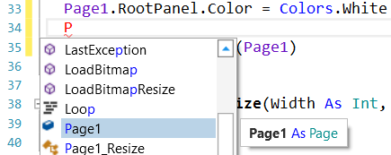 A drop-down list appears with all available keywords, views, routines etc.

The first item beginning with the letter ‘P’ is highlighted.

Click on Return to validate.

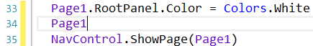

P is completed to Page1.

Now enter a dot “.”

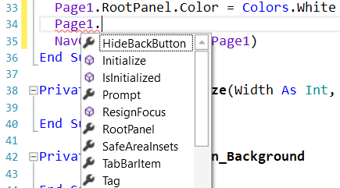

The drop-down list contains all properties of a Page view.

With the Down key go down to RootPanel.

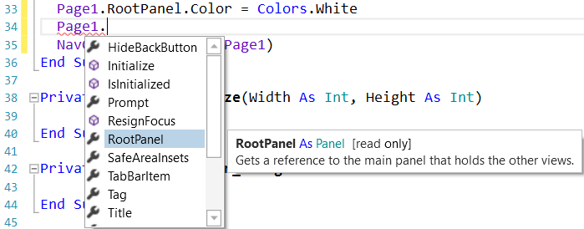

We see RootPanel highlighted, and besides the list the in-line help with the syntax for the property and an explanation.

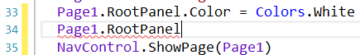 Click on Return to validate.

Enter a dot “.”

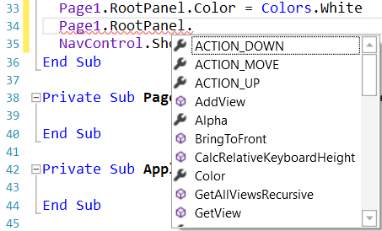

Again we get a drop-down list with the properties of a Panel.

With the Down key go down to LoadLayout.

Again we see the syntax and the explanation.

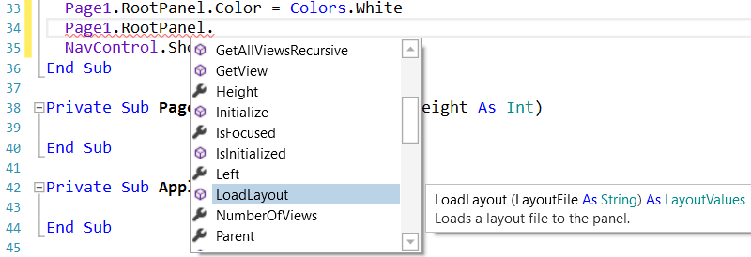

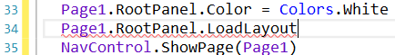 Click on Return to validate.

Enter “(”.

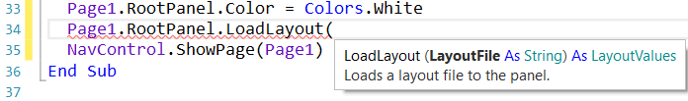

The in-line help shows what to do and the explanation.

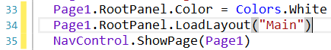Complete the line with the layout file name.

The file extension is not needed.

The file name "Main" is between quotes because it is a String.

The yellow line in the left border shows that a modification was made in the code.

As soon as you save the code the yellow line will be changed to a green line.

We want to generate a new problem as soon as the program starts. Therefore, we add a call to the New subroutine in Application_Start.

Private Sub **Application_Start** (Nav As NavigationController)

NavControl = Nav

Page1.Initialize("Page1")

Page1.Title = "Page 1"

Page1.RootPanel.Color = Colors.White

NavControl.ShowPage(Page1)

New

End Sub

New is displayed in red because the ‘New’ routine has not yet been defined.

Generating a new problem means generating two new random values between 1 and 9 (inclusive) for Number1 and Number2, then showing the values using the lblNumber1 and lblNumber2 ‘Text’ properties.

To do this we enter following code:

In Sub Process_Globals we add two variables for the two numbers.

Private Number1, Number2 As Int

End Sub

And the 'New' Subroutine:

Private Sub **New**

Number1 = Rnd(1, 10) ' Generates a random number between 1 and 9

Number2 = Rnd(1, 10) ' Generates a random number between 1 and 9

lblNumber1.Text = Number1 ' Displays Number1 in label lblNumber1

lblNumber2.Text = Number2 ' Displays Number2 in label lblNumber2

lblComments.Text = "Enter the result" & CRLF & "and click on OK"

txfResult.Text = "" ' Sets edtResult.Text to empty

End Sub

The following line of code generates a random number from '1' (inclusive) to '10' (exclusive) :

Rnd(1, 10)

In this line Number1 = Rnd(1, 10) ' Generates a random number between 1 and 9

The text after the quote, ' Generates..., is considered as a comment.

It is good practice to add comments explaining the purpose of the code.

The following line displays the comment in the lblComment view:

lblComments.Text = "Enter the result" & CRLF & "and click on OK"

CRLF is the LineFeed character.

Now we add the code for the Button click event.

We have two cases:

- When the Button text is equal to "O K", it means that a new problem is displayed, and the program is waiting for the user to enter a result and press the Button.

- When the Button text is equal to "NEW", it means that the user has entered a correct answer and when the user clicks on the Button a new problem will be generated.

Private Sub **btnAction_Click**

If btnAction.Text = "O K" Then

If txfResult.Text="" Then

Msgbox("No result entered","E R R O R")

Else

CheckResult

End If

Else

New

btnAction.Text = "O K"

End If

End Sub

If btnAction.Text = "O K" Then checks if the Button text equals "O K"

If yes then we check if the TextField is empty.

If yes, we display a MessageBox telling the user that there is no result in the TextField view.

If no, we check if the result is correct or if it is wrong.

If no then we generate a new problem, set the Button text to "O K" and clear the TextField view.

The last routine checks the result.

Private Sub **CheckResult**

If txfResult.Text = Number1 + Number2 Then

lblComments.Text = "G O O D result" & CRLF & "Click on NEW"

btnAction.Text = "N E W"

Else

lblComments.Text = "W R O N G result" & CRLF & "Enter a new result" & CRLF & "and click OK"

End If

End Sub

With If txfResult.Text = Number1 + Number2 Then we check if the entered result is correct.

If yes, we display in the lblComments label the text below:

'G O O D result'

'Click on NEW'

and we change the Button text to "N E W ".

If no, we display in the lblComments label the text below:

W R O N G result

Enter a new result

and click OK

Let us now compile the program and transfer it to the Device.

In the IDE on top click on  or press F5:

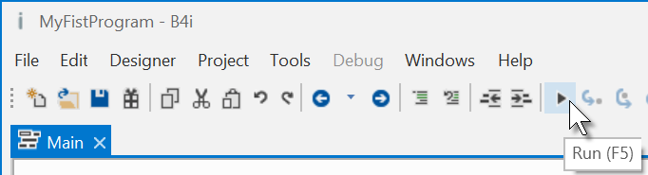

The program is going to be compiled.

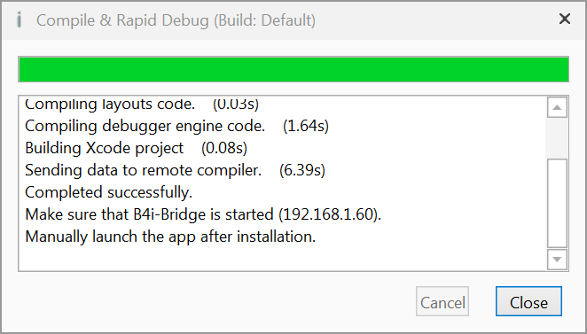

When you see

'Completed successfully.' as in the message box, the compiling and transfer is finished.



Looking at the device, you should see something similar to the image below when you first run the program.

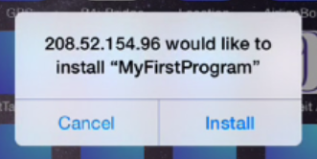

Touch on .

Then you will see somewhere on the device the icon of the program 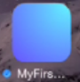, touch it to run the program.

Then you should see something similar to the image on the left, with different numbers.

Of course, we could make aesthetic improvements in the layout, but this was not the main issue for the first program.

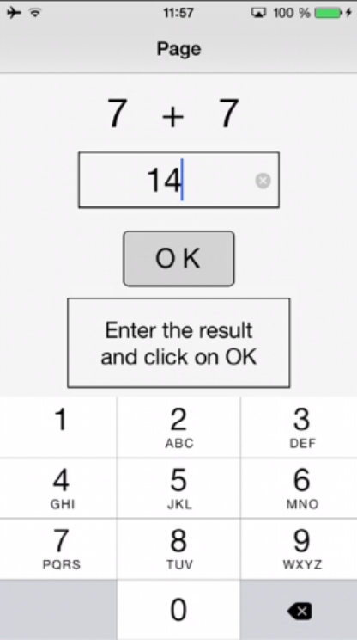

Touch on 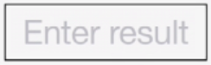 to activate the keyboard

Enter 14

You will see this screen.

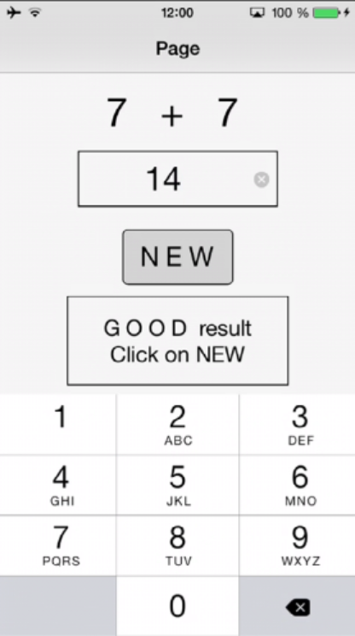

Click on 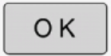 to confirm the result entry.

If the result is correct you will see the screen on the left.

If the result is wrong the message is:

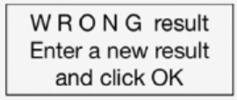

## Second B4i program (SecondProgram.b4i)

The project is available in the SourceCode folder:

SourceCode\SecondProgram\B4i\SecondProgram.b4i.

Improvements to “My first program”.

* Independent numeric keyboard to avoid the use of the virtual keyboard.
* Colors in the comment label.

Create a new folder called “SecondProgram”. Copy all the files and folders from MyFirstProgram to the new SecondProgram folder and rename the program file MyFirstProgram.b4i to SecondProgram.b4i and MyFirstProgram.meta to SecondProgram.meta.

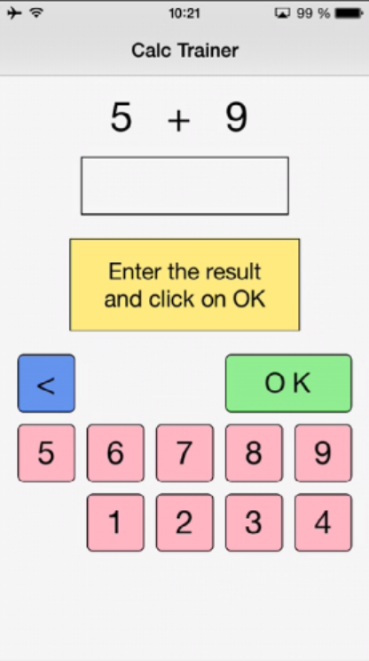Load this new program in the IDE.

We need to change the Package Name.

In the IDE 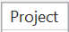 menu.

Click on 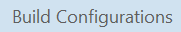.

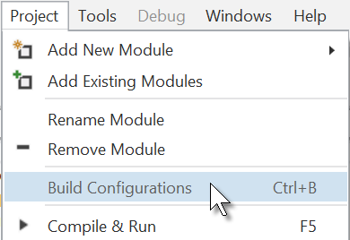

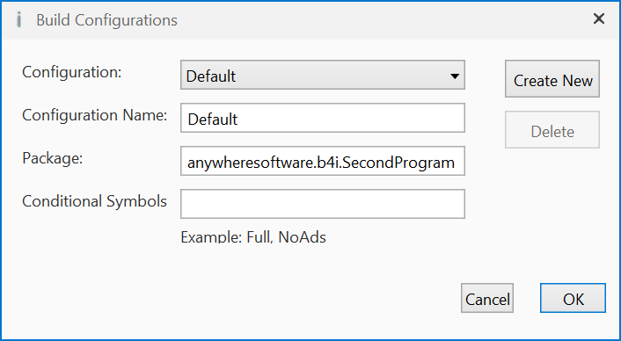

Change the Package name to anywheresoftware.b4i.SecondProgram and click on 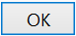.

Then we must change the ApplicationLabel on the very top of the code.

#Region Project Attributes

#ApplicationLabel: SecondProgram

Run the Designer.

We want to replace the txfResult TextField view by a new Label.

In the Abstract Designer, click on the txfResult view.

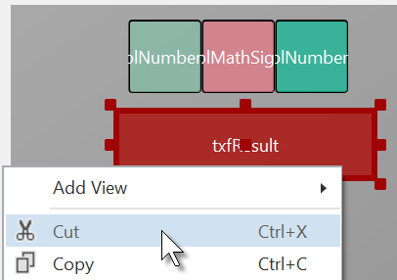

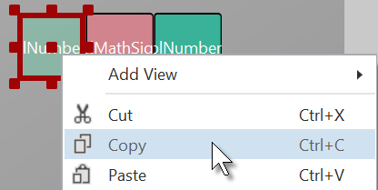

Right click on txfResult Right click on lblNumber1

and click on . and click on .

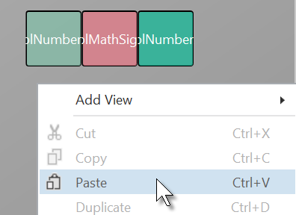

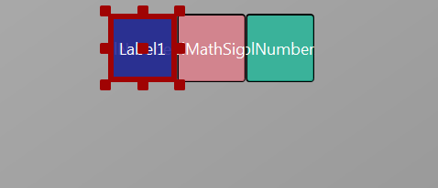

Right click somewhere else The new label covers lblNumber1.

and click on .

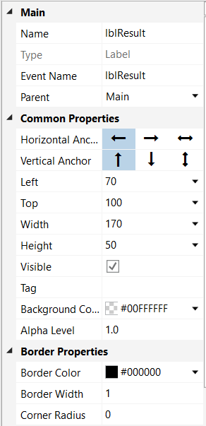

Modify the following properties:

Name to lblResult

Left, Top, Width, Height

Boarder Width to 1

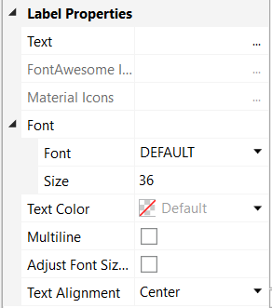

Text to "" no character

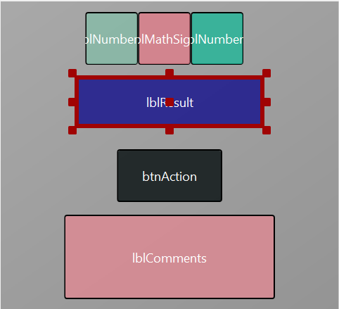

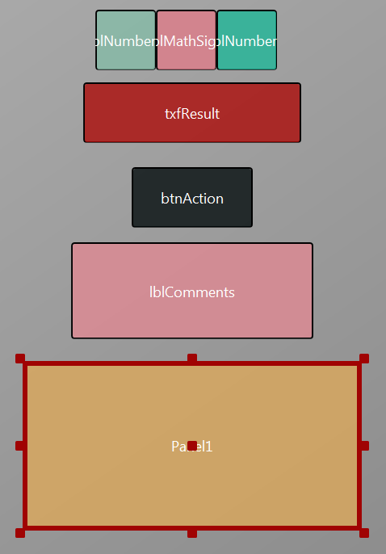

Let us add a Panel for the keyboard buttons.

Position and resize it as in the image.

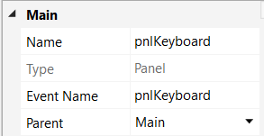

Change its Name to pnlKeyboard

"pnl" for Panel, the view type.

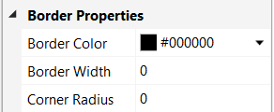

Change

Border Width to 0

Corner radius to 0

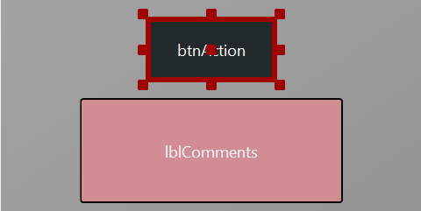

We will move btnAction from Main to the pnlKeyboard Panel.

Click on btnAction.

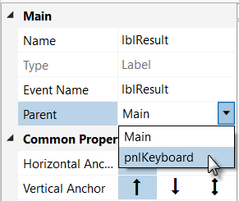

In the Parent list click on .

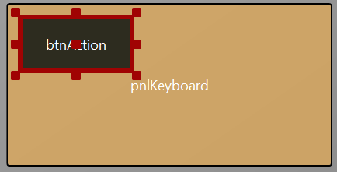

The button now belongs to the Panel.

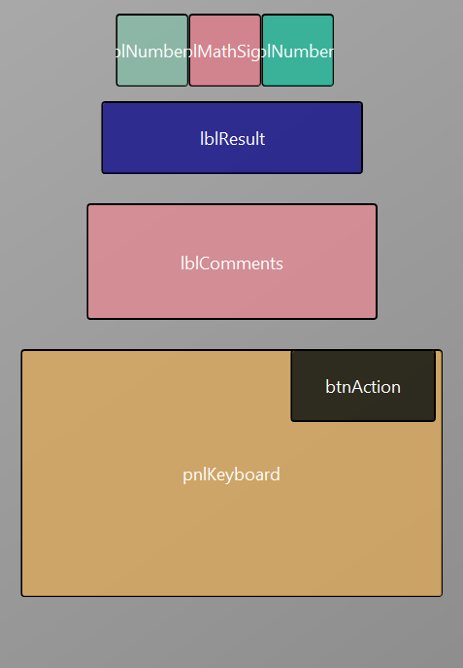

Set these properties:

Now we rearrange the views to get some more space for the keyboard.

Set the properties below:

lblNumber1 Top = 10

lblMathSign Top = 10

lblNumber2 Top = 10

lblResult Top = 70

lblComments Top = 140

pnlKeyboard Left = 15

pnlKeyboard Top = 240

pnlKeyboard Width = 290

pnlKeyboard Height = 170

pnlKeyboard BorderWidth = 0

Move btnAction to the upper right corner of pnlKeyboard.

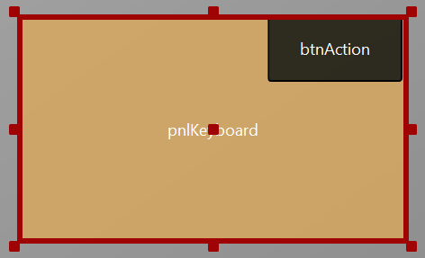 Click on the pnlKeyboard panel to select it.

Click on 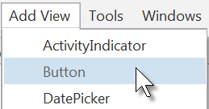

to add a new button.

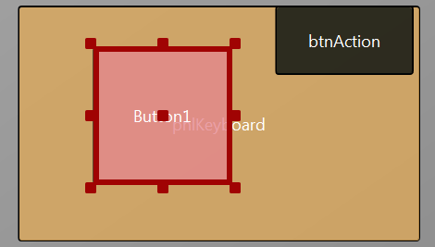

The new button is added.

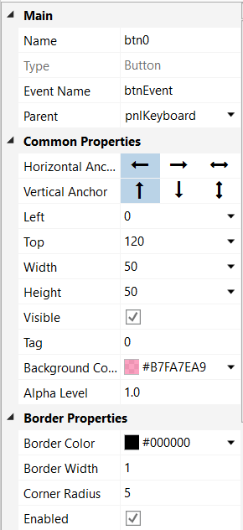

Change following properties:

Name to btn0

Event name to btnEvent

Left to 0

Top to 120

Width to 50

Height to 50

Tag to 0

Background Color to #B7FA7EA9

Boarder Width to 1

Corner Radius to 5

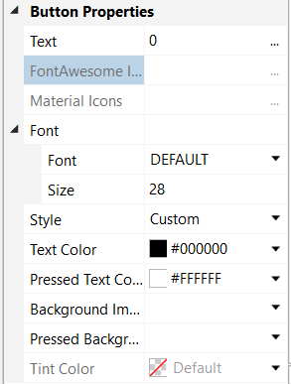

Text to 0

Size to 28

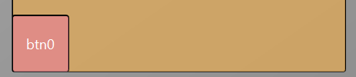

The button looks now like this.

Let us duplicate btn0 and position the new one beside button btn0.

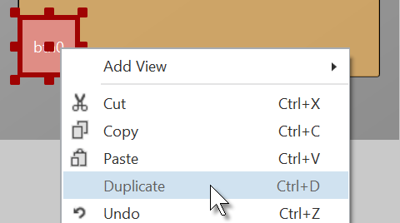

Select the Button btn0.

Right click on btn0

and click on .

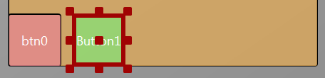

Move the new Button next to the previous one with a space.

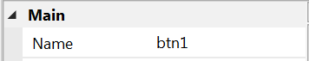 Change the following properties:

Name to btn1

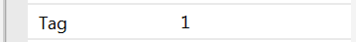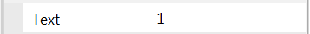

Tag to 1

Text to 1

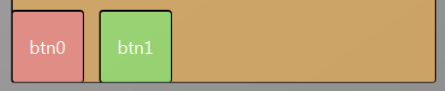

And the result.

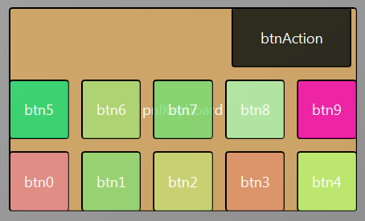Add 8 more Buttons and position them like in the image.

Change following properties:

Name btn2, btn3, btn4 etc.

Tag 2 , 3 , 4 etc.

Text 2 , 3 , 4 etc.

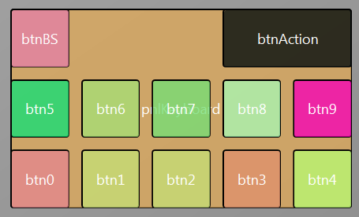

To create the BackSpace button, duplicate one of the number buttons, and position it in the top left corner.

Resize and position btnAction.

Change their Name, Tag, Text and Color properties as below.

btnBS **<** btnAction O K

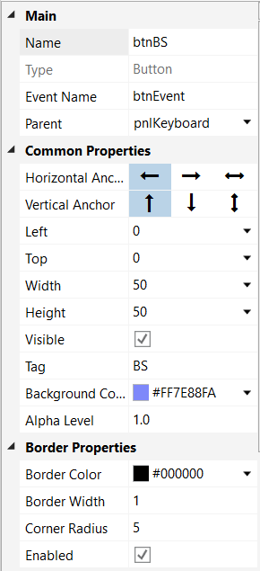 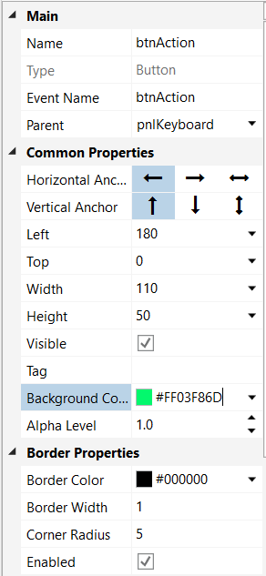

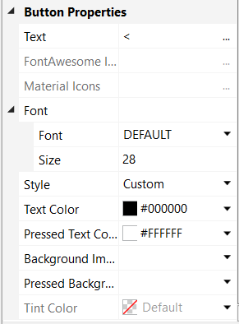 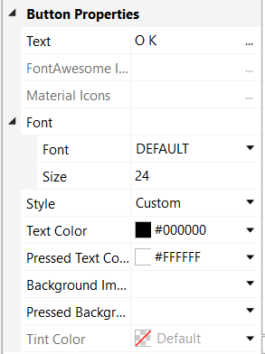

Another improvement is to center the objects on the screen.

For this, we add some code in the Designer Scripts in the Script-General window.

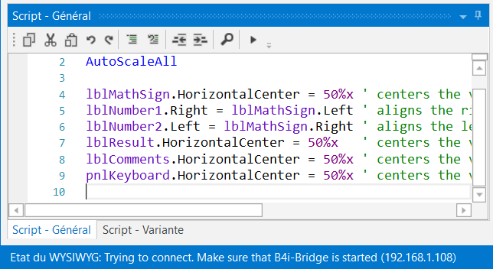

'All variants script

AutoScaleAll

lblMathSign.HorizontalCenter = 50%x ' centers the view on the middle of the screen

lblNumber1.Right = lblMathSign.Left ' aligns the right edge ont the left edge

lblNumber2.Left = lblMathSign.Right ' aligns the left edge ont the right edge

lblResult.HorizontalCenter = 50%x ' centers the view on the middle of the screen

lblComments.HorizontalCenter = 50%x ' centers the view on the middle of the screen

pnlKeyboard.HorizontalCenter = 50%x ' centers the view on the middle of the screen

The first two lines are added by default, we leave them.

'All variants script

AutoScaleAll

lblSigneMath.HorizontalCenter = 50%x

HorizontalCenter centers a view horizontally on the screen at the given value, 50%x in our case, which means in the middle of the screen.

lblNombre1.Right = lblSigneMath.Left

Aligns the right edge of lblNombre1 on the left edge of lblSigneMath, positons lblNombre1 just besides lblSigneMath on the left.

lblNombre2.Left = lblSigneMath.Right

Aligns the left edge of lblNombre2 on the right edge of lblSigneMath, positons lblNombre2 just besides lblSigneMath on the right.

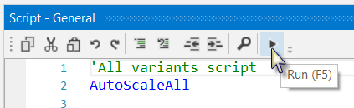

To see the result, click on 

in the Script – General window.

This executes the code.

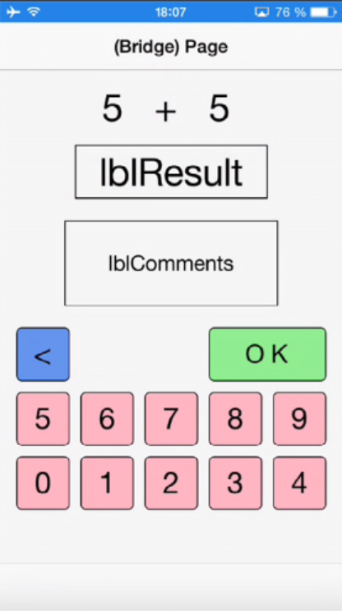

The finished new layout on the device.

If you had connect the device since the beginning you could have followed all the evolutions of the layout on the device.

Now we will update the code.

First, we must replace the txfResult by lblResult because we replaced the TextField view by a Label.

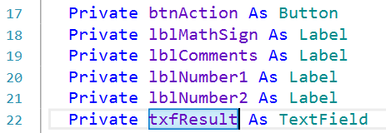

Double click on txfResult to select it.

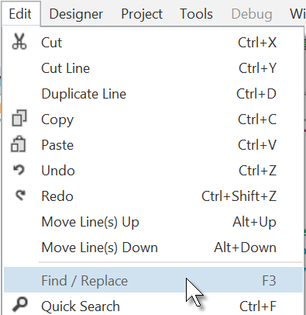

Click on 

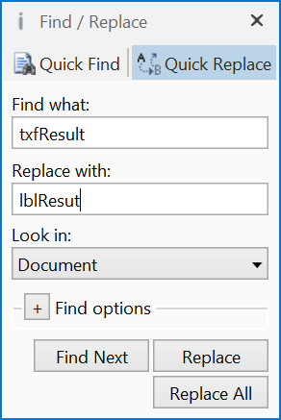

The Find / Replace window is displayed.

Click on 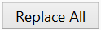 and close the window.

We also need to change its view type form TextField to Label.

Private lblResult As Label

Now we write the routine that handles the Click events of the Buttons.

The Event Name for all buttons, except btnAction, is "btnEvent".

The routine name for the associated click event will be btnEvent_Click.

Enter the following code:

Private Sub **btnEvent_Click**

End Sub

We need to know what button raised the event. For this, we use the Sender object which is a special object that holds the object reference of the view that generated the event in the event routine.

Private Sub **btnEvent_Click** To have access to the properties of the view that raised the

Dim btnSender As Button event we declare a local variable

Dim btnSender As Button.

btnSender = Sender And set btnSender = Sender.

Select btnSender.Tag Then, to differentiate between the backspace button and

Case "BS" the numeric buttons we use a Select / Case / End Select

Case Else structure and use the Tag property of the buttons.

End Select Remember, when we added the different buttons we

End Sub set their Tag property to BS, 0, 1, 2 etc.

Select btnSender.Tag Select sets the variable to test.

Case "BS" Checks if it is the button with the "BS" tag value.

Case Else Handles all the other buttons.

Now we add the code for the numeric buttons.

We want to add the value of the button to the text in the lblResult Label.

Select btnSender.Tag

Case "BS"

Case Else

lblResult.Text = lblResult.Text & btnSender.Text

End Select

End Sub

This is done in this line

lblResult.Text = lblResult.Text & btnSender.Text

The "&" character means concatenation, so we just append to the already existing text the value of the Text property of the button that raised the event.

Now we add the code for the BackSpace button.

Select btnSender.Tag

Case "BS"

If lblResult.Text.Length > 0 Then

lblResult.Text = lblResult.Text.SubString2(0, lblResult.Text.Length - 1)

End If

Case Else

lblResult.Text = lblResult.Text & btnSender.Text

End Select

End Sub

When clicking on the BS button we must remove the last character from the existing text in lblResult. However, this is only valid if the length of the text is bigger than 0. This is checked with:

If lblResult.Text.Length > 0 Then

To remove the last character we use the SubString2 function.

lblResult.Text = lblResult.Text.SubString2(0,lblResult.Text.Length - 1)

SubString2(BeginIndex, EndIndex) extracts a new string beginning at BeginIndex (inclusive) until EndIndex (exclusive).

Now the whole routine is finished.

Private Sub **btnEvent_Click**

Private btnSender As Button

btnSender = Sender

Select btnSender.Tag

Case "BS"

If lblResult.Text.Length >0 Then

lblResult.Text = lblResult.Text.SubString2(0,lblResult.Text.Length - 1)

End If

Case Else

lblResult.Text = lblResult.Text & btnSender.Text

End Select

End Sub

In Sub btnAction_Click we add, at the end, lblResult.Text = "" to clear the text.

Else

New

btnAction.Text = "O K"

lblResult.Text = ""

End If

End Sub

We can try to improve the user interface of the program by adding some colors

to the lblComments Label.

Let us set:

- Yellow for a new problem

- Light Green for a GOOD answer

- Light Red for a WRONG answer.

We first modify the New routine, where we add this line

lblComments.Color = Colors.RGB(255,235,128)

Private Sub **New**

Number1 = Rnd(1, 10) ' Generates a random number between 1 and 9

Number2 = Rnd(1, 10) ' Generates a random number between 1 and 9

lblNumber1.Text = Number1 ' Displays Number1 in label lblNumber1

lblNumber2.Text = Number2 ' Displays Number2 in label lblNumber2

lblComments.Text = "Enter the result" & CRLF & "and click on OK"

lblComments.Color = Colors.RGB(255,235,128) ' yellow color

lblResult.Text = "" ' Sets lblResult.Text to empty

End Sub

And in the CheckResult routine we add the two lines with lblComments.Color =...

Private Sub **CheckResult**

If lblResult.Text = Number1 + Number2 Then

lblComments.Text = "G O O D result" & CRLF & "Click on NEW"

lblComments.Color = Colors.RGB(128,255,128) ' light green color

btnAction.Text = "N E W"

Else

lblComments.Color = Colors.RGB(255,128,128) ' light red color

lblComments.Text = "W R O N G result" & CRLF & "Enter a new result" & CRLF & "and click OK"

End If

End Sub

And we give the program a more meaningful title by adding Page1.Title = "Calc Trainer" in Application_Start just before NavControl.ShowPage(Page1).

 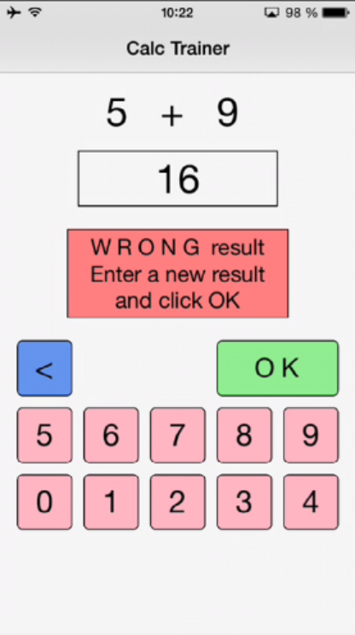 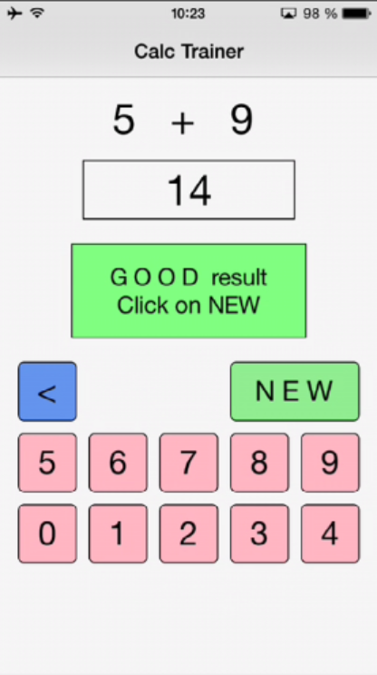

Another improvement would be to hide the '0' button to avoid entering a leading '0'.

For this, we hide the button in the New subroutine with line btn0.Visible = False.

Private Sub **New**

Number1 = Rnd(1, 10) ' Generates a random number between 1 and 9

Number2 = Rnd(1, 10) ' Generates a random number between 1 and 9

lblNumber1.Text = Number1 ' Displays Number1 in label lblNumber1

lblNumber2.Text = Number2 ' Displays Number2 in label lblNumber2

lblComments.Text = "Enter the result" & CRLF & "and click on OK"

lblComments.Color = Colors.RGB(255,235,128) ' yellow color

lblResult.Text = "" ' Sets lblResult.Text to empty

btn0.Visible = False

End Sub

We see that btn0 is in red, this means that this object is not recognized by the IDE.

btn0.Visible = False

So we must declare it, by adding btn0 into line 17:

Private btnAction, btn0 As Button

Now btn0 is no more in red.

btn0.Visible = False

In addition, in the btnEvent_Click subroutine, we hide the button if the length of the text in lblResult is equal to zero and show it if the length is greater than zero.

Private Sub **btnEvent_Click**

Dim btnSender As Button

btnSender = Sender

Select btnSender.Tag

Case "BS"

If lblResult.Text.Length >0 Then

lblResult.Text = lblResult.Text.SubString2(0,lblResult.Text.Length - 1)

End If

Case Else

lblResult.Text = lblResult.Text & Send.Tag

End Select

If lblResult.Text.Length = 0 Then

btn0.Visible = False

Else

btn0.Visible = True

End If

End Sub

# Getting started B4J

B4J is a **100% free** development tool for desktop, server and IoT solutions.  
With B4J you can easily create desktop applications (UI), console programs (non-UI) and server solutions.  
The compiled apps can run on Windows, Mac, Linux and ARM boards (such as Raspberry Pi).

The B4J language is like Visual Basic and B4A language.  
  
B4J includes a powerful GUI designer, built-in support for multiple screens and orientations.

What you need:

* The B4J program, this is a Windows program running on a PC.
* The Java SDK on the PC, free.

## Installing B4J

### Installing Java JDK

B4J depends on the free Java JDK component.

**If you are already using B4A or B4i you can skip this chapter.**

Installation instructions:

The first step should be to install the **Java JDK**, as B4J requires it.  
Note that there is no problem with having several versions of Java installed on the same computer.  
  
- Open the [Java 8 JDK download link](http://www.oracle.com/technetwork/java/javase/downloads/jdk8-downloads-2133151.html).

- Check the Accept License Agreement radio button.  
- Select **"Windows x86"** or **"Windows x64"** (for 64 bit machines) in the platforms list.

- Download the file and install it.

### Installing B4J

Download and install the B4J file on your computer.

As B4J is for free, there is no license file needed like for B4A and B4i.

## Configure Paths in the IDE

Then you need to configure the different paths in the IDE.

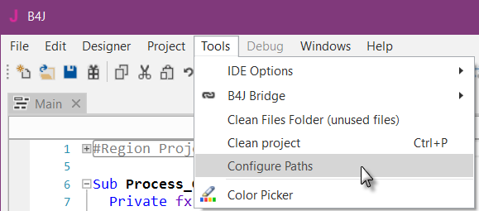

Run the IDE.

In the  menu click on .

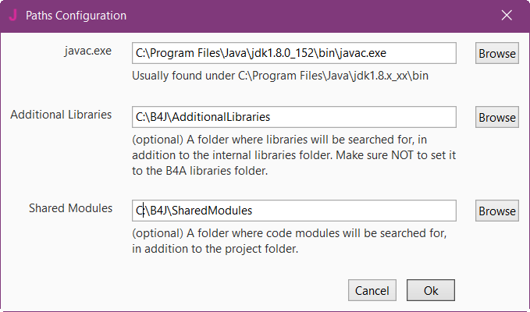

**javac.exe**:

Enter the folder of the javac.exe file.

**Additional libraries**:

Create a specific folder for additional libraries, for example C:\B4J\AdditionalLibraries.

**Shared Modules**:

Create a specific folder for shared modules, for example C:\B4J\SharedModules.

## My first program (MyFirstProgram.b4j)

Let us write our first program. The suggested program is a math trainer for kids.

The project is available in the SourceCode folder shipped with this booklet:

SourceCode\MyFirstProgram\B4J\MyFirstProgram.b4j

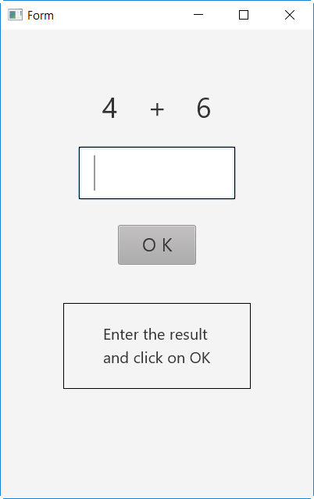

On the screen, we will have:

- 2 Labels displaying randomly generated numbers (between 1 and 9)

- 1 Label with the math sign (+)

- 1 TextField where the user must enter the result

- 1 Button, used to either confirm when the user has finished entering the result or generate a new calculation.

- 1 Label with a comment about the result.

In B4J:

- Label is an object to show text.

- TextField is an object allowing the user to enter text, like EditText in B4A.

- Button is an object allowing user actions.

We will design the layout of the user interface with the Designer, the Abstract Designer and a Form on the screen.

We will go step by step through the whole process.

The Designer manages the different objects of the interface.

The Abstract Designer shows the positions and sizes of the objects and allows moving or resizing them on the screen.

On the Form, we see the real result.

**Run the IDE** 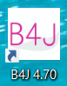

**Save the project.**

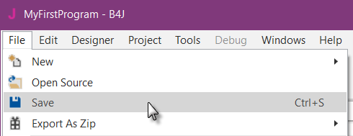

You must save the project before you can run the Designer.

Create a new folder MyFirstProgram and save the project with the name MyFirstProgram.

**Set the Package Name.**

Each program needs a package name.

In the menu  click on .

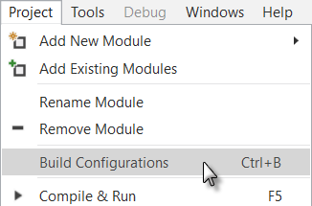

This window appears:

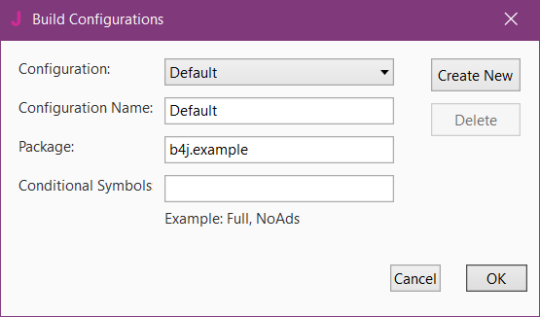

The default name is b4j.example. We will change it to b4j.MyFirstProgram.

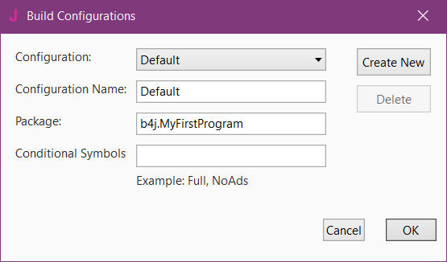

**Set the Form size.**

The Form size is the size of the main window, called Form, shown on the PC screen.

On top of the code you see Region Project Attributes.

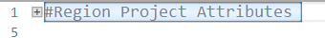

Regions are code parts which can be collapsed

or extended.

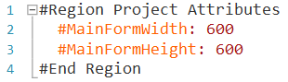Clicking on  will expand the Region.

Clicking on  will collapse the Region.

Regions are explained in Collapse a Region.

Here we can define the size of the project main window called Form.

The default values are Width = 600 and Height = 400.

We change these to Width = 400 and Height = 600.

#Region Project Attributes

#MainFormWidth: 400

#MainFormHeight: 600

#End Region

**In the IDE open the Designer**.

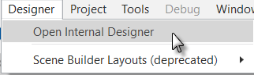

Wait until the Designer is ready.

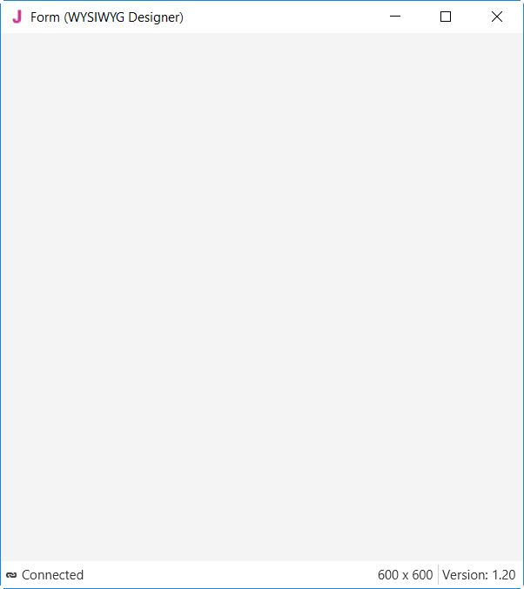

We get a WYSIWYG Form.

And the Designer looks like this.

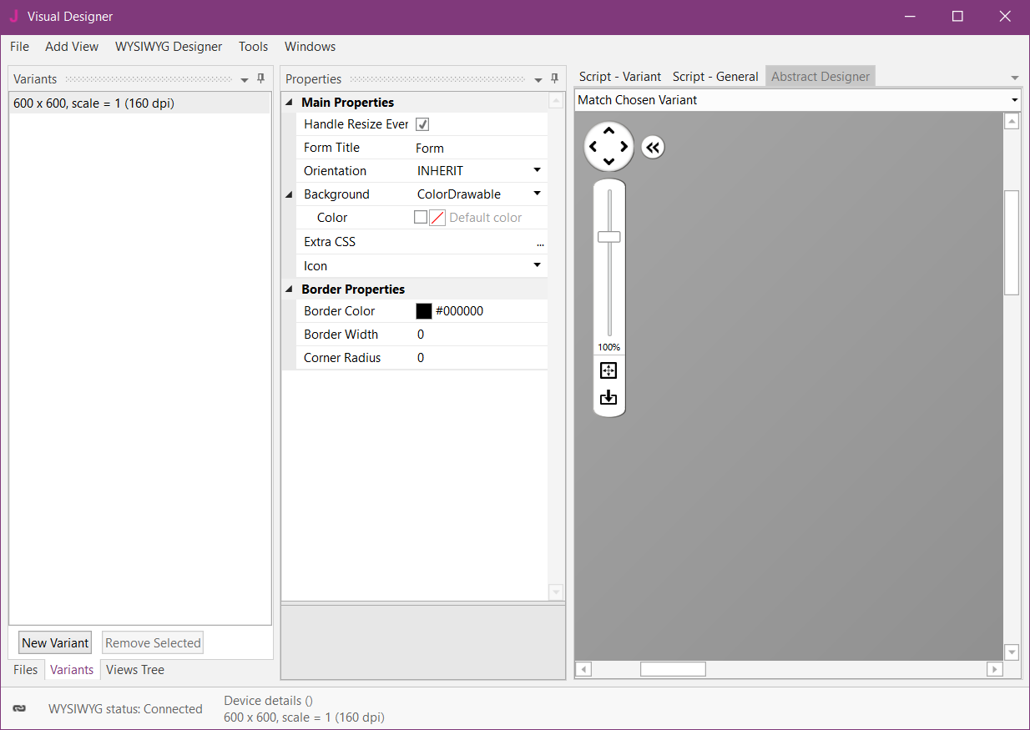

Note that in the bottom left of the Designer window you see the connection status to the WYSIWYG Form:

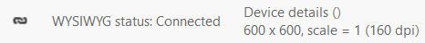

If you close the WYSIWYG Form you will see this status:

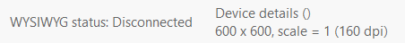

With the Designer, we have also the Abstract Designer which shows the layout not exactly WYSIWYG but the positions and size of the different objects.

Only the top of the image is shown.

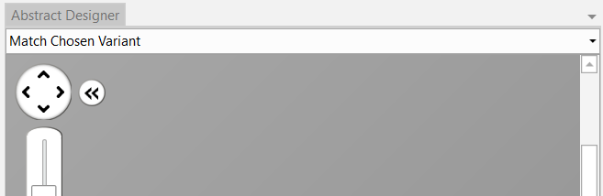

The dark gray area represents the screen area of the connected ‘device’ which is the WYSIWYG Form.

The default screen size variant is 600 * 600, we define a new variant with the same values, 400 * 600, as in the Project Attributes.

Click on .

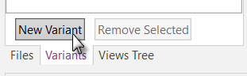

In this window click on  and enter the two values.

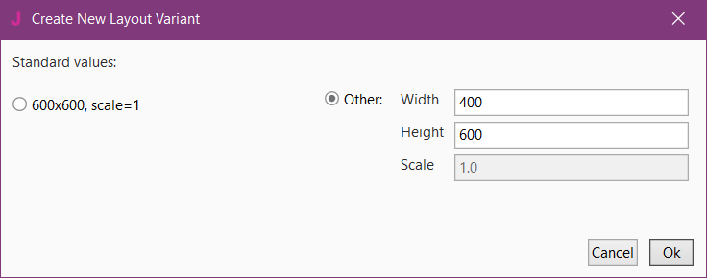

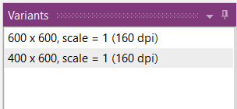

On top of the Variants window we see the new variant.

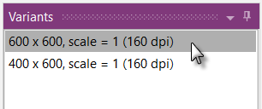

Click on  to select the 600 * 600 variant.

Click on  to remove the 600 * 600 variant.

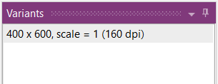

Click on  to show the Views Tree window.

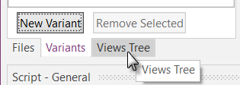

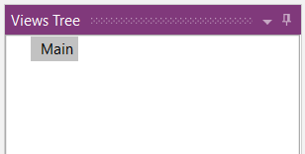

Now we will add the 2 Labels for the numbers.

In the Designer, add a Label.

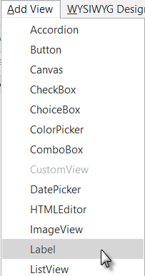In the Designer menu  click on .

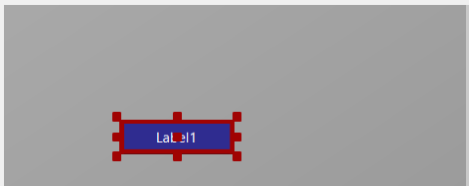

The Label appears in the Abstract Designer, in the Views Tree window and its default properties are listed in the Properties window.

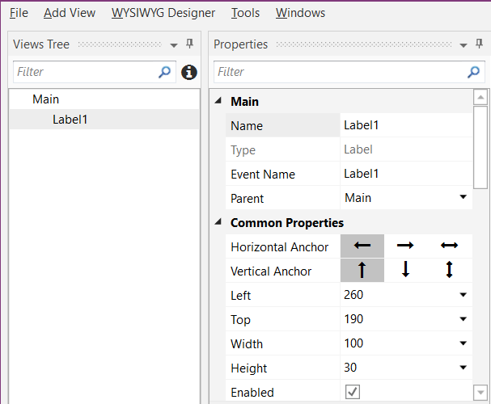

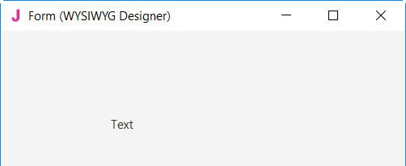

And in the WYSIWYG Form.

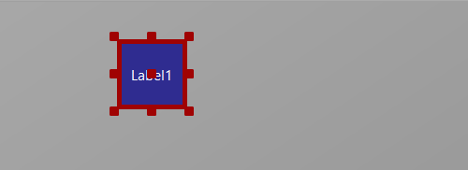

Resize and move the Label with the red squares like this.

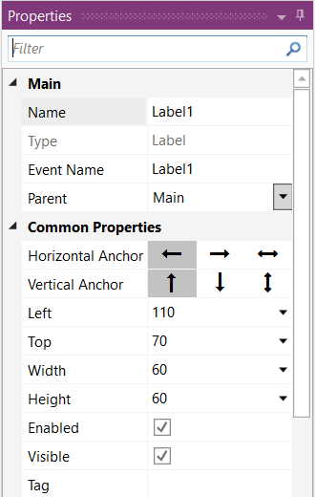

The new properties Left, Top, Width and Height are directly updated in the Properties window.

You can also modify the Left, Top, Width and Height properties directly in the Properties window.

Let us change the properties of this first Label, per our requirements.

By default, the name is Label with a number, here Label1.

Let us change its name to lblNumber1.

The three letters 'lbl' at the beginning mean 'Label', and 'Number1' means the first number.

It is recommended to use significant names for nodes so we know directly what kind of node it is and its purpose.

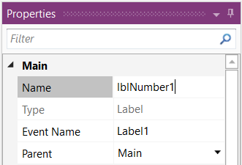

Pressing the 'Return' key or clicking elsewhere will also change the Event Name property.

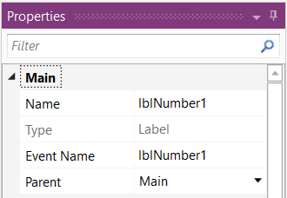

Main : Main module.

Name : name of the node.

Type : type of the node. In this case, Label,   
 which is not editable.

Event Name : generic name of the routines that handle  
 the events of the Label.

Parent : parent node the Label belongs to.

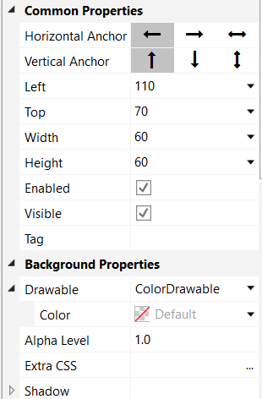 Let us check and change the other properties:

Set Left, Top, Width and Height to the values in the picture.

Visible is checked.

We leave the default colors.

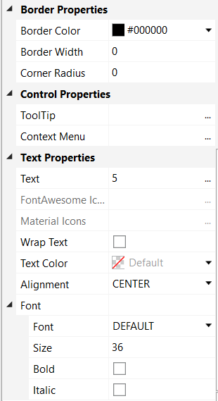

Text set to 5

Set Text Alignment to Center.

We leave the default Font.

Size, we set it to 36.

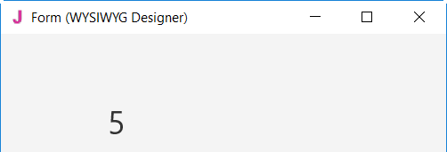And the result in the Abstract Designer and on the WYSIWYG Form



We need a second Label, like the first one. Instead of adding a new one, we copy the first one with the same properties. Only the Name and Left properties will change.

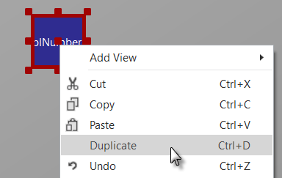 Right click on lblNumber1 and click on  in the popup menu.

The new label covers the previous one.

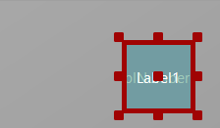

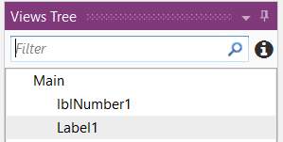

In the left part, in the Views Tree, you see the different nodes.

The new label Label1 is added.

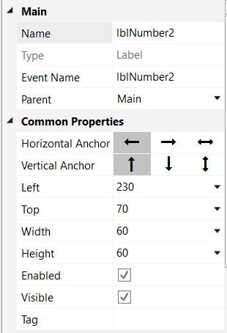

Let us position the new Label and change its name to lblNumber2.

Change the name to lblNumber2.

The Left property to 230.

 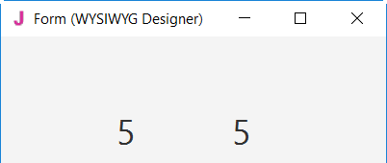

And the result in the Abstract Designer and on the WYSIWYG Form.

Let us now add a 3rd Label for the math sign. We copy once again lblNumber1.

Right click on lblNumber1 in the Abstract Designer and click on  in the popup menu.



The new label covers lblNumber1.

Position it between the first two Labels and change its name to lblMathSign and its

Text property to '+'.

 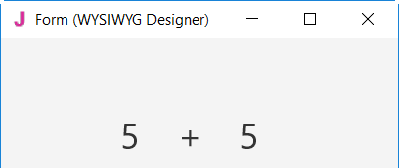

And the result in the Abstract Designer and on the WYSIWYG Form.

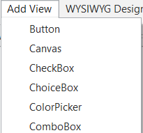

Now let us add a TextField node.

In the Designer  menu

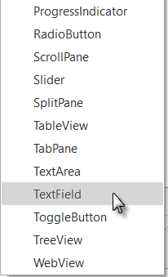click on .

Position it below the three Labels and change its name to txfResult.

'txf' means TextField and 'Result' for its purpose.

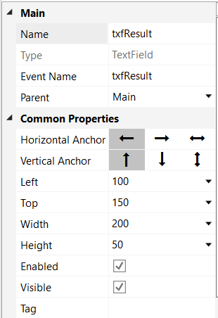

Change these properties.

Name to txfResult

Left, Top, Width and Height.

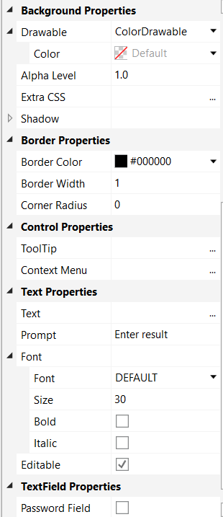

Border Width to 1

Prompt to Enter result

Prompt represents the text shown in the TextField node if no text is entered.

Size to 30

After making these changes, you should see something like this.

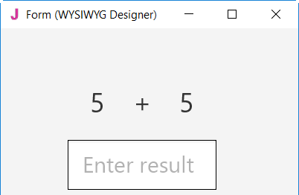

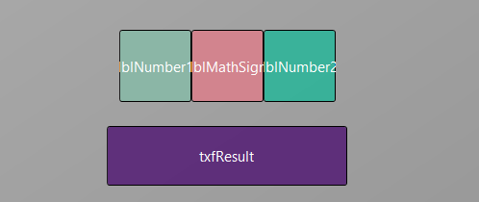

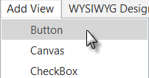Now, let's add the Button which, when pressed, will either check the result the user supplied as an answer, or generate a new math problem, depending on the user's input.

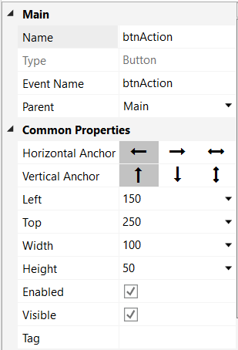

Position it below the TextField node. Resize it and change following properties:

Name to btnAction

Left, Top, Width and Height.

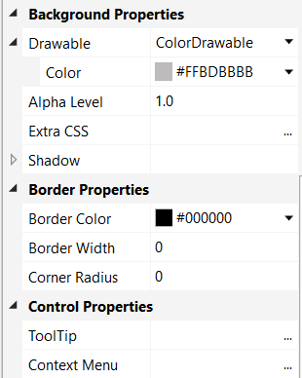

Background Color to #FFBDBBBB

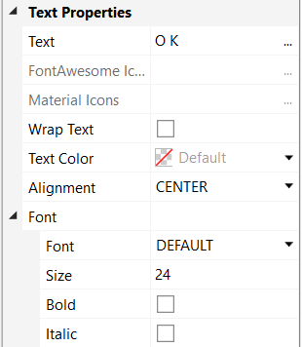

Text to O K (with a space between O and K)

Result (pictures reduced size)

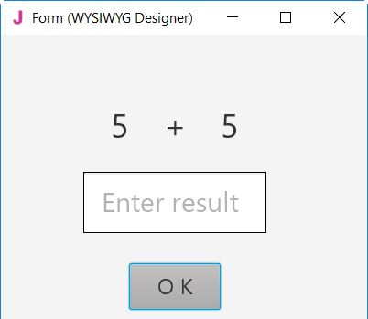Size to 24

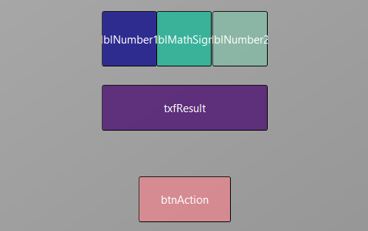

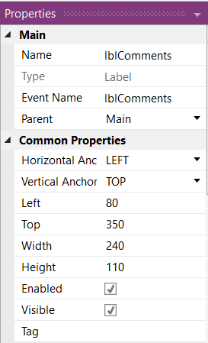Let us add the last Label for the comments. Position it below the Button and resize it.

Change the following properties:

Name to lblComments

Left, Top, Width and Height.

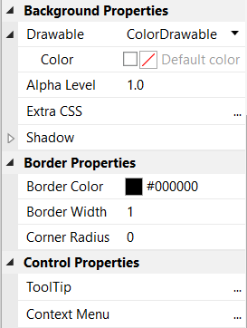

Border Width to 1

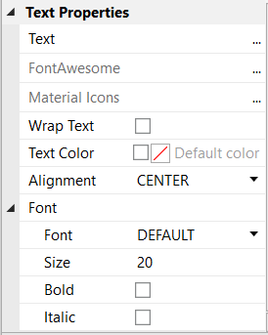

Text empty

Font Size to 20

And the result.

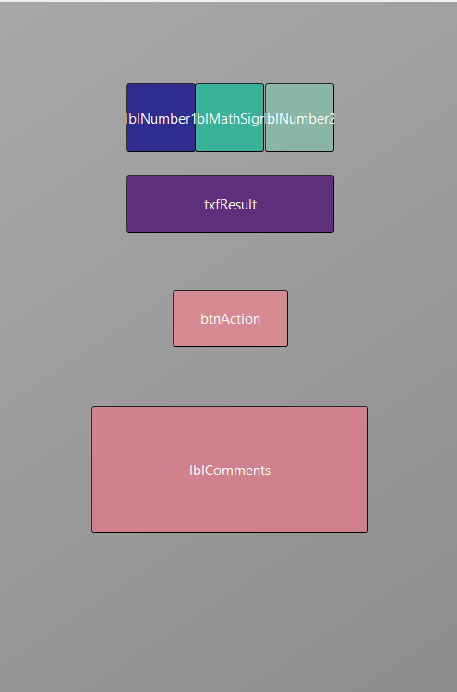 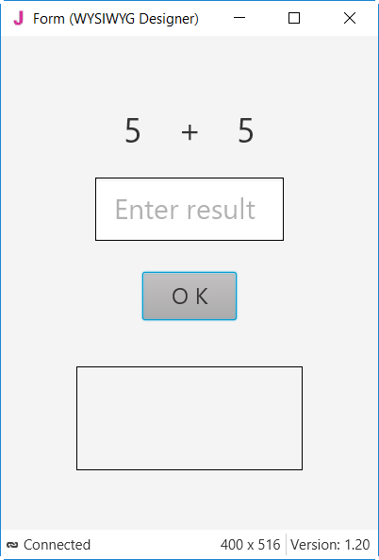

Now we save the layout in a file.

Click on 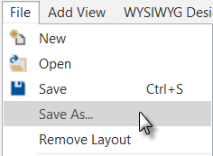 and save it with the name 'Main'.

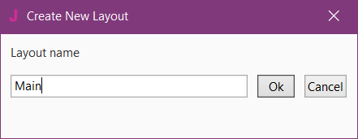

Click on .

To write the routines for the project, we need to reference the Views in the code.

This can be done with the *Generate Members* tool in the Designer.

The *Generate Members* tool automatically generates references and subroutine frames.

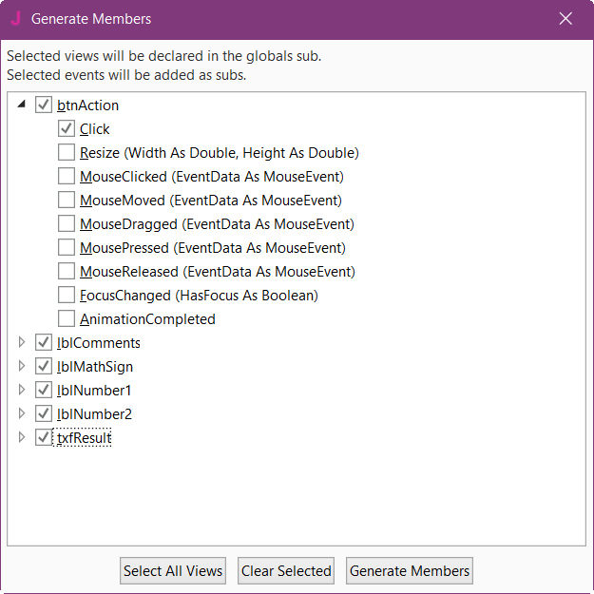

Click on

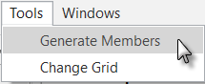

to open the generator.

Here we find all the nodes added to the current layout.

We check all nodes and check the MouseClicked event for the btnAction Button.

Checking a node  generates its reference in the Process_Globals routine in the code.

This is needed to make the node recognized by the system and allow the autocomplete function.

Private btnAction As Button

Private lblComments As Label

Private lblMathSign As Label

Private lblNumber1 As Label

Private lblNumber2 As Label

Private txfResult As TextField

Clicking on shows all events for the selected node 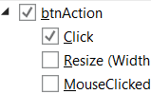.

Clicking on an event of a node  generates the Sub frame for this event.

Sub **btnAction_Click** (EventData As MouseEvent)

End Sub

Click on  to generate the references and Sub frames, then close the window.

Now we go back to the IDE to enter the code.

On the top of the program code we have: 

Click on  to open the Region. We have the code below

#Region Project Attributes

#MainFormWidth: 400

#MainFormHeight: 600

#End Region

Change MainFormWidth from 600 to 400 to adjust the default dimensions of the from.

Just below, we have:

Sub **Process_Globals**

Private fx As JFX

Private MainForm As Form

Private btnAction As Button

Private lblComments As Label

Private lblMathSign As Label

Private lblNumber1 As Label

Private lblNumber2 As Label

Private txfResult As TextField

End Sub

These lines are automatically in the project code.

Private fx As JFX

Private MainForm As Form

B4J needs a MainForm, and the JFX library for the nodes, details in chapter *Program flow / Process life cycle* in the B4x Basic Language booklet.

Below the code above we have the AppStart routine which is the first routine executed when the program starts.

The content below is also added automatically in each new project.

Sub **AppStart** (Form1 As Form, Args() As String)

MainForm = Form1

'MainForm.RootPane.LoadLayout("Layout1") 'Load the layout file.

MainForm.Show

End Sub

MainForm = Form1 > Sets Form1 to the variable MainForm.

'MainForm.RootPane.LoadLayout("Layout1") > Loads a layout file if needed.

MainForm.Show > Shows the MainForm

First, we need our program to load the layout file we defined in the previous pages.

The file must be loaded onto the MainForm.RootPane, we uncomment the line   
'MainForm.RootPane.LoadLayout("Layout1")

and change the layout file name.

Sub **AppStart** (Form1 As Form, Args() As String)

MainForm = Form1

MainForm.RootPane.LoadLayout("Main") 'Load the layout file.

MainForm.Show

End Sub

We want to generate a new problem as soon as the program starts. Therefore, we add a call to the New subroutine in AppStart.

Sub **AppStart** (Form1 As Form, Args() As String)

MainForm = Form1

MainForm.RootPane.LoadLayout("Main") 'Load the layout file.

MainForm.Show

New

End Sub

New is displayed in red because the ‘New’ routine has not yet been defined.

Generating a new problem means generating two new random values between 1 and 9 (inclusive) for Number1 and Number2, then showing the values using the lblNumber1 and lblNumber2 ‘Text’ properties.

To do this we enter following code:

In Sub Process_Globals we add two variables for the two numbers.

Private Number1, Number2 As Int

End Sub

And the 'New' Subroutine:

Private Sub **New**

Number1 = Rnd(1, 10) ' Generates a random number between 1 and 9

Number2 = Rnd(1, 10) ' Generates a random number between 1 and 9

lblNumber1.Text = Number1 ' Displays Number1 in label lblNumber1

lblNumber2.Text = Number2 ' Displays Number2 in label lblNumber2

lblComments.Text = "Enter the result" & CRLF & "and click on OK"

txfResult.Text = "" ' Sets edtResult.Text to empty

End Sub

The following line of code generates a random number from '1' (inclusive) to '10' (exclusive) :

Rnd(1, 10)

In this line Number1 = Rnd(1, 10) ' Generates a random number between 1 and 9

The text after the quote, ' Generates..., is considered as a comment.

It is good practice to add comments explaining the purpose of the code.

The following line displays the comment in the lblComment node:

lblComments.Text = "Enter the result" & CRLF & "and click on OK"

CRLF is the LineFeed character.

Now we add the code for the Button click event.

We have two cases:

- When the Button text is equal to "O K", it means that a new problem is displayed, and the program is waiting for the user to enter a result and press the Button.

- When the Button text is equal to "NEW", it means that the user has entered a correct answer and when the user clicks on the Button a new problem will be generated.

Private Sub **btnAction_Click**

If btnAction.Text = "O K" Then

If txfResult.Text="" Then

lblComments.Text = "No result entered" & CRLF & "Enter a result" & CRLF & "and click on OK"

Else

CheckResult

End If

Else

New

btnAction.Text = "O K"

End If

End Sub

If btnAction.Text = "O K" Then checks if the Button text equals "O K".

If yes, we check if the TextField is empty.

If yes, we display a message in the comment field telling the user that there is no result in the  
 TextField node.

If no, we check if the result is correct or if it is wrong.

If no, we generate a new problem, set the Button text to "O K" and clear the TextField node.

The last routine checks the result.

Private Sub **CheckResult**

If txfResult.Text = Number1 + Number2 Then

lblComments.Text = "G O O D result" & CRLF & "Click on NEW"

btnAction.Text = "N E W"

Else

lblComments.Text = "W R O N G result" & CRLF & "Enter a new result" & CRLF & "and click OK"

End If

End Sub

With If txfResult.Text = Number1 + Number2 Then we check if the entered result is correct.

If yes, we display in the lblComments label the text below:

'G O O D result'

'Click on NEW'

and we change the Button text to "N E W ".

If no, we display in the lblComments label the text below:

W R O N G result

Enter a new result

and click OK

Let us now compile and run the program.

In the IDE on top click on 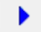 :

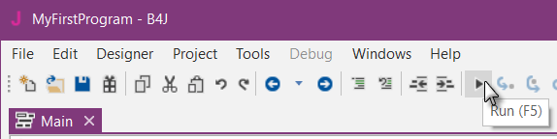

The program is going to be compiled.

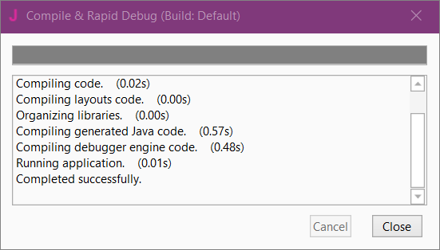

When you see

'Completed successfully.' as in the message box, the compiling and transfer is finished.

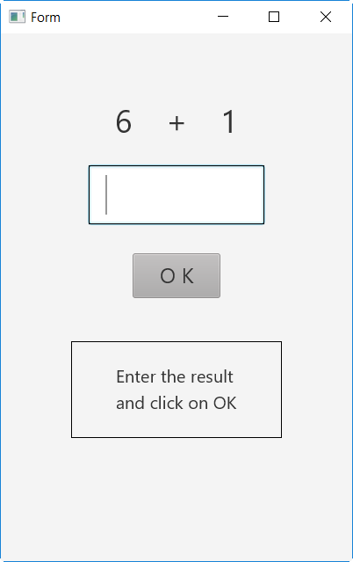

Then you should see something like the image on the left, with different numbers.

Of course, we could make aesthetic improvements in the layout, but this was not the main issue for the first program.

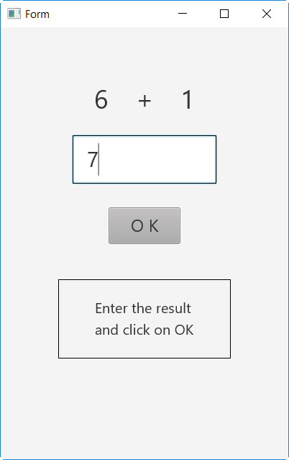

Enter 7

Click on 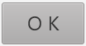 to confirm the result entry.

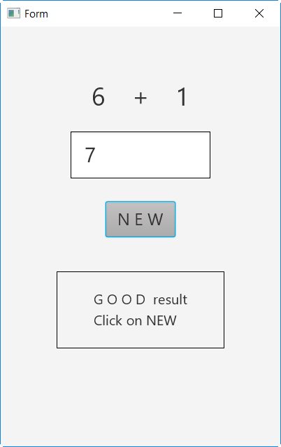

If the result is correct you will see the screen on the left.

If the result is wrong the message is displayed :

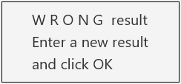

Click on  to define a new problem.

## Second B4J program (SecondProgram.b4j)

The project is available in the SourceCode folder: SourceCode\SecondProgram\SecondProgram.b4j.

Improvements to “My first program”.

* Independent numeric keyboard to avoid the use of the PC keyboard.
* Colors in the comment label.

Create a new folder called “SecondProgram”. Copy all the files and folders from MyFirstProgram to the new SecondProgram folder and rename the program file MyFirstProgram.b4j to SecondProgram.b4j and MyFirstProgram.b4j.meta to SecondProgram.b4j.meta.

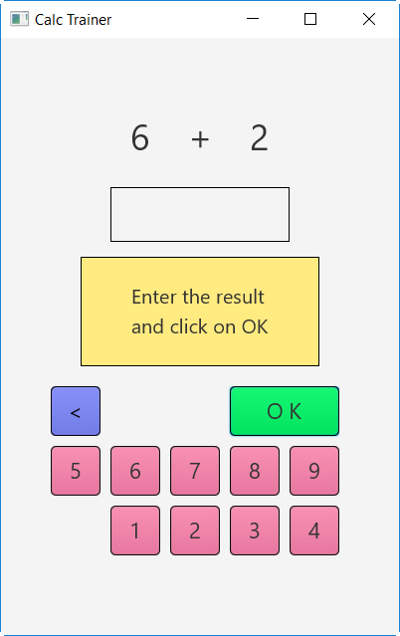

Load this new program in the IDE.

Run the Designer.

We need to change the Package Name.

In the IDE  menu.

Click on .



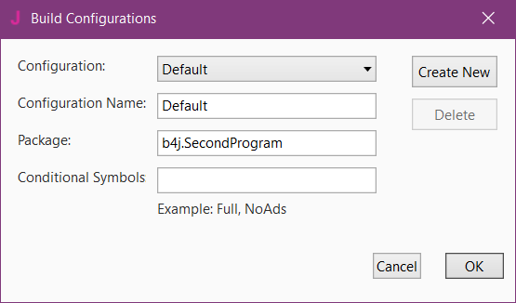

Change the Package name to b4j.SecondProgram and click on 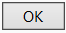.

We want to replace the txfResult TextField node by a new Label.

In the Abstract Designer, click on the txfResult node.

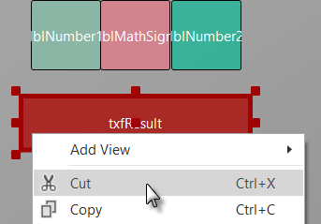

Right click on txfResult and click on .

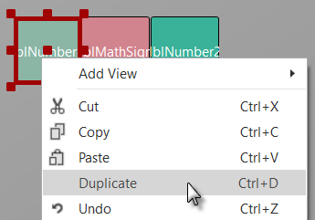

Right click on lblNumber1 and click on .

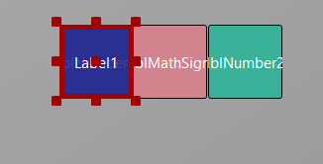

The new label covers lblNumber1.

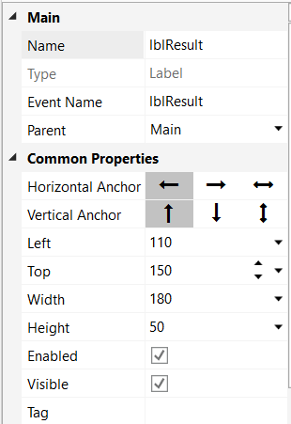

Modify the following properties:

Name to lblResult

Left, Top, Width, Height

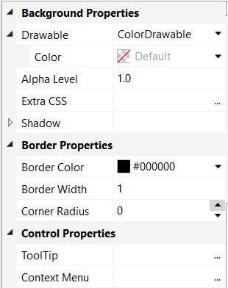

Border Width to 1

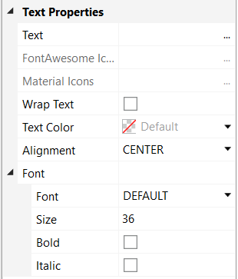

Text to "" no character

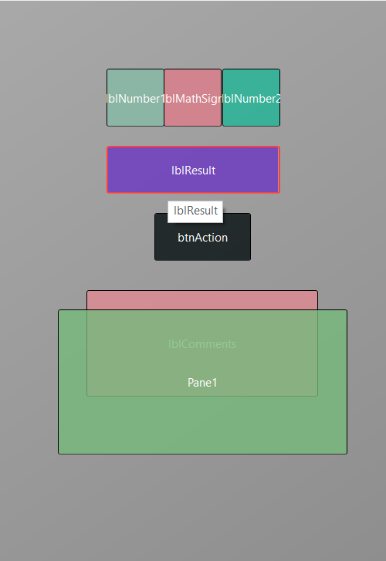

Let us add a Pane for the keyboard buttons.

Position and resize it as in the image.

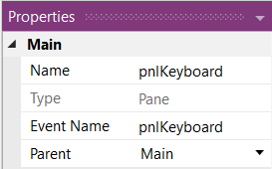

Change its Name to pnlKeyboard

"pnl" for Pane (B4A habit pnl for Panel), the node type.

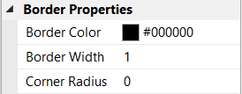

Change

Corner radius to 0

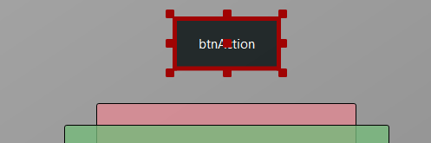

We will move btnAction from Main to the pnlKeyboard Panel.

Click on btnAction.

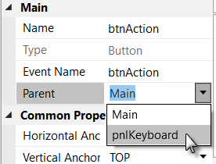

In the Parent list click on .

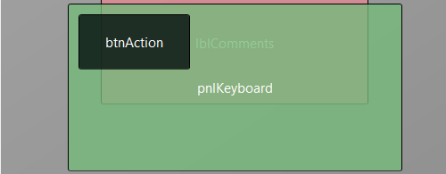

The button now belongs to the Pane.

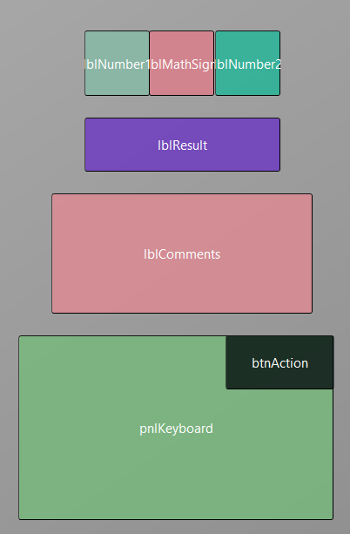

Now we rearrange the nodes to get some more space for the keyboard.

Set the properties below:

lblComments Top = 220

pnlKeyboard Left = 30

pnlKeyboard Top = 350

pnlKeyboard Width = 290

pnlKeyboard Height = 170

pnlKeyboard BorderWidth = 0

Move btnAction to the upper right corner of pnlKeyboard.

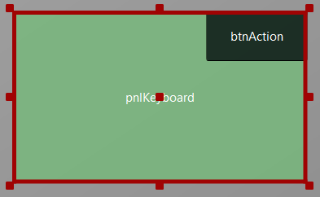 Click on the pnlKeyboard pane to select it.

Click on 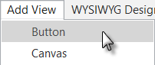

to add a new button.

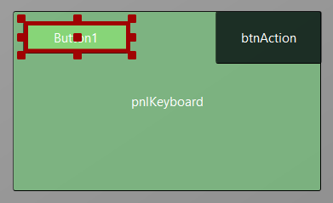

The new button is added.

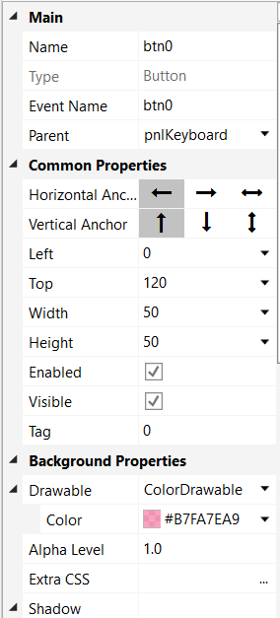

Change following properties:

Name to btn0

Event name to btnEvent

Left to 0

Top to 120

Width to 50

Height to 50

Tag to 0

Color to #B7FA7EA9

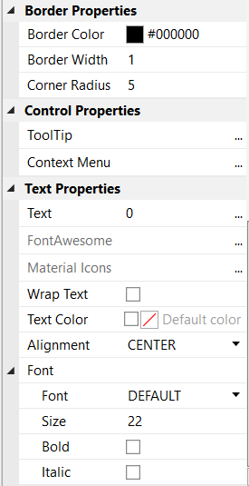

Border Width to 1

Corner Radius to 5

Text to 0

Size to 22

The button looks now like this.

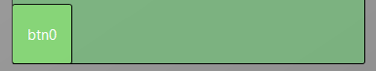

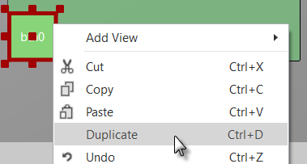Let us duplicate btn0 and position the new one beside button btn0.

Select the Button btn0.

Right click on btn0

and click on .

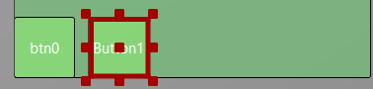

Move the new Button next to the previous one with a space.

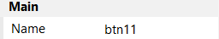Change the following properties:

Name to btn1

Tag to 1

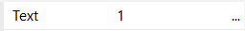

Text to 1

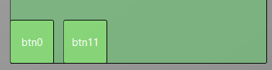

And the result.

Add 8 more Buttons and position them like in the image.

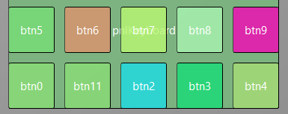

Change following properties:

Name btn2, btn3, btn4 etc.

Tag 2 , 3 , 4 etc.

Text 2 , 3 , 4 etc.

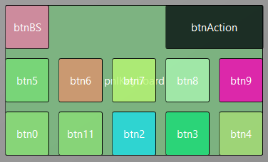

To create the BackSpace button, duplicate one of the number buttons, and position it in the top left corner.

Resize and position btnAction.

Change their Name, Tag, Text and Color properties as below.

btnBS **<** btnAction O K

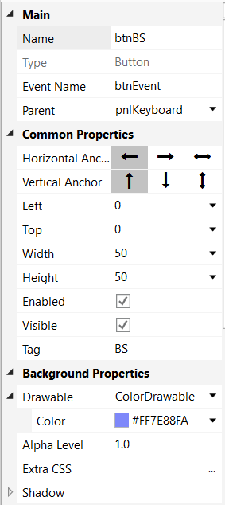 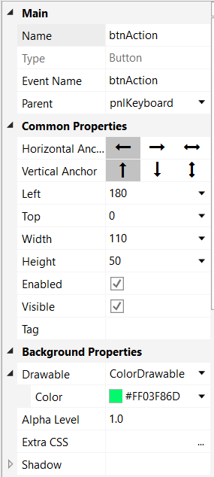

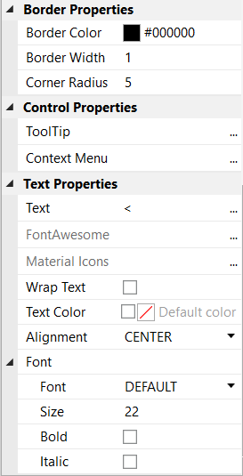 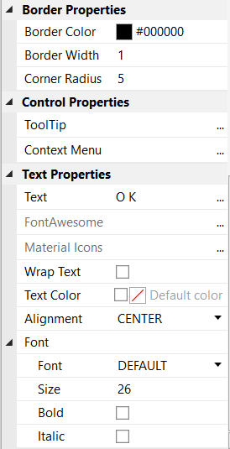

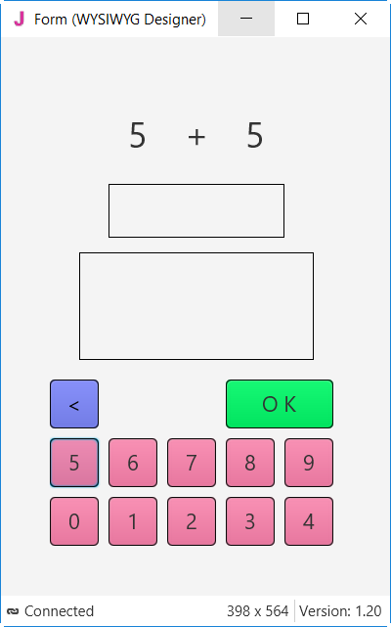

The finished new layout in the WYSIWYG form.

You could have followed all the evolutions of the layout in the WYSIWYG form.

Now we will update the code.

First, we must replace the txfResult by lblResult because we replaced the TextField node by a Label.

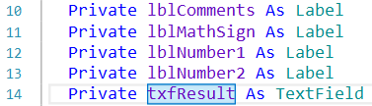

Double click on txfResult to select it.

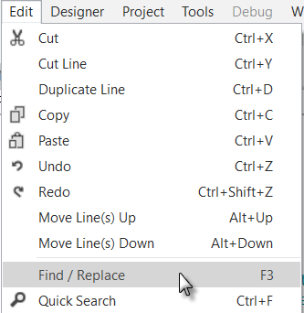

Click on .

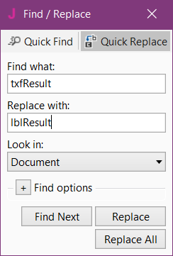

The Find / Replace window is displayed.

Click on  and close the window.

We also need to change its node type form TextField to Label.

Private lblResult As Label

Now we write the routine that handles the Click events of the Buttons.

The Event Name for all buttons, except btnAction, is "btnEvent".

The routine name for the associated click event will be btnEvent_Click.

Enter the following code:

Private Sub **btnEvent_MouseClicked**

End Sub

We need to know what button raised the event. For this, we use the Sender object which is a special object that holds the object reference of the node that generated the event in the event routine.

Private Sub **btnEvent_MouseClicked** To have access to the properties of the node that raised the

Private btnSender As Button event we declare a local variable

Private btnSender As Button.

btnSender = Sender and set btnSender = Sender.

Select btnSender.Tag Then, to differentiate between the backspace button and

Case "BS" the numeric buttons we use a Select / Case / End Select

Case Else structure and use the Tag property of the buttons.

End Select Remember, when we added the different buttons we

End Sub set their Tag property to BS, 0, 1, 2 etc.

Select btnSender.Tag Select sets the variable to test.

Case "BS" Checks if it is the button with the "BS" tag value.

Case Else Handles all the other buttons.

Now we add the code for the numeric buttons.

We want to add the value of the button to the text in the lblResult Label.

Select btnSender.Tag

Case "BS"

Case Else

lblResult.Text = lblResult.Text & btnSender.Text

End Select

End Sub

This is done in this line

lblResult.Text = lblResult.Text & btnSender.Text

The "&" character means concatenation, so we just append to the already existing text the value of the Text property of the button that raised the event.

Now we add the code for the BackSpace button.

Select btnSender.Tag

Case "BS"

If lblResult.Text.Length > 0 Then

lblResult.Text = lblResult.Text.SubString2(0, lblResult.Text.Length - 1)

End If

Case Else

lblResult.Text = lblResult.Text & btnSender.Text

End Select

End Sub

When clicking on the BS button we must remove the last character from the existing text in lblResult. However, this is only valid if the length of the text is bigger than 0. This is checked with:

If lblResult.Text.Length > 0 Then

To remove the last character, we use the SubString2 function.

lblResult.Text = lblResult.Text.SubString2(0, lblResult.Text.Length - 1)

SubString2(BeginIndex, EndIndex) extracts a new string beginning at BeginIndex (inclusive) until EndIndex (exclusive).

Now the whole routine is finished.

Private Sub **btnEvent_MouseClicked** (EventData As MouseEvent)

Private btnSender As Button

btnSender = Sender

Select btnSender.Tag

Case "BS"

If lblResult.Text.Length >0 Then

lblResult.Text = lblResult.Text.SubString2(0,lblResult.Text.Length - 1)

End If

Case Else

lblResult.Text = lblResult.Text & btnSender.Text

End Select

End Sub

In Sub btnAction_MouseClicked we add, at the end, lblResult.Text = "" to clear the text.

Else

New

btnAction.Text = "O K"

lblResult.Text = ""

End If

End Sub

We can try to improve the user interface of the program by adding some colors

to the lblComments Label.

Let us set:

- Yellow for a new problem

- Light Green for a GOOD answer

- Light Red for a WRONG answer.

We first modify the New routine, where we add this line

CSSUtils.SetBackgroundColor(lblComments, fx.Colors.RGB(255,235,128))

We need to use the CSSUtils library for that! See next page how to add a library.

Private Sub **New**

Number1 = Rnd(1, 10) ' Generates a random number between 1 and 9

Number2 = Rnd(1, 10) ' Generates a random number between 1 and 9

lblNumber1.Text = Number1 ' Displays Number1 in label lblNumber1

lblNumber2.Text = Number2 ' Displays Number2 in label lblNumber2

lblComments.Text = "Enter the result" & CRLF & "and click on OK"

CSSUtils.SetBackgroundColor(lblComments, fx.Colors.RGB(255,235,128)) ' yellow color

lblResult.Text = "" ' Sets lblResult.Text to empty

End Sub

And in the CheckResult routine we add the two lines with CSSUtils.SetBackgroundColor...

Private Sub **CheckResult**

If lblResult.Text = Number1 + Number2 Then

CSSUtils.SetBackgroundColor(lblComments, fx.Colors.RGB(128,255,128)) ' light green color

lblComments.Text = "G O O D result" & CRLF & "Click on NEW"

lblComments.Style = "-fx-background-color: palgreen;" ' palegreen color

btnAction.Text = "N E W"

Else

CSSUtils.SetBackgroundColor(lblComments, fx.Colors.RGB(255,128,128)) ' light red color

lblComments.Text = "W R O N G result" & CRLF & "Enter a new result" & CRLF & "and click OK"

End If

End Sub

And we give the program a more meaningful title by adding MainForm.Title = "Calc Trainer" in AppStart just after MainForm.Show.

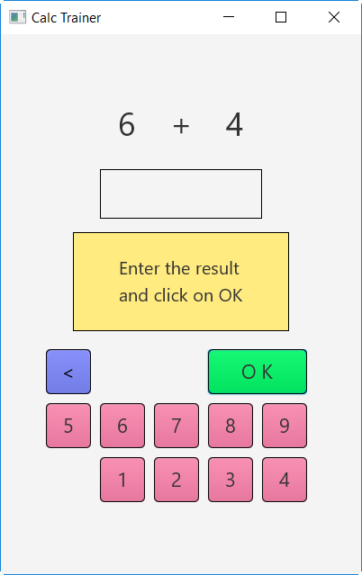 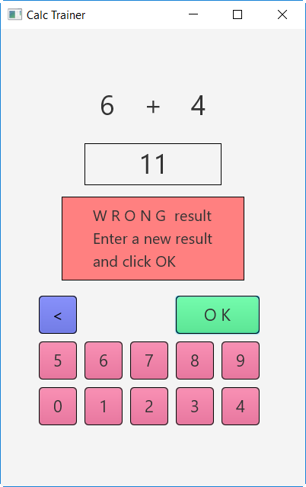 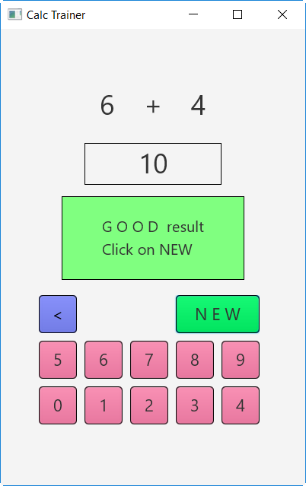

Add the CSSUtils library to the project.

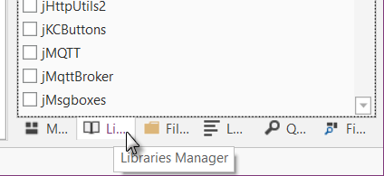

In the lower right corner click on the Libraries Manager Tab.

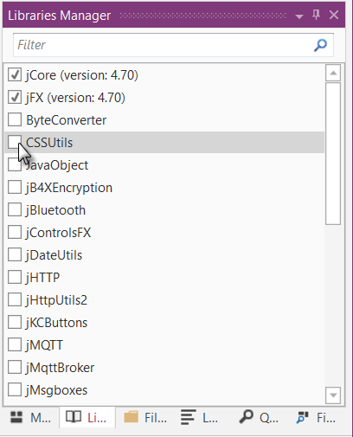

In the libraries list check CSSUtils.

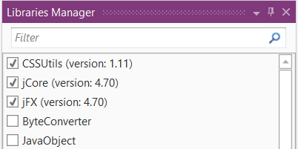

And the result.

The CSSUtils library is added to the project.

The libraries are ordered by alphabetic order.

The use of libraries is detailed in chapter 3.8 Libraries in the B4x Basic Language booklet.

Another improvement would be to hide the '0' button to avoid entering a leading '0'.

For this, we hide the button in the New subroutine with line btn0.Visible = False.

Private Sub **New**

Number1 = Rnd(1, 10) ' Generates a random number between 1 and 9

Number2 = Rnd(1, 10) ' Generates a random number between 1 and 9

lblNumber1.Text = Number1 ' Displays Number1 in label lblNumber1

lblNumber2.Text = Number2 ' Displays Number2 in label lblNumber2

lblComments.Text = "Enter the result" & CRLF & "and click on OK"

lblComments.Color = Colors.RGB(255,235,128) ' yellow color

lblResult.Text = "" ' Sets lblResult.Text to empty

btn0.Visible = False

End Sub

We see that btn0 is in red, this means that this object is not recognized by the IDE.

btn0.Visible = False

So we must declare it, by adding btn0 into line 9:

Private btnAction, btn0 As Button

Now btn0 is no more in red.

btn0.Visible = False

In addition, in the btnEvent_MouseClicked subroutine, we hide the button if the length of the text in lblResult is equal to zero and show it if the length is greater than zero.

Private Sub **btnEvent_MouseClicked** (EventData As MouseEvent)

Dim btnSender As Button

btnSender = Sender

Select btnSender.Tag

Case "BS"

If lblResult.Text.Length > 0 Then

lblResult.Text = lblResult.Text.SubString2(0,lblResult.Text.Length - 1)

End If

Case Else

lblResult.Text = lblResult.Text & Send.Tag

End Select

If lblResult.Text.Length = 0 Then

btn0.Visible = False

Else

btn0.Visible = True

End If

End Sub

# Getting started B4R

**B4R - The simplest way to develop native, powerful Arduino programs.**

B4R follows the same concepts of the other B4X tools (B4A, B4i, B4J), providing a simple and powerful development tool.

Compiled apps run on Arduino compatible boards.

## Installing Arduino IDE

B4R needs the installation of Arduino IDE version 1.6.7+.

Download Arduino IDE from this link: <https://www.arduino.cc/en/Main/Software> and install it.

You should not install Arduino 1.6.12 because there is a bug.

You should not install Arduino from this site: http://www.arduino.org/downloads

It wont work.

## Install Microsoft .Net Framework

On most computers Microsoft .Net Framework is already preinstalled.

If it is not the case, you must install either:

* [.Net Framework 4.5.2](https://www.microsoft.com/en-us/download/details.aspx?id=42642) for Windows Vista +
* [.Net Framework 4.0](https://www.microsoft.com/en-us/download/details.aspx?id=17851) for Windows XP

## Install and configure B4R

- Download and install B4R.

- Open B4R.  
- Choose Tools menu - Configure Paths.

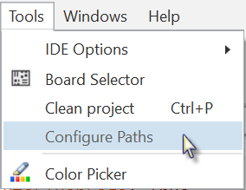

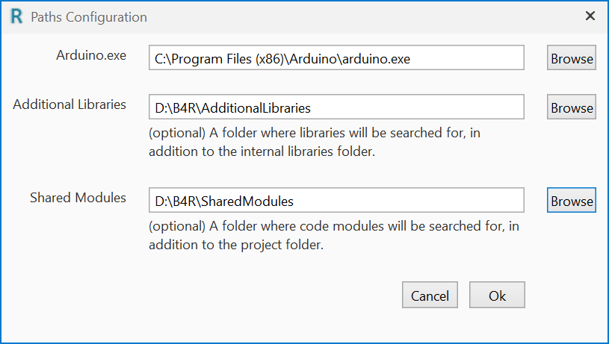

Use the 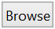 button to locate "arduino.exe". The path will depend on where you installed the Arduino IDE.

It is recommended to create a specific folder for Additional Libraries.

B4R utilizes two types of libraries:

* Standard libraries, which come with B4R and are located in the  
  Libraries folder of B4R.   
  These libraries are automatically updated when you install a new version of B4R.
* Additional libraries, which are not part of B4R, should be saved in a specific folder different from the standard libraries folder.  
  More details in chapter Additional libraries in the B4x Basic Language booklet.

You may also define a special folder for Shared Modules.

A same Code Module can be shared between different projects without the need to load it in the project folder.

## Connecting a board

When you connect a board to the PC with the USB cable Windows will load the driver and display the Serial port used.

## Select a Board

Run B4R.

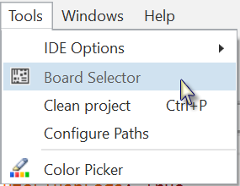

Click on Board Selector.

The window below will be displayed.

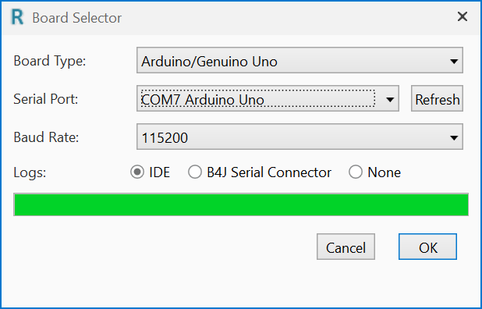

Select the Board Type in the drop down list.

Select the Serial Port and select the Baud Rate.

If only one board is connected it will automatically be recognized.

You will see only boards which are connected.

Depending on the board type several other properties can be set.

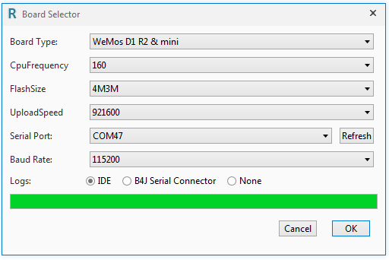

## Arduino UNO board

In this chapter I will explain some basic functions of the Arduino UNO board which may be useful for beginners.

The Arduino UNO board is the basic board of the Arduino family.

There exist other more advanced boards.

* Arduino DUE
* Arduino MEGA
* Arduino MICRO
* etc. see [Compare board specs](https://www.arduino.cc/en/Products/Compare).

Additional boards called ‘Shields’ can be clipped onto the Arduino boards.

* Arduino Wi-Fi Shield 101
* Arduino Ethernet Shield
* etc.

**The Arduino UNO**:

The source of the information in this chapter is a summary from the [Arduino site](https://www.arduino.cc/en/Main/ArduinoBoardUno).

Digital Input / Output pins

On board

LED 13

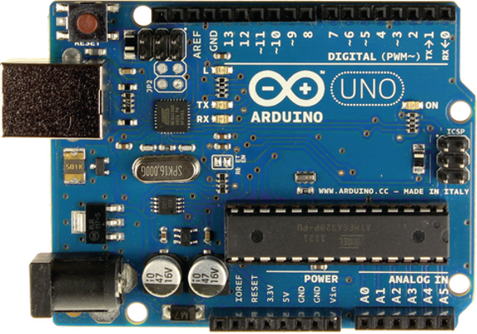

LED Serial

TX / RX

USB plug

LED

Power ON

DC Power plug

Power pins

Analog Input pins

### Power supply

The board can be supplied with power either from the DC power jack (7 - 12V), the USB connector (5V), or the VIN pin of the board (7-12V).

**Supplying voltage via the 5V or 3.3V pins bypasses the regulator, and can damage your board (see the pins below). We don't advise it**.

### Pins

The Arduino UNO has 3 pin sockets:

* Power pins.
* Digital Input / Output pins.
* Analog Input pins.

### Power pins

The Power pins are:

* **GND** Power ground, 2 pins.
* **VIN** Power supply input.The input voltage to the Uno board when it's using an external power source (as opposed to 5 volts from the USB connection or other regulated power source). You can supply voltage through this pin, or, if supplying voltage via the power jack, access it through this pin.  
  Voltage 7 – 12 V.
* **5V** 5 Volt reference voltage. **Don’t provide the power to this pin!**  
  This pin outputs a regulated 5V from the regulator on the board.
* **3.3V** 3.3 Volt reference voltage. **Don’t provide the power to this pin!**  
  A 3.3 volt supply generated by the on-board regulator. Maximum current draw is 50 mA.
* **RESET**  
  Bring this line LOW to reset the microcontroller. Typically used to add a reset button to shields which block the one on the board.
* **IOREF**   
  This pin on the Uno board provides the voltage reference with which the microcontroller operates. A properly configured shield can read the IOREF pin voltage and select the appropriate power source or enable voltage translators on the outputs to work with the 5V or 3.3V.

#### Digital Input / Output pins

Each of the 14 digital pins on the Uno can be used as an input or output, using the *pinMode* method, *DigitalRead* and *DigitalWrite* functions. They operate at 5 volts. Each pin can provide or receive 20 mA as recommended operating condition and has an internal pull-up resistor (disconnected by default) of 20-50 kohm. A maximum of 40mA is the value that must not be exceeded on any I/O pin to avoid permanent damage to the microcontroller.

In addition, some pins have specialized functions:

* Serial: 0 (RX) and 1 (TX). Used to receive (RX) and transmit (TX) TTL serial data. These pins are connected to the corresponding pins of the ATmega8U2 USB-to-TTL Serial chip.
* PWM: ~3, ~5, ~6, ~9, ~10, and ~11. These numbers have this “~” prefix.  
  They can provide 8-bit PWM (**P**ulse **W**idth **M**odulation) outputs with the *AnalogWrite* function allowing to modulate the brightness of a LED (**L**ight **E**mitting **D**iode) or run   
  DC motors at different speeds.  
  A value of 0 means always OFF and 255 means always ON.  
  Usage:  
  pinTest3.AnalogWrite(Value As UInt)  
  pinTest3.AnalogWrite(196)  
  After *AnalogWrite* the pin will generate a steady square wave of the specified duty cycle until the next call to ***AnalogWrite*** (or a call to ***DigitalRead*** or ***DigitalWrite*** on the same pin). The frequency of the PWM signal on most pins is approximately 490 Hz. On the Uno and similar boards, pins 5 and 6 have a frequency of approximately 980 Hz. Pins 3 and 11 on the Leonardo also run at 980 Hz.
* LED 13: There is a built-in LED driven by digital pin 13. When the pin is HIGH value, the LED is on, when the pin is LOW, it's off.

#### Analog input pins

The Arduino UNO has 6 Analog input pins A0 to A5 with 10 bit analog to digital converters (0 to 1023 resolution).

The reference voltage is 5 Volt allowing a resolution of 4.9 mV per unit.

While the main function of the analog pins for most Arduino users is to read analog sensors, the analog pins also have all the functionality of general purpose input/output (GPIO) pins (the same as digital pins 0 - 13).

### Input modes INPUT / INPUT_PULLUP

If you have your pin configured as an INPUT, and are reading a switch, when the switch is in the open state the input pin will be "floating", resulting in unpredictable results. In order to assure a proper reading when the switch is open, a [pull-up or pull-down resistor](https://en.wikipedia.org/wiki/Pull-up_resistor) must be used. The purpose of this resistor is to pull the pin to a known state when the switch is open. A 10 K ohm resistor is usually chosen, as it is a low enough value to reliably prevent a floating input, and at the same time a high enough value to not draw too much current when the switch is closed.

The INPUT_PULLUP mode adds an internal pull up resistor no need to add one externally.

With a pull up resistor the pin returns False when the switch is closed because it sets the input to 0 Volt.

### Basic Pin functions

#### Initialize

Initializes a pin.

**Pin.Initialize**(Pin As Byte, Mode As Byte)

**Pin** is the pin number.

* 0, 1, 2, 3 etc. for digital pins
* Pin.A0, Pin.A1 , Pin.A2 etc. for analog pins.

**Mode** is one of the three connection modes:

* MODE_INPUT
* MODE_INPUT_PULLUP adds an internal pull up resistor.
* MODE_OUTPUT

Example1: Initialize digital pin 3 as input.

Private pinTest1 As Pin

pinTest1.Initialize(3, pinTest1.MODE_INPUT)

Example2: Initialize digital pin 3 as input with pull up resistor.

Private pinTest2 As Pin

pinTest2.Initialize(3, pinTest2.MODE_INPUT_PULLUP)

Example3: Initialize digital pin 3 as output.

Private pinTest3 As Pin

pinTest3.Initialize(3, pinTest3.MODE_OUTPUT)

Example4: Initialize analog pin 4 as input.

Private pinTest4 As Pin

pinTest4.Initialize(pinTest4.A4, pinTest4.MODE_INPUT)

The analog pins, on the Arduino UNO, can also be accessed with numbers, like:

pinTest4.Initialize(18, pinTest4.MODE_INPUT)

Pin.A0 = 14

Pin.A1 = 15

Pin.A2 = 16

Pin.A3 = 17

Pin.A4 = 18

Pin.A5 = 19

Initializing an analog pin as output works like a digital output pin.

#### DigitalRead

Reads the current digital value of a pin.

The return value is True or False.

**Pin.DigitalRead** returns a Boolean.

There are two input modes depending on the input signal.

* Pin.MODE_INPUT
* Pin. MODE_INPUT_PULLUP adds an internal pullup resistor for use with a switch.

Example:

Private pinTest1 As Pin

pinTest1.Initialize(3, pinTest.MODE_INPUT)

Private Value As Boolean

Value = pinTest1.DigitalRead

The Arduino uses internally 0 and 1 for a boolean variable.

Log("State: ", Value)

Will write either 0 for False or 1 for True in the Logs. In the code you can use False and True.

#### DigitalWrite

Writes a Boolean value to the given pin.

It can be used for all digital pins and also all analog pins.

**Pin.DigitalWrite** (Value As Boolean)

Example:

Private pinTest3 As Pin

pinTest3.Initialize(3, pinTest3.MODE_OUTPUT)

pinTest3.DigitalWrite(True) directly with the value.

pinTest3.DigitalWrite(Value) with a variable.

#### AnalogRead

AnalogRead reads the current value of an analog pin.

The return value is an UInt with values between 0 and 1023 (10 bits).

The reference voltage is 5V.

Example:

Private pinPot As Pin

pinPot.Initialize(pinPot.A4, pinPot.MODE_INPUT)

Private Value As UInt

Value = pinPot.AnalogRead

#### AnalogWrite

AnalogWrite writes a Byte value to the given pin.

AnalogWrite has nothing to do with the analog pins nor with AnalogRead.

AnalogWrite can only be used on the digital pins ~3, ~5, ~6, ~9, ~10, and ~11 on the Arduino UNO, the pins with the ~ prefix.

**Pin.AnalogWrite** (Value As UInt)

Example: we use digital pin ~3 which allows PWM.

Private pinTest3 As Pin

pinTest3.Initialize(3, pinTest3.MODE_OUTPUT)

pinTest3.AnalogWrite(145) directly with the value.

pinTest3.AnalogWrite(Value) with a variable, Value must be a UInt variable.

## First example programs

All the projects were realized with the [Arduino Starter Kit](https://www.arduino.cc/en/Main/ArduinoStarterKit).

The diagrams for the projects were realized with the [Fritzing](http://fritzing.org/home/) software.

When we run the IDE we get the default code like below.

The #Region Project Attributes is normally collapsed; these attributes are explained below.

#Region Project Attributes

#AutoFlushLogs: True

#CheckArrayBounds: True

#StackBufferSize: 300

#End Region

Sub **Process_Globals**

'These global variables will be declared once when the application starts.

'Public variables can be accessed from all modules.

Public Serial1 As Serial

End Sub

Private Sub **AppStart**

Serial1.Initialize(115200)

Log("AppStart")

End Sub

#AutoFlushLogs: AutoFlushLogs: True assures that the Logs are sent without problems.

AutoFlushLogs: False can lead to program crashes.

#CheckArrayBounds: Checks the array bounds or not.

#StackBufferSize: Sets the default Stack buffer size.

Public Serial1 As Serial Defines the serial interface with the computer.

Serial1.Initialize(115200) Initializes the serial port with a Baud rate of 115200 Hertz.

Log("AppStart") Shows AppStart in the Logs Tab when the program starts.

The Logs are explained in chapter *Logs* in the B4x IDE booklet.

### Button.b4r

Let us write our first program.

It’s similar to Erels Button example from the forum. It uses a pushbutton switch and the Led 13 on the Arduino UNO board.

The project Button.b4r is available in the SourceCode folder.

* Open B4R.
* Save the project as Button in a folder with the name Button.
* Build the board with the pushbutton and the wires.
* Connect the Arduino to the PC.
* Write the code.
* Run the program.

#### Sketch

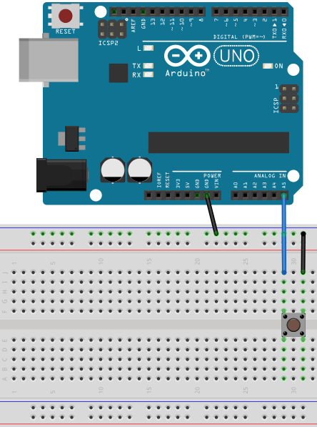

Material:

* 1 pushbutton switch

Connect one Arduino **GND** (ground) pin to the ground **GND** line of the breadboard.

Then connect one pin of the pushbutton switch to the ground line.

And connect the other pin of the pushbutton to pin **A5** of the Arduino analog pins.

We could have connected the first pin of the pushbutton directly to the **GDN** pin of the Arduino, but the connection in the image is ready for the next examples.

We could also have used one of the digital pins instead of the analog pin.

#### Code

Sub **Process_Globals**

Public Serial1 As Serial

Private pinButton As Pin 'pin for the button

Private pinLED13 As Pin 'pin for LED 13 on the Arduino

End Sub

We declare the pins for the pushbutton and the on board Led 13.

Private Sub **AppStart**

Serial1.Initialize(115200)

Log("AppStart")

pinButton.Initialize(pinButton.A5, pinButton.MODE_INPUT_PULLUP)   
'Using the internal pull up resistor to prevent the pin from floating.

pinButton.AddListener("pinButton_StateChanged")

pinLED13.Initialize(13, pinLED13.MODE_OUTPUT)

End Sub

We initialize pinButton, as the analog pin **A5**, with pinButton.A5 and set the input mode to pinButton.MODE_INPUT_PULLUP. We need a pullup resistor to prevent the pin from floating,

MODE_INPUT_PULLUP connects an internal pull up resistor.

We add pinButton.AddListener("pinButton_StateChanged"), to generate a StateChanged event when the state of pin pinButton changes which means that the pushbutton is pressed or released.

We initialize pinLED13, as the onboard Led as digital pin 13 and set the output mode to pinLED13.MODE_OUTPUT.

Sub **pinButton_StateChanged** (State As Boolean)

Log("State: ", State)

'state will be False when the button is clicked because of the PULLUP mode.

pinLED13.DigitalWrite(Not(State))

End Sub

We add a Log, Log("State: ", State), to display the state in the Logs.

We write the State to the digital output of the on board led, pinLED13.DigitalWrite(Not(State)).

We write Not(State) because State will be False when the pushbutton is pressed because of the PULLUP mode.

Click on  or press F5 to run the code.

When you press the pushbutton, led 13 on the Arduino UNO will be ON and when you release the pushbutton led 13 will be OFF.

### LedGreen.b4r

For this project we use a copy of the Button project.

Create a new LedGreen folder, copy the files of the Button project and rename the Button.xxx files to LedGreen.xxx.

We add a green Led which can be switched on and off with the button from the first example.

The project LedGreen.b4r is available in the SourceCode folder.

#### Sketch

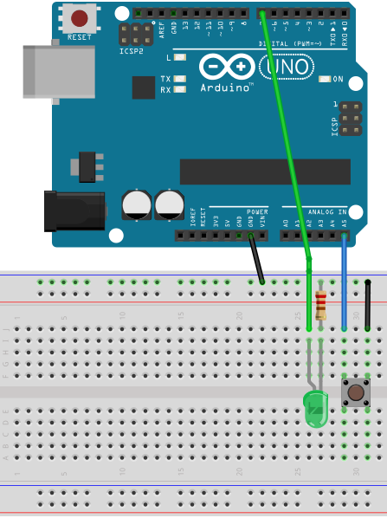

Material:

* 1 pushbutton switch
* 1 green LED
* 1 220 Ω resistor

We keep the mounting of the pushbutton switch from the first example.

One pin on the **GND** line of the breadboard.

The other pin to **A5** of the Arduino analog pins.

And we

- Add a green Led on the breadboard.

- Connect the cathode (-) via a 220 Ω resistor to the

ground **GND** line of the breadboard.

- Connect the anode (+) to digital pin **7**.

#### Code

Sub **Process_Globals**

Public Serial1 As Serial

Private pinButton As Pin 'pin for the button

Private pinLEDGreen As Pin 'pin for the green Led

Private LightOn = False As Boolean

End Sub

We keep the definition of pinButton.

We change the definition

Private pinLED13 As Pin

to

Private pinLEDGreen As Pin

for the green Led

We add a global boolean variable LightOn which is True when the light is ON.

Private Sub **AppStart**

Serial1.Initialize(115200)

pinButton.Initialize(pinButton.A5, pinButton.MODE_INPUT_PULLUP)

'Using the internal pull up resistor to prevent the pin from floating.

pinButton.AddListener("pinButton_StateChanged")

pinLEDGreen.Initialize(7, pinLEDGreen.MODE_OUTPUT)

End Sub

We leave the code for pinButton.

We initialize pinLEDGreen as digital pin **7** and set the output mode to pinLEDGreen.MODE_OUTPUT.

Private Sub **pinButton_StateChanged** (State As Boolean)

If State = False Then 'remember, False means button pressed.

LightOn = Not(LightOn)

pinLEDGreen.DigitalWrite(LightOn)

End If

End Sub

Every time State is False, pushbutton pressed, we change the variable LightOn and write it to pinLEDGreen.

### LedGreenNoSwitchBounce.b4r

For this proejct we use exactly the same circuit as LedGreen.b4r.

The only difference is in the code.

The project LedGreenNoSwitchBounce.b4r is available in the SourceCode folder.

The pushbutton switch we use in our projects has a problem called bouncing.

The signal of a mecanical switch is not clean, the switch has several bounces which are interpreted by the the digital inputs as several state changes. If we have an even number of state changes it is similar to having done nothing.

But we want only one state change per button press.

Image of switch bouncing ([source Wikipedia](https://en.wikipedia.org/wiki/Switch)):

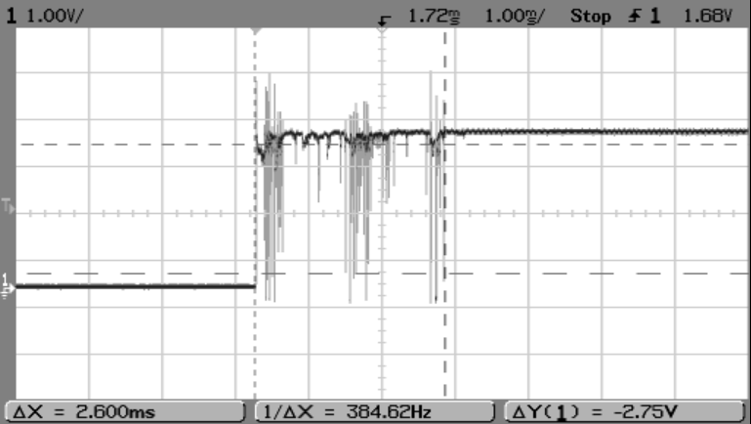

The switch bounces between on and off several times before settling.

To solve this problem we don’t react in the pinButton_StateChanged routine on state changes within a given time.

#### Sketch



Material:

* 1 pushbutton switch
* 1 green LED
* 1 220 Ω resistor

We keep the mounting of the pushbutton switch from the first example.

One pin on the **GND** line of the breadboard.

The other pin to digital pin **7** on the Arduino.

And we

- Add a green Led on the breadboard.

- Connect the cathode (-) via a 220 Ω resistor to the

ground **GND** line of the breadboard.

- Connect the anode (+) to digital pin **7**.

#### Code

The code is almost the same as LedGreen.b4r.

Sub **Process_Globals**

Public Serial1 As Serial

Private pinButton As Pin 'pin for the button

Private pinLEDGreen As Pin 'pin for the green Led

Private LightOn = False As Boolean

Private BounceTime As ULong

Private BounceDelay = 10 As ULong

End Sub

We add two new variables: BounceTime and BounceDelay.

Private Sub **AppStart**

Serial1.Initialize(115200)

'Using the internal pull up resistor to prevent the pin from floating.

pinButton.Initialize(pinButton.A5, pinButton.MODE_INPUT_PULLUP)

pinButton.AddListener("pinButton_StateChanged")

pinLEDGreen.Initialize(7, pinLEDGreen.MODE_OUTPUT)

End Sub

Same as LedGreen.b4r

New pinButton_StateChanged routine:

Private Sub **pinButton_StateChanged** (State As Boolean)

If State = False Then 'remember, False means button pressed.

If Millis - BounceTime < BounceDelay Then

Return 'Return, bouncing

Else

LightOn = Not(LightOn)

pinLEDGreen.DigitalWrite(LightOn)

BounceTime = Millis 'reset BounceTime to current time

End If

End If

End Sub

Every time State is False, pushbutton pressed:

* We check if the time between the current state change and the first state change.  
  If the time is shorter than BounceDelay, which means a bounce, we do nothing.  
  If the time is longer than BounceDelay, which means a real state change, we execute the code.
* We change the variable LightOn and write it to pinLEDGreen.
* Set the new BounceTime.

### TraficLight.b4r

This project is an evolution of the LedGreen project and simulates traffic lights.

We use a copy of the LedGreen project.

Create a new TrafficLight folder, copy the files of the LedGreen project and rename the *LedGreen.xxx* files to *TrafficLight.xxx*.

The lights can be switched on and off with the pushbutton switch from the previous examples.

The timing for the change from red to green and green to red is managed

with a Timer TimerGreenRed and the duration of the yellow light is managed

with a second Timer TimerYellow.

The project TrafficLight.b4r is available in the SourceCode folder.

#### Sketch

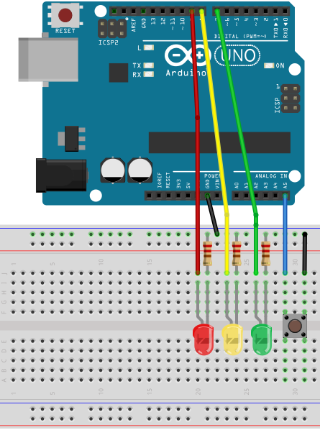

Material:

* 1 pushbutton switch
* 1 green Led
* 1 yellow Led
* 1 red led
* 3 220 Ω resistors

We

- add a yellow and a red Led similar to the green one.

- connect the yellow led (+) to digital pin **8.**

- connect the red led (+) to digital pin **9**.

#### Code

Sub **Process_Globals**

Public Serial1 As Serial

Private pinButton As Pin 'pin for the button

Private pinLEDGreen, pinLEDYellow, pinLEDRed As Pin 'pins for the Leds

Private TimerGreenRed, TimerYellow As Timer

Private LightOn = False As Boolean

Private LightGreen = False As Boolean

Private BounceTime As ULong

Private BounceDelay = 10 As ULong

End Sub

We declare the button and the three led Pins, the two Timers and two global

variables LightOn and LightGreen.

LightOn = False > light OFF

LightGreen = True > green light ON

Private Sub **AppStart**

Serial1.Initialize(115200)

TimerGreenRed.Initialize("TimerGreenRed_Tick", 2000)

'Using the internal pull up resistor to prevent the pin from floating.

pinButton.Initialize(pinButton.A5, pinButton.MODE_INPUT_PULLUP)

pinButton.AddListener("pinButton_StateChanged")

pinLEDGreen.Initialize(7, pinLEDGreen.MODE_OUTPUT)

pinLEDYellow.Initialize(8, pinLEDYellow.MODE_OUTPUT)

pinLEDRed.Initialize(9, pinLEDRed.MODE_OUTPUT)

End Sub

We initialize TimerGreenRed with the Tick event ("TimerGreenRed_Tick" and an interval of 2000 which means that the Tick event is raised every 2 seconds (2000 milli seconds).

We initialize TimerYellow with the Tick event ("TimerYellow_Tick" and an interval of 500 which means that the Tick event is raised every 0.5 second (500 milli seconds).

We keep the code for the button and the green Led, initialize pinLEDYellow as digital pin **8** as output and initialize pinLEDRed as digital pin **9** as output.

The code is hopefully self-explanatory.

Private Sub **pinButton_StateChanged** (State As Boolean)

' Log("State: ", State) 'Log the State value

If State = False Then 'if State = False

If Millis - BounceTime < BounceDelay Then

Return

Else

pinLEDRed.DigitalWrite(True) 'switch ON the red LED

LightOn = Not(LightOn) 'change the value of LightOn

BounceTime = Millis

' Log("Light: ", LightOn) 'Log the LightOn value

TimerGreenRed.Enabled = LightOn 'enable TimerGreenRed Timer

If LightOn = False Then 'if LightOn = False

pinLEDGreen.DigitalWrite(False) 'switch OFF LED Green

pinLEDYellow.DigitalWrite(False) 'switch OFF LED Yellow

pinLEDRed.DigitalWrite(False) 'switch OFF LED Red

End If

End If

End If

End Sub

Private Sub **TimerGreenRed_Tick**

If LightGreen = True Then 'if LightGreen = True

' Log("TimerGreenRed_Tick LightYellow") 'write the Log

CallSubPlus("EndYellow", 500, 0)

pinLEDGreen.DigitalWrite(False) 'switch OFF LED Green

pinLEDYellow.DigitalWrite(True) 'switch ON LED Yellow

LightGreen = False 'set LightGreen to False

Else

Log("TimerGreenRed_Tick LightGreen") 'write the Log

pinLEDRed.DigitalWrite(False) 'switch OFF LED Red

pinLEDGreen.DigitalWrite(True) 'switch ON LED Green

LightGreen = True 'set LightGreen to True

End If

End Sub

Private Sub **EndYellow**(Tag As Byte)

' Log("TimerYellow_Tick LightRed") 'write the Log

' Log(" ")

pinLEDYellow.DigitalWrite(False) 'switch OFF LED Yellow

pinLEDRed.DigitalWrite(True) 'switch ON LED Red

End Sub

We use the EndYellowNous routine to switch from the yellow light to the red light.

This routine is called with the CallSubPlus keyword which allows to call a routine with a given delay.

CallSubPlus("EndYellow", 500, 0)

EndYellow = Name of the routine

500 = Delay, 0.5 seconde (500 milliseconds)

0 = Tag, not used in our case.

We can switch ON or OFF the traffic lights with the pushbutton switch.

# Help tools

To find answers to many questions about B4x the following tools are very useful.

## Search function in the forum

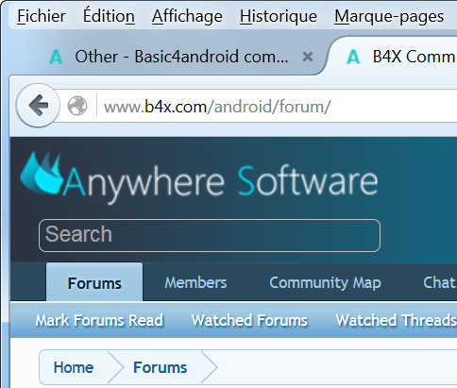

In the upper left corner you find the searchbox for the forum. Depending on the window size it can be on the top right side.

Enter a question or any keywords and press 'Return'.

The function shows you the posts that match your request.

Example: Enter the keyword ScrollView : 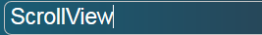

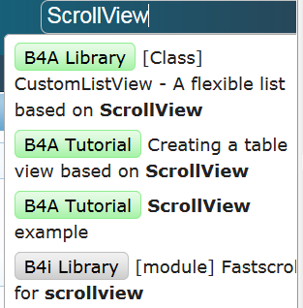

A list of the result is displayed below the search box.

Click on an item to show the thread.

And the result:

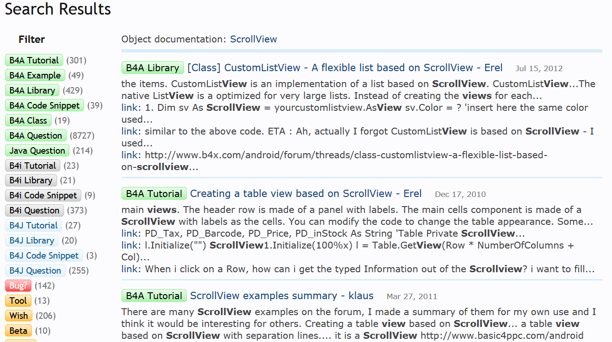

On the left you have a list of forums which you can filter.

Click on the title to show the selected post.

## B4x Help Viewer

This program shows xml help files. It was originally written by Andrew Graham (agrham) for B4A. I modified it, with Andrews’ agreement, to show B4A, B4J, B4i and B4R xml help files.

The program can be [downloaded](http://www.basic4ppc.com/android/forum/threads/b4i-help-viewer.46969/) from the forum.

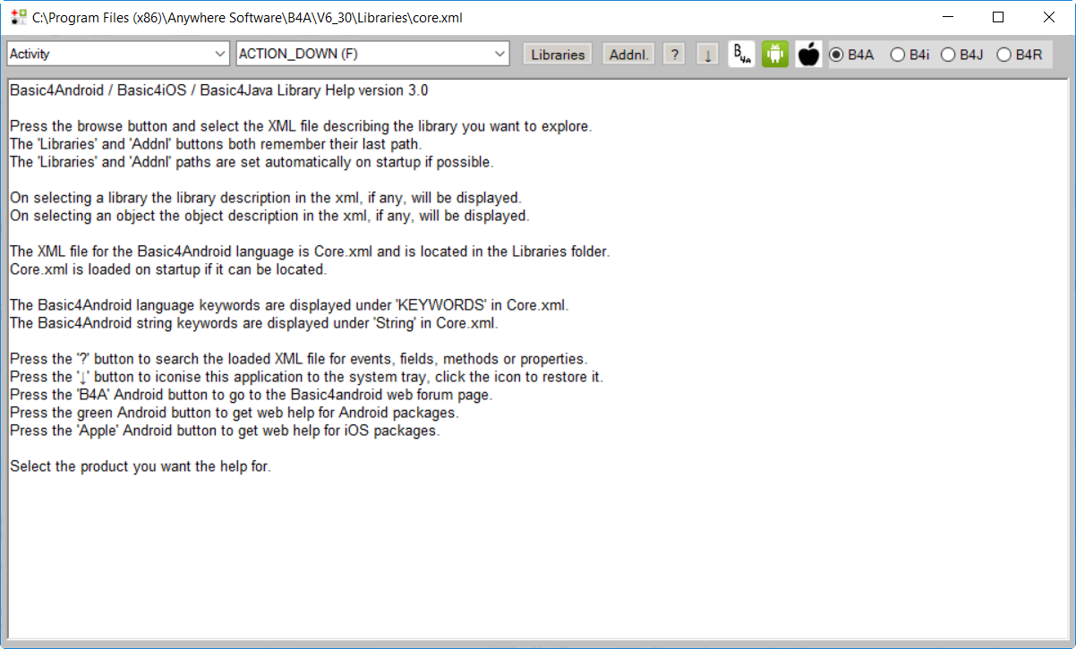

On top we find:



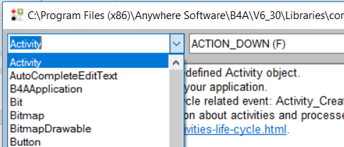

In the upper left corner a drop down list shows the different objects included in the selected library.

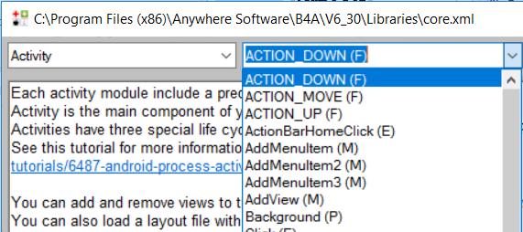

Besides the objects list you find another drop down list with the

* methods(M)
* events(E)
* properties(P)
* fields(F) constants

for the selected object.

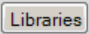 Select the standard library to display.

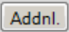 Select the additional library to display.

 Search engine to find the object for a given keyword.

 Closes B4AHelp

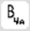 Launches the forum 'Online Community'.

 Launches the Android Developers site.

 Launches the iOS developer’s site.

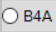 B4A help files.

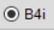 B4i help files.

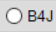 B4J help files.

 B4R help files.

 Standard libraries

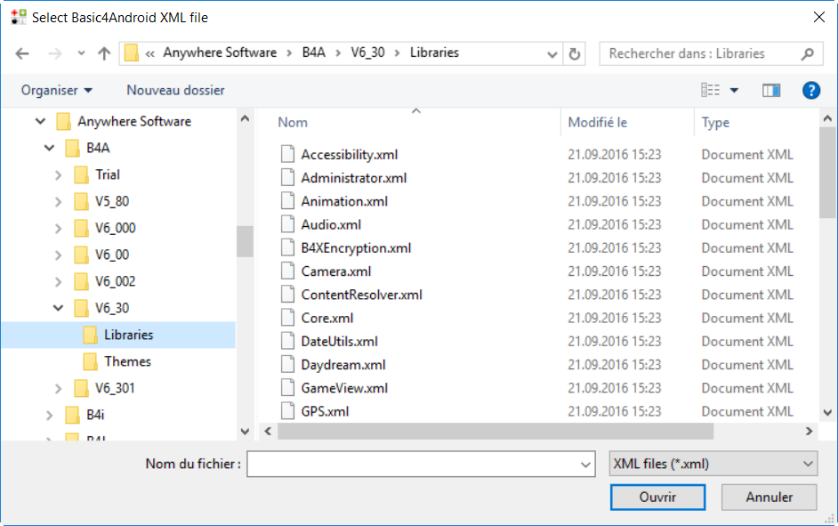

Select the library to display and click on 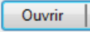 (Open).

Here  you can select the directory where the standard libraries are saved.

Once selected the directory is saved for the next start of the program.

 Additional libraries.

The same also for the additional libraries.

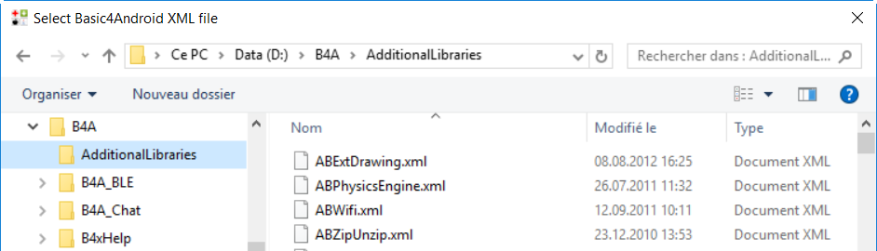

Here  you can select the directory for the additional libraries.

 Search engine for the selected library.

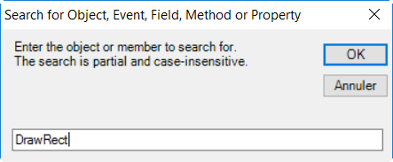

Example:

Selected library: Core

Enter *DrawRect*

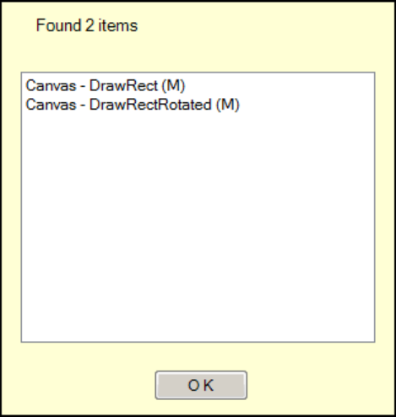

And the result.

We get the object Canvas and two methods.

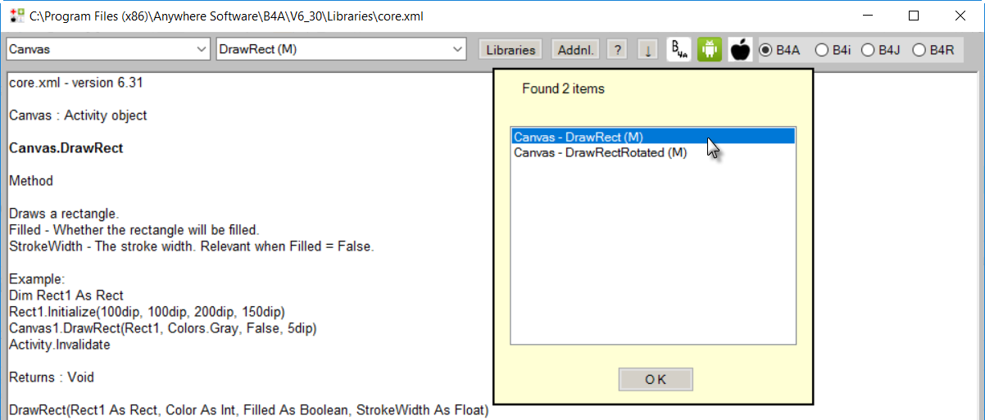

Click on an item in the list to show its help.

Click on 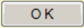 to leave the search result list.

## Help documentation - B4A Object Browser

This is also a standalone Windows program showing the help files of libraries.

It has been written by Vader and can be downloaded [here](http://www.basic4ppc.com/forum/basic4android-getting-started-tutorials/25682-help-documentation-docloader-16.html#post148746).

A pdf documentation on how to use the program is part of the download.

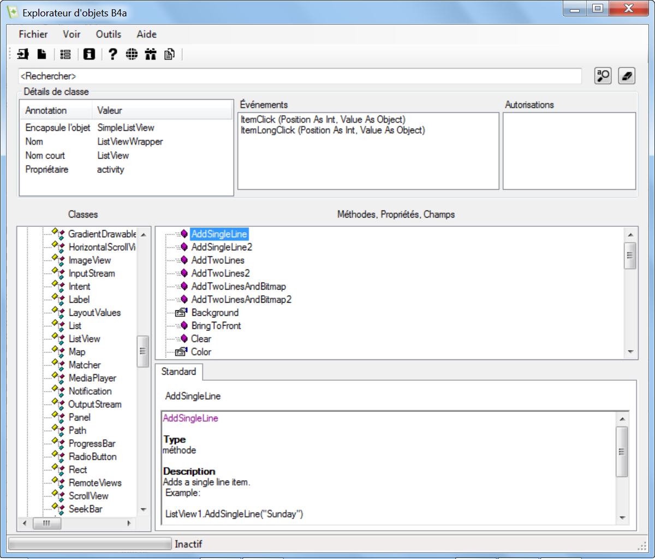

## Useful links

### B4A

A useful link for layout graphics. [Android cheat sheet for graphic designers](http://petrnohejl.github.io/Android-Cheatsheet-For-Graphic-Designers/)

**Android Developers**. [Design](http://developer.android.com/design/index.html) [Develop](http://developer.android.com/develop/index.html) [Distribute](http://developer.android.com/distribute/index.html)

**Android Developers** searching for any request.

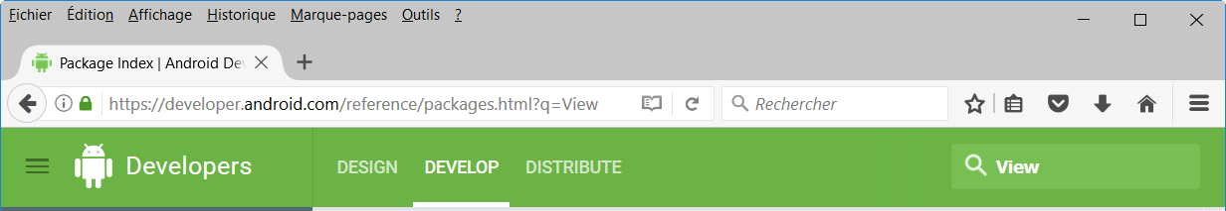

In the upper right corner you find the search field.

Enter *View* in the field: 

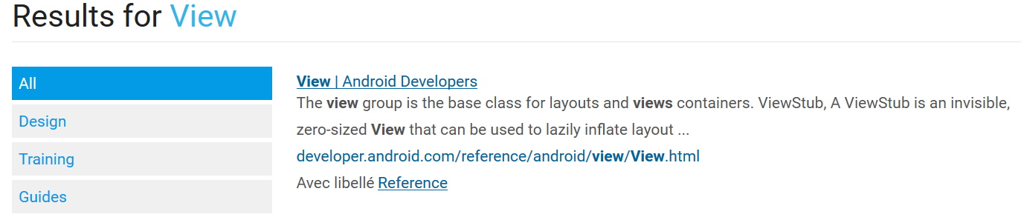Click on the link View | Android Developers.

And you get all the information about Views.

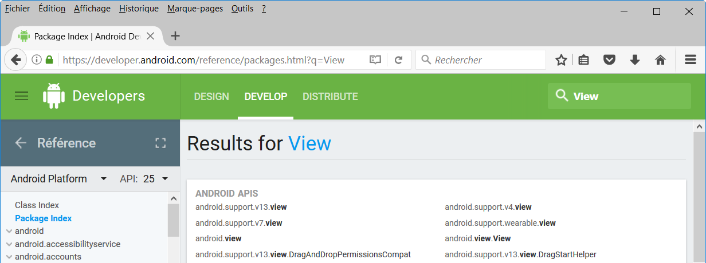

### B4i

iOS developers:

<https://developer.apple.com/ios/human-interface-guidelines/overview/themes/>

It’s the Apple site with all information about iOS.

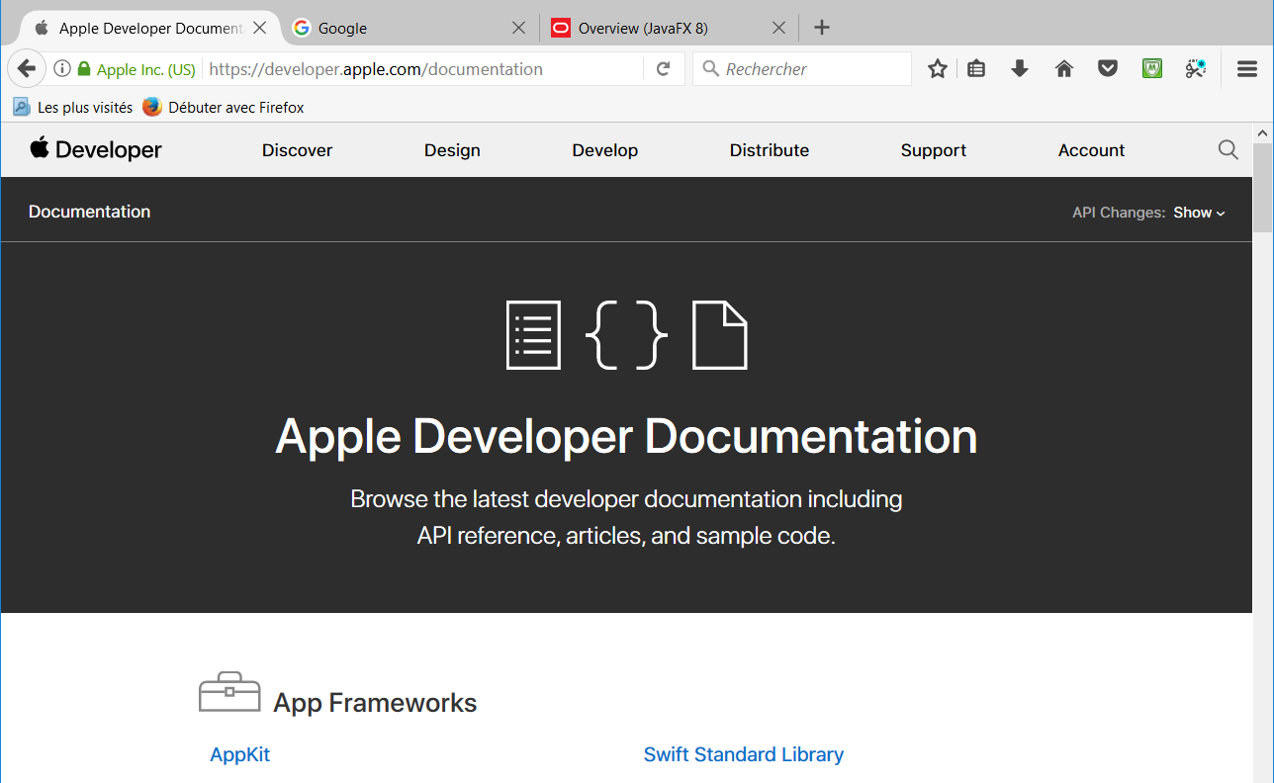

### B4J

Oracle Overview FavaFX API:

<http://docs.oracle.com/javase/8/javafx/api/toc.htm>

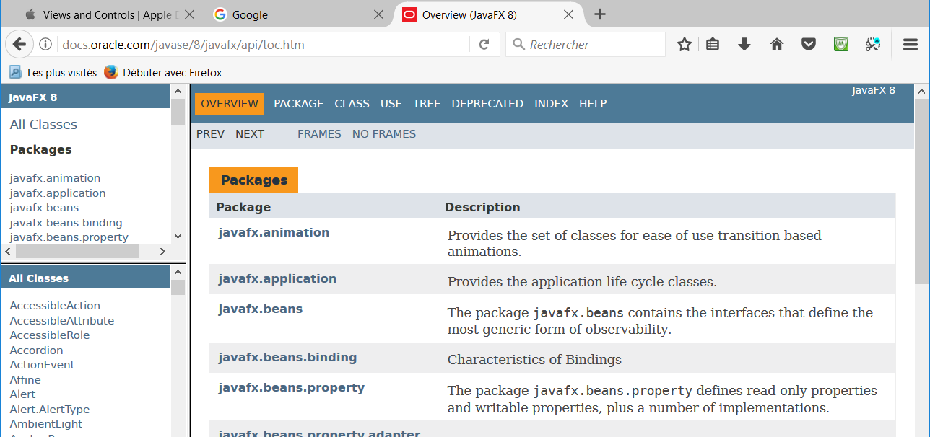

### B4R

Arduino HomePages:

<https://www.arduino.cc/en/Guide/HomePage>

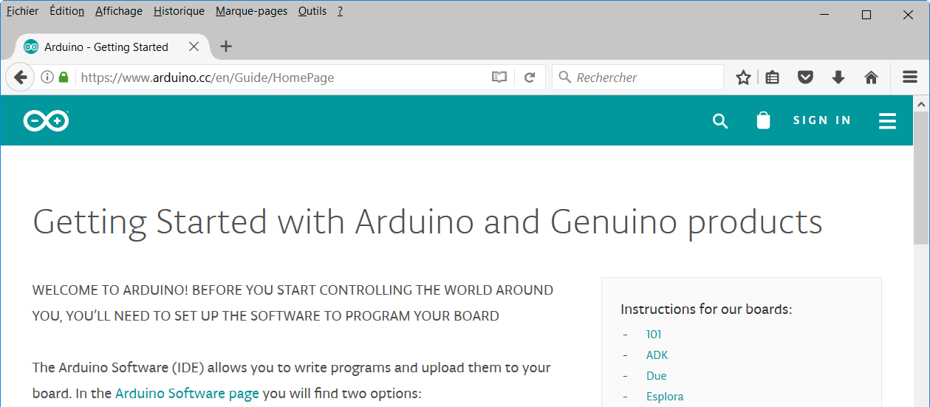

## Books

**B4A book**

Written by Philip Brown under the pseudo Wyken Seagrave.



<http://pennypress.co.uk/b4a-book/>

**MagBook** Build your own Android App.

Written by Nigel Whitfield.

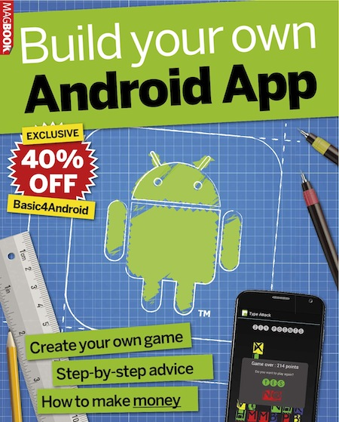

<http://www.magbooks.com/product/build-your-own-android-app/>